Appendix 13B-3 Wave Run-up on

Smooth Impermeable Slope

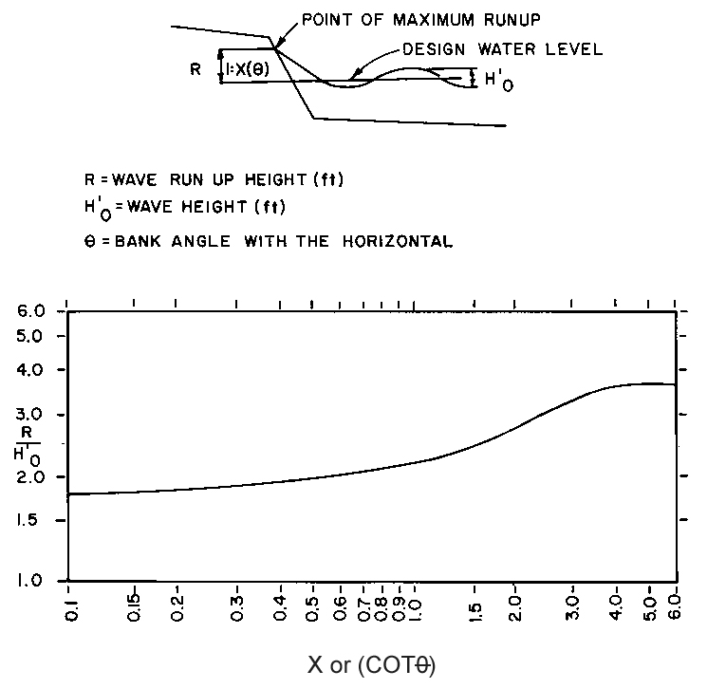

Source: HEC-11

