Appendix 13B-2 Design Breaker Wave

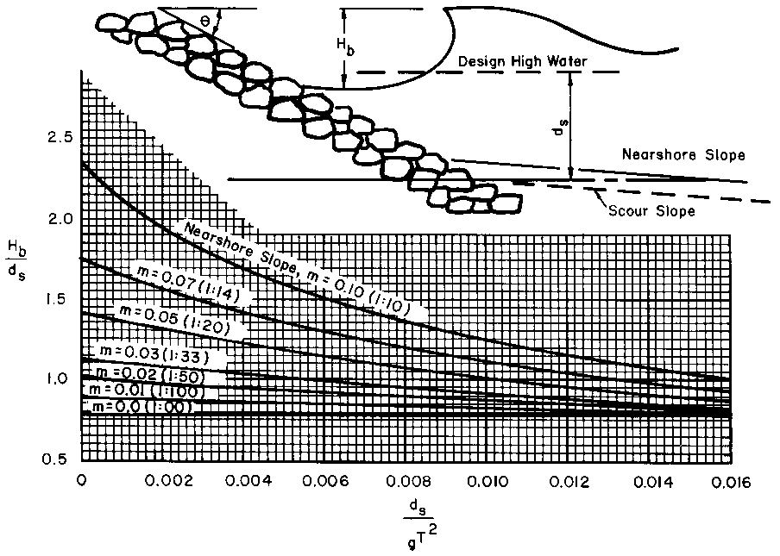

Source: Model Drainage Manual AASHTO 2005

