Appendix 13B-1 Nomographs of Significant Wave Height

Prediction Curves as Functions of

Windspeed, Fetch Length, and Wind Duration
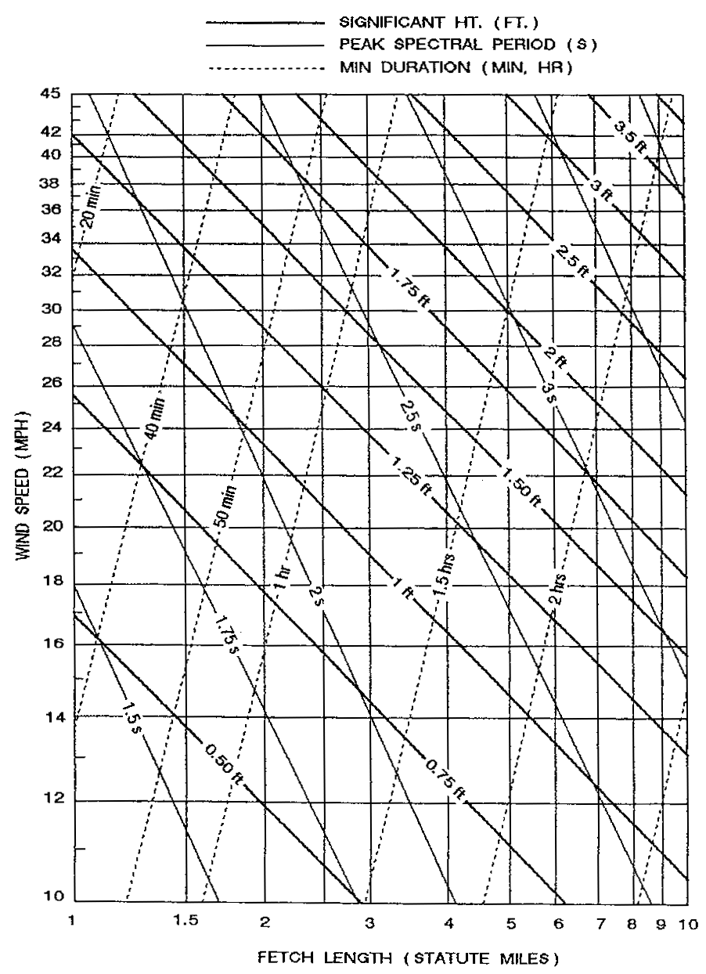

Source: HEC-11

