Chapter 13 - Shore Protection
TABLE OF CONTENTS
Chapter 13 - Shore Protection 13-1
13.1 Introduction 13-1
13.1.1 General 13-1
13.1.2 Assessing Highway Protection Needs in the Coastal Zone 13-1
13.1.2.1 Wave Attack 13-1
13.1.2.2 Littoral Drift 13-2
13.1.2.3 Seasonal Changes in Beach Morphology 13-2
13.1.2.4 Foundation Conditions 13-2
13.1.2.5 Corrosion 13-2
13.1.2.6 Highway Protection Measures 13-3
13.1.3 Lakes 13-3
13.2 The Coastal and Shoreline Area 13-4
13.2.1 Introduction 13-4
13.2.2 Tidal Elevation Nomenclature 13-5
13.2.3 Tidal Elevation Conversion 13-7
13.2.4 Design High Water 13-8
13.2.5 Determination of Mean High/Low Tide Levels 13-8
13.3 Dynamic Beach Processes 13-11
13.3.1 Introduction 13-11
13.3.2 Normal Conditions 13-11
13.3.3 Storm Conditions 13-12
13.3.4 Beach and Dune Recovery 13-14
13.4 Design Waves 13-15
13.4.1 Introduction 13-15
13.4.2 Significant Height and Period 13-15
13.5 Simplified Methods for Estimating Wave Conditions 13-17
13.5.1 Introduction 13-17
13.5.2 Predicting Wind Generated Waves 13-17
13.5.2.1 Wave Height 13-17
13.5.2.2 Hindcasting 13-17
13.5.2.3 Forecasting 13-17
13.5.2.4 Breaking Waves 13-18
13.5.2.5 Prediction Procedure 13-19
13.5.2.5.1 Wind Speed Estimation 13-19
13.5.2.5.2 Site Maximization Procedure 13-19
13.5.2.5.3 Design Breaker Wave 13-19
13.5.2.3.4 Wave Run-up 13-20
13.5.3 Adjustments for Flooded Vegetated Land 13-21
13.6 Flood Prediction Methods 13-22
13.6.1 Introduction 13-22
13.6.2 Coastal Flooding 13-22
13.6.3 Tidal Flow Restrictions 13-22
13.6.4 Lake Shore Flooding 13-23
13.7 Riprap Shore Protection 13-24
13.7.1 Introduction 13-24
13.7.2 General Features 13-24
13.7.2.1 Shore Protection Design 13-24
13.8 References 13-28
List of Tables
Table 13-1. Correction Factors For Wave Run-up 13-20
List of Figures
Figure 13-1. Visual Definition of Terms Describing a Typical Beach Profile 13-4
Figure 13-2. Nomenclature of Tidal Ranges 13-6
Figure 13-3. Normal Wave Action on Beach and Dune 13-11
Figure 13-4. Initial Attack of Storm Waves on Beach and Dune 13-12
Figure 13-5. Storm Wave Attack of Foredune 13-13
Figure 13-6. After Storm Wave Attack of Beach and Dune 13-13
Figure 13-7. Riprap Rock Shore Protection Typical Design Configuration 13-26
List of Appendices
Appendix 13A-1. Definitions and Abbreviations
Appendix 13A-2. Symbols
Appendix 13B-1. Nomographs of Significant Wave Height Prediction Curves as Functions of Windspeed, Fetch Length, and Wind Duration
Appendix 13B-2. Design Breaker Wave
Appendix 13B-3. Wave Run-up on Smooth Impermeable Slope
Appendix 13B-4. Nomographs for Design of Rock Slope Shore Protection (For Shoal Water)
Appendix 13B-5. Nomographs for Design of Rock Slope Shore Protection (For Deep Water)
Appendix 13B-6. Nomograph for Riprap Size to Resist Wave Action

Shore Protection

Introduction

General
Highways that encroach upon coastal zones, including bays, estuaries and tidal basins, and the shore of lakes and reservoirs, present unique circumstances which require additional measures to protect the roadway from erosion. Much of the discussion in the other chapters of this manual applies to these unique areas but does not address in detail the special aspects of seasonal variation and extremes of wind, wave, current, and tide upon banks and shores covered in this chapter. The information contained within this chapter may be used for preliminary design, minor design, and general information. Major designs should involve, in addition to the hydraulics engineer, coastal engineers, coastal geologists, oceanographers or other specialists in the interaction of wind, tides and waves. The procedures used should also be from the source documents/manuals, so that the most current methodologies are used.*

Assessing Highway Protection Needs in the Coastal Zone
Highways in the coastal environment experience a wide array of threats to long-term stability that are unique to the coastal zone.

Wave Attack
The primary threat is from wave attack. The susceptibility of a highway to wave attack is dependent on location relative to tidal elevations, the underlying geology, and the exposure of the coastline.
Headlands and rocks that have historically withstood the relentless pounding of tide and waves can usually be relied on to protect adjacent highway locations. However, because headlands project out from the coast, wave action is usually concentrated at these locations. The need for shore protection structures on headlands are generally limited to highway locations at the top or bottom of bluffs having a history of sloughing and along beach fronts.
Wave attack on a sloping beach is less severe than on a headland, due to the gradual shoaling of the bed that causes incoming waves to break before they reach the shoreline. However, on long shallow sloping beaches, waves can reform after passing over bars.
The relative degree of protection or exposure of the shoreline affects the strength of wave attack. Coastlines exposed to long fetch lengths cans be subject to high wave attack from wind-generated waves.

Littoral Drift
Littoral drift of beach sands may either be an asset or a liability. Littoral drift is a normal beach process. If a beach is stable then the net littoral drift is zero. If the amount of sediment brought into a section of beach by littoral drift exceeds outgoing sediment, then a new beach could be built in front of the embankment, reducing the depth of water at its toe and the corresponding height of the waves attacking it. If the net littoral drift is negative (degrading) or subject to seasonal variations, then shore protection measures may be necessary to retain the beach and protect the roadway.
On the other hand, if sand is in scant supply, backwash from revetment tends to degrade the beach or bed, and an allowance should be made for this scour when designing the revetment, both as to weight of stones and depth of foundation. Groins would be ineffective for such locations; if they succeeded in trapping some littoral drift, beaches located down-drift may retreat due to undernourishment.

Seasonal Changes in Beach Morphology
Changes in the beach profile occur on a seasonal basis due to changes in the earth’s tilt and seasonal weather variation. Changes in the axial tilt can reverse littoral currents. They also change the heights and ranges of tidal elevations.
Oceans are generally warmer than land during the winter resulting in low pressures over the water surface. Lower pressure results in higher tide ranges than occurs during summer. Thus, beach erosion is increased and “winter beaches” possess a steeper beach profile and more predominant offshore bars. Generally the shift is a recession, increasing the exposure of beach locations to the hazard of damage by wave action. On strands or along extensive embayments, recession at one end may develop accession at the other. Observations made during location should include investigation of this phenomenon. For strands, the hazard may be avoided by locating the highway on the backshore facing the lagoon.

Foundation Conditions
Foundation conditions vary widely for beach locations. On a receding shore, good bearing may be found on soft but substantial rock underlying a thin mantel of sand. Bed stones and even gravity walls have been founded successfully on such foundations.
Long straight beaches, spits and strands, are radically different, often with softer clays or organic materials underlying the sand. Sand usually being plentiful at such locations, subsidence is greater hazard than scour and location should anticipate a "floating" foundation for flexible, self-adjusting types of protection.

Corrosion
The corrosive effect of salt water is a major concern for hydraulic structures located along the coastline. The long-term effect on special coatings should be monitored.

Highway Protection Measures
Highways located in the coastal zone may be protected through two alternative measures – location planning and armoring.
In planning oceanfront locations, alignments should be selected that minimize the threat of wave attack and are located on stable land surfaces.
Often existing roadways cannot be relocated and new roadways must be exposed to wave attack. Structural measures may be used to armor the embankment face, or off shore devices like groins may be used to aggrade the beach at embankment toe.

Lakes
Under the right set of conditions, wind can create large waves on lakes. Height of waves is a function of fetch, so that the larger (or longer) the lake, the higher waves break upon reaching shoals, reducing the effects of erosion along embankments behind shallow coves and increasing the threat at headlands or along causeways in deep water. Constant rippling of tiny waves may cause severe erosion of certain soils.
The erosive force of wave action is a function of the fetch and in most inland waters is not very serious. In fresh waters the establishment of vegetal cover can often provide effective protection, but planners should not overlook the possibility of moderate erosion before the cover becomes established. Any light armor treatment should be adequate for this transitional period.
Older lakes have built thick beds of precipitated silt and organic matter. Bank protection along or across such lakes must be designed to suit foundations available, it usually being more practical to use lightweight or self-adjusting types supported by soft bed materials than to excavate mud to stiffer underlying soils. The warning is especially applicable to protection of causeway embankments.

The Coastal and Shoreline Area

Introduction
The beach and near-shore zone of a coast is the region where the forces of the sea react against the land. The physical system within this region is composed primarily of the motion of the sea, which supplies energy to the system, and the shore, which absorbs this energy. Because the shoreline is the intersection of the air, land and water, the physical interactions which occur in this region are unique, very complex, and difficult to fully understand. As a consequence, a large part of the understanding of the beach and near-shore physical system is simply descriptive in nature.
Where the land meets the ocean at a sandy beach, the shore has natural defenses against attack by waves, currents, and storms. The first of these defenses is the sloping near-shore bottom that causes waves to break offshore, dissipating their energy over the surf zone. The process of breaking often creates an offshore bar in front of the beach that helps to trip following waves. The broken waves re-form to break again, and may do this several times before finally rushing up the beach foreshore. At the top of wave up-rush a ridge of sand is formed. Beyond this ridge, or crest of the berm, lies the flat beach berm that is reached only by higher storm waves. Figure 13-1 shows a visual definition of the terms used to describe a typical beach profile.
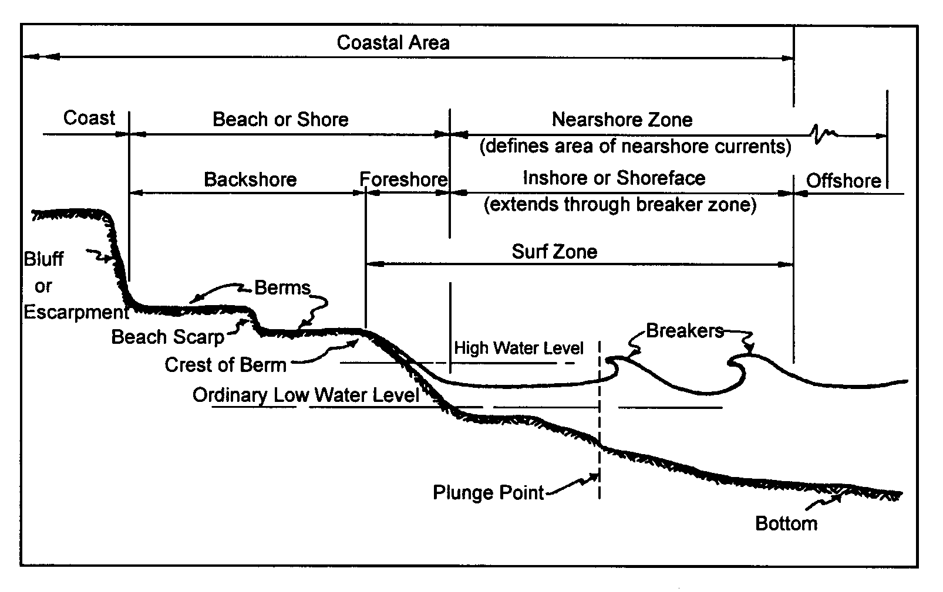
Figure 13-1. Visual Definition of Terms Describing a Typical Beach Profile
The motions of the sea that contribute to the beach and near-shore physical system include waves, tides, currents, storm surges, and tsunamis. Wind waves are by far the largest contribution of energy from the sea to the beach and near-shore physical system. As winds blow over the water, waves are generated in a variety of sizes from ripples to large ocean waves. Following is a discussion of the coastal forces of motion. For more information on the mechanics of waves and shore phenomena, refer to publications developed by the US Army Corps of Engineers, Coastal and Hydraulic Engineering Laboratory. Procedures use in evaluating shore protection were developed by the Corps of Engineers and published as the Shore Protection Manual (1984), referred to as SPM. The Corps of Engineers has updated the SPM. The updated manual is called the Coastal Engineering Manual and was* published in 2002.

Tidal Elevation Nomenclature
A depiction of tidal elevations and nomenclature is presented in Figure 13-2. Note that a typical tidal cycle in the Chesapeake Bay and Virginia Atlantic Coast has two highs and two lows. The average of all the higher highs for a long period (preferably in multiples of the 19-year metonic cycle) is mean higher high water (MHHW), and the average of all the lower lows is Mean Lower Low Water (MLLW). The vertical difference MHHW and MLLW is the Diurnal Range (R).
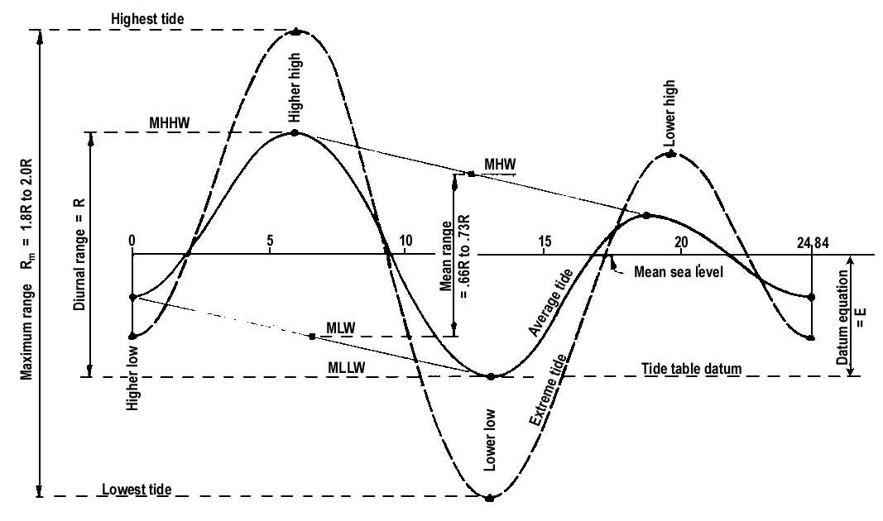
Figure 13-2. Nomenclature of Tidal Ranges
The average of all highs (indicated graphically as the mean of higher high and lower high) is the mean high water (MHW). The average of all lows (indicated graphically as the mean of higher low and lower low) is mean low water (MLW). The vertical difference between MHW and MLW is the mean range.
The maximum tide range (R_{m}) is defined as the vertical difference between the Highest High Tide and the Lowest Low Tide.
Mean Sea Level (MSL) is defined as the mean height of the surface of the sea for all stages of the tide over a Tidal Epoch (19 year Metonic Cycle*). Confusion often arises when MSL is referenced as a vertical datum. Mean Tide Level (MTL) is the midway point between MLW and MHW. MSL is not necessarily synonymous with MTL. Often, when a bridge drawing or other document refers to MSL as its vertical datum, it is actually referring to a fixed datum. When the datum is named as MSL, the user of the data must clarify whether the reference is equivalent to MTL for the current tidal epoch. If it is found that MSL actually refers to a fixed datum, the user must determine the relationship between that fixed datum and the datum used in the study at hand.
The fixed datums used most commonly in the United States are the National Geodetic Vertical Datum of 1929 (NGVD29) and the North American Vertical Datum of 1988 (NAVD88). These reference surfaces were established by NGS. High-accuracy benchmarks referenced to these datums have been set by NGS throughout the nation.
NGVD29 was called the Sea Level Datum of 1929 until the name was changed in 1973. Many older plan sets, maps and documents refer to a datum of Sea Level or Mean Sea Level that is actually equivalent to NGVD29. One must not assume this equivalency, however, without verification.
The National Oceanic and Atmospheric Association (NOAA) publishes information on tidal elevations for the east and west coasts of North America and the Gulf of Mexico. Typically, elevations are referenced to MLW, MLLW or a local gage datum instead of National Geodetic Vertical Datum (NGVD 1929 or NAVD 1988*). Bathymetric maps are typically referenced to MLW so that mariners may know the depth of water at low tides.
Daily tide predictions for points in the Chesapeake Bay and the Virginia shoreline are based on daily predictions for Washington, D.C., and Hampton Roads, VA. Tidal differences and other constants for locations along the Chesapeake Bay and Virginia shoreline are available from at the following NOAA Internet web site: www.nos.noaa.gov.

Tidal Elevation Conversion
A conversion must be made to relate the elevation of Design High Water to the appropriate vertical datum (NGVD 1929 or NAVD 1988, whichever is being used on the project in question) used in Highway Design. A series of geodetic bench marks have been established which permit conversion of local MLLW datum to the more accepted NGVD-29 or NAVD-88. The relationships between MLW and NGVD-29 or NAVD-88 for gage locations in Virginia are available from the following NOAA Internet web site: http://tidesandcurrents.noaa.gov/station_retrieve.shtml?type=Bench%20Mark%20Data%20Sheets&state=Virginia&id1=863
Conversions for intermediate points may be made by interpolating between stations. Additional information on MLLW and NGVD-29 and NAVD-88 may be found by consulting the NOAA publication Tide Tables High and Low Water Predictions (for the East Coast of North and South America).
Conversion of tide elevations should be undertaken with care and independently checked. Common errors are:
- Forgetting to convert from water levels to a vertical datum
- Adding the factor instead of subtracting it
- Using half the diurnal range as the stage of high water

Design High Water
Small waves and conditions indicate that when protection is necessary, one of the key elements in a successful design is establishing the elevation appropriate for the protection features. The most frequently used term is Design High Water. Design High Water for shore protection is a high stage of the static or still-water level of the sea. The height of Design High Water is referenced to tidal elevations such as Mean Low Water or Mean Sea Level. Except for inland waters affected by wind tides, floods and seiches, the level usually used for design is the highest tide.

Determination of Mean High/Low Tide Levels
It is frequently necessary to determine Mean High Water (MHW) and Mean Low Water (MLW) levels as a requisite for obtaining various federal, state, and/or local environmental permits. The National Oceanic and Atmospheric Administration (NOAA) publishes such information for the east and west coasts of North America and the Gulf of Mexico. Unfortunately, the elevations shown in these publications are predicated on local, mean lower* low water (MLLW) datum instead of National Geodetic Vertical Datum of 1929 (NGVD 29) or the newer North American Vertical Datum of 1988 (NAVD 88). A series of geodetic bench marks have been established which permit conversion of mean low water datum to the more meaningful NGVD 29 and/or NAVD 88 Datum. A table of these tidal bench marks for Virginia, including the Chesapeake Bay and its tributaries, is located on the following NOAA's internet web site: http://tidesandcurrents.noaa.gov/station_retrieve.shtml?type=Bench%20Mark%20Data%20Sheets&state=Virginia&id1=863
To determine the MHW and MLW elevations, proceed as follows:
- Go to the web site shown above and scroll up or down the table of the Tidal Bench Marks until you find the one closest to the location in which you are interested. Click on the link.
- The screen will change to show information for the site selected. Scroll down until you see a link designated as “National Geodetic Vertical Datum (NGVD 29)” and click on it. You may also click on “Datums Page” in the top left hand corner and it will take you to the same spot on the page.
- The screen will change again, displaying a bar graph showing pertinent tide levels including MHW (Mean High Water), MLW (Mean Low Water) and usually a correction factor for both NGVD-29 and NAVD-88 datums. The MHW and MLW values shown on the graph are in terms of local MLLW (Mean Lower Low Water) datum and must be converted to either NGVD-29 or NAVD-88 datums. An example graphic display is shown below.
- If you want MHW and MLW elevations in terms of NAVD-88 datum, subtract the correction factor shown for NAVD-88 datum from the values shown for MHW and MLW.

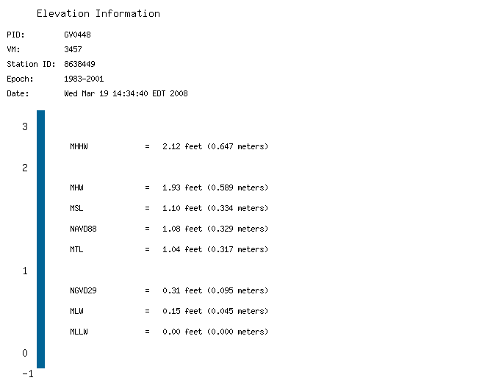
The NAVD 88 and the NGVD 29 elevations related to MLLW were computed from Bench Mark, TIDAL 7 STA 81, at the station.
Displayed tidal datums are Mean Higher High Water(MHHW), Mean High Water (MHW), Mean Tide Level(MTL), Mean Sea Level (MSL), Mean Low Water(MLW), and Mean Lower Low Water(MLLW) referenced on 1983-2001 Epoch.

Example: Find the mean low and high water elevations on the James River near Claremont, Virginia in terms of NAVD-88 datum.
Step 1 Consult NOAA’s internet web site, locate link for* the tidal benchmark for the James River near Claremont and click on it.
Step 2 When the screen changes, scroll down the page until you get to the link “National Geodetic Vertical Datum (NGVD 29” and click on it.
Step 3 When the graphic is displayed note that MHW = 1.93 ft and MLW = 0.15 ft. in terms of local, MLLW datum and that the NAVD-88 correction factor is 1.08 ft.
Step 4 Subtract the NAVD-88 correction factor of 1.08 ft. from both values to get MHW and MLW in terms of NAVD-88 datum.
MHW = 1.93 – 1.08 = 0.85 ft. Use 0.9 ft. for Mean High Water (MHW)
MLW = 0.15 – 1.08 = -0.93 ft. Use –0.9 ft. for Mean Low Water (MLW)
Answer: Mean Low Water (MLW) elevation = -0.9 ft.
Mean High Water (MHW) elevation = 0.9 ft.

Dynamic Beach Processes

Introduction
The beach constantly adjusts its profile to provide the most efficient means of dissipating incoming wave energy. This adjustment is the beach's natural dynamic response to the sea.
There are two general types of dynamic beach response to wave motion: response to normal conditions and response to storm conditions. Under normal conditions, the wave energy is easily dissipated by the beach's natural defense mechanisms. However, when storm conditions generate waves containing increased amounts of energy, the coast must respond with extraordinary measures, such as sacrificing large sections of beach and dune. In time the beach may recover, but often not without a permanent alteration.

Normal Conditions
As a wave moves toward shore, it encounters the first beach defense in the form of the sloping near-shore bottom. When the wave reaches a water depth equal to about 1.3 times the wave height, the wave collapses or breaks. Thus a wave 1-foot high will break in a depth of about 1.3 feet. Breakers are classified as four types— plunging, spilling, surging, or collapsing. The form of breakers is controlled by wave steepness and near-shore bottom slope. Breaking results in a dissipation of wave energy by the generation of turbulence in the water and by the transport of sediment lifted off the bottom and tossed around by the turbulent water. Broken waves often re-form to break again, losing additional energy. Finally, the water travels forward as a foaming, turbulent mass and expends most of its remaining energy in a rush up the beach slope (Figure 13-3).
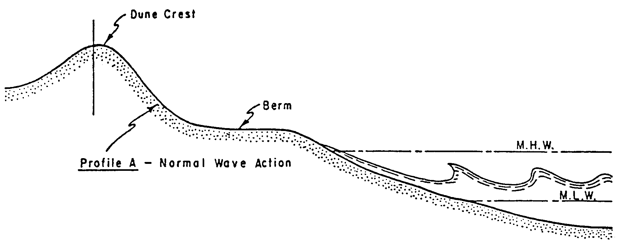
Figure 13-3. Normal Wave Action on Beach and Dune
If there is an increase in the incoming wave energy, the beach adjusts its profile to facilitate the dissipation of the additional energy. This is most frequently done by the seaward transport of beach material to an area where the bottom water velocities are sufficiently reduced to cause sediment deposition. Eventually enough material is deposited to form an offshore bar that causes the waves to break farther seaward, widening the surf zone over which the remaining energy must be dissipated. Tides compound the dynamic beach response by constantly changing the elevation at which the water intersects the shore and by providing tidal currents.

Storm Conditions
Strong winds generate high, steep waves. In addition, these winds often create a storm surge that raises the water level and allows waves to attack higher parts of the beach not ordinarily subjected to waves. The storm surge allows the large waves to pass over the offshore bar formation without breaking. When the waves finally break, the remaining width of the surf zone is not sufficient to dissipate the increased energy contained in the storm waves. The remaining energy is spent in erosion of the beach, berm, and sometimes dunes that are now exposed to wave attack by virtue of the storm surge.
Eroded material is carried offshore in large quantities where it is deposited on the near-shore bottom to form an offshore bar. This bar eventually grows large enough to break the incoming waves farther offshore, forcing the waves to spend their energy in the surf zone. This process is illustrated in Figure 13-4.
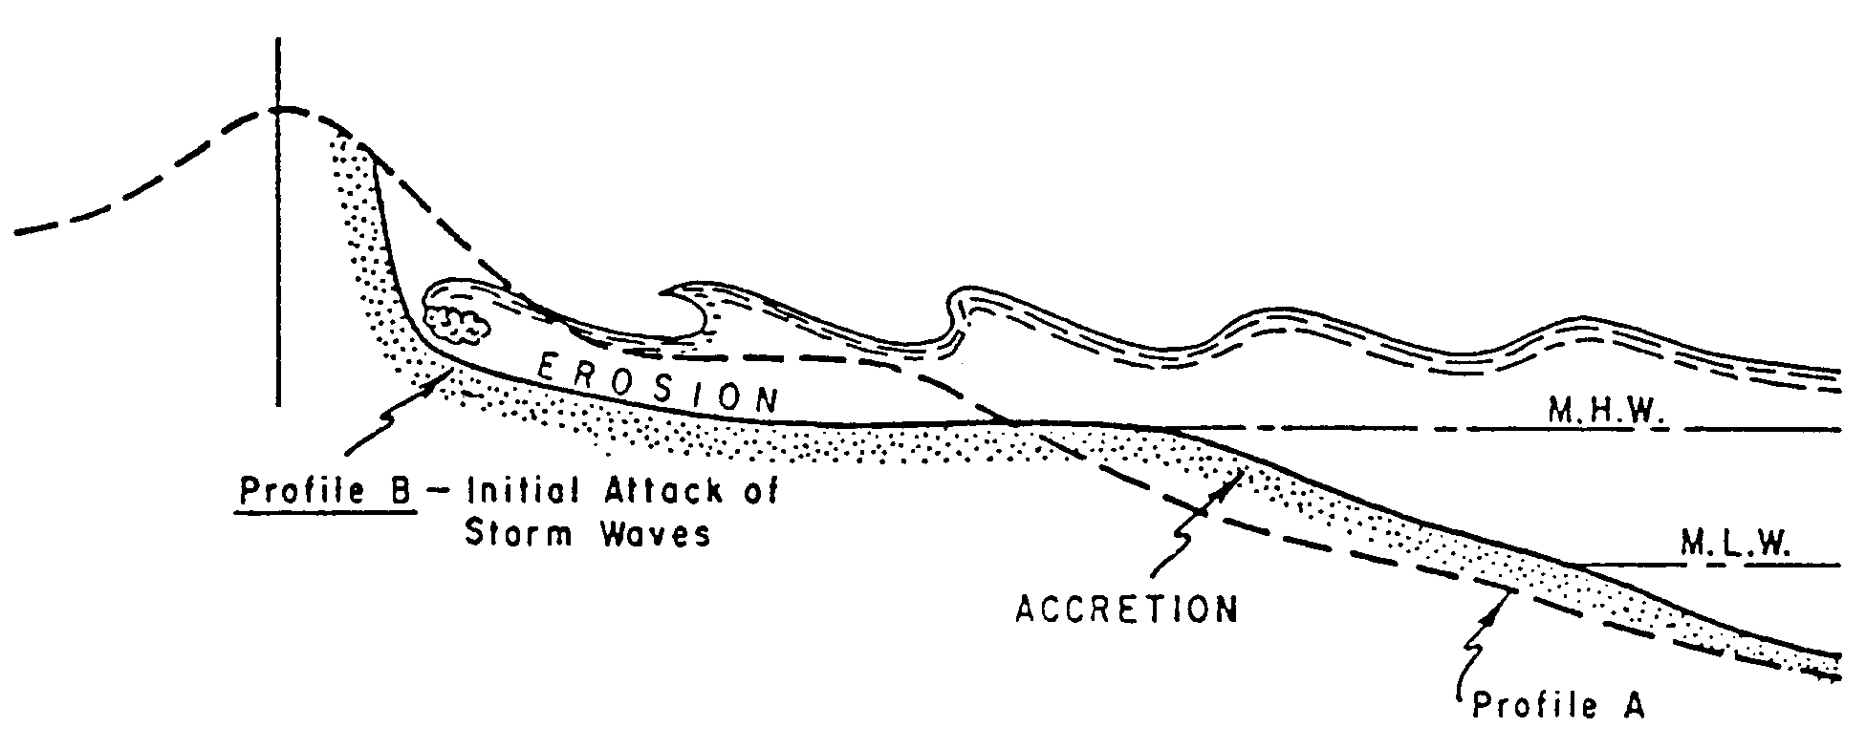
Figure 13-4. Initial Attack of Storm Waves on Beach and Dune
Beach berms are built naturally by waves to about the highest elevation reached by normal storm waves. When storm waves erode the berm and carry the sand offshore, the protective value of the berm is reduced and large waves can overtop the beach. The width of the berm at the time of a storm is thus an important factor in the amount of upland damage a storm can inflict.
In severe storms, such as hurricanes, the higher water levels resulting from storm surges allow waves to erode parts of a dune. It is not unusual for 50 to 100 feet wide dunes to disappear in a few hours. Storm surges are especially damaging if they occur concurrently with high astronomical tides (Figure 13-5).
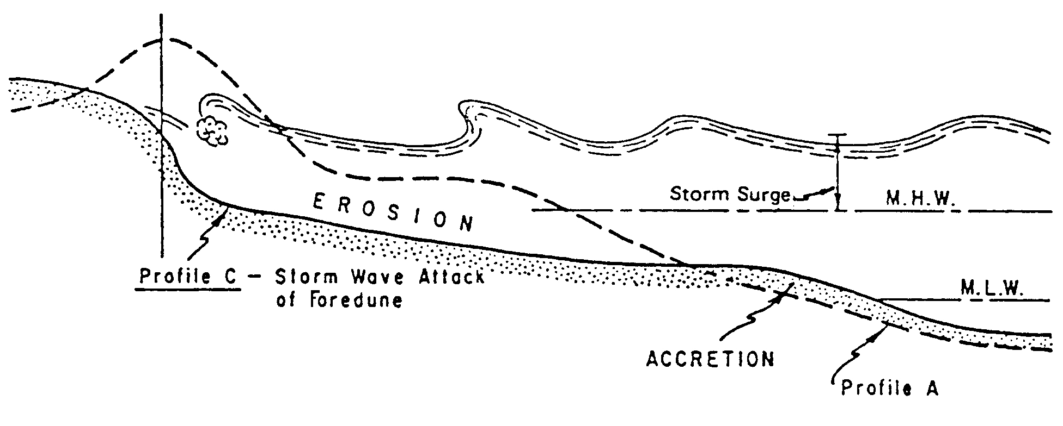
Figure 13-5. Storm Wave Attack of Foredune
In essence, the dynamic response of a beach under storm attack is a sacrifice of some beach, and often dune, to provide material for an offshore bar. This bar protects the shoreline from further erosion. After a storm or storm season, natural defenses may again be reformed by wave and wind action (Figure 13-6).
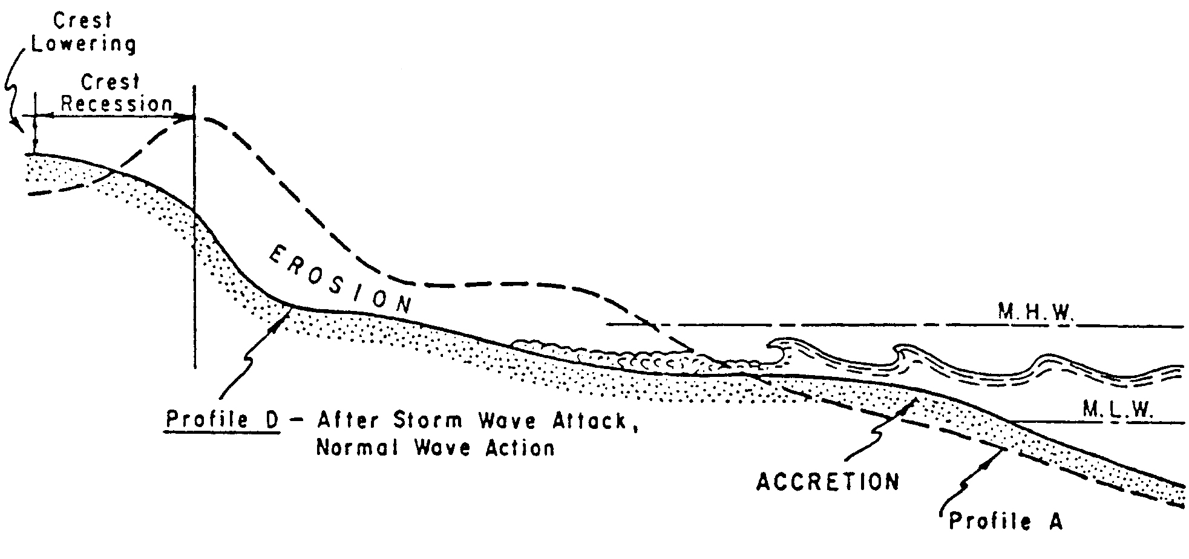
Figure 13-6. After Storm Wave Attack of Beach and Dune
The storm surge and wave action may succeed in completely overtopping the dunes causing extensive coastal flooding. When this occurs, beach and dune sediments are swept landward by the water, and in the case of barrier islands, are deposited as overwash fans on the backshore or in the lagoon. This process results in a loss of sand from the dynamic beach system. Often, storm overwash and storm flooding return flow will erode enough sand to cut a new tidal inlet through the barrier island.

Beach and Dune Recovery
Some beach systems may be in quasi-equilibrium. Sediment supplied to the beach from littoral transport replaces sediment lost to overwash. Sediment deposited into offshore bars is redeposited on the beach. Following a storm there is a return to more normal conditions that are dominated by low, long swells. These waves transport sand from the offshore bar, built during the storm, and place the material on the beach. The rebuilding process takes much longer than the short span of erosion which took place.
Alternate erosion and accretion may be seasonal on some beaches; the winter storm waves erode the beach, and the summer swell (waves) rebuilds it. Beaches also appear to follow long-term cyclic patterns, where they may erode for several years and then accrete for several years.
A series of violent local storms over a short period of time can disturb a system in equilibrium and result in severe erosion of the shore because the natural protection does not have time to rebuild between storms. Sometimes full recovery of the beach never occurs because sand is deposited too far offshore during the storm to be returned to the beach by the less steep, normal waves that move material shoreward.
Other beach systems may be in disequilibrium. Erosion of the beach and dune system results in retreat of the beach. Roadways and structures placed near the beach may become threatened over time.

Design Waves

Introduction
The pattern of waves on any body of water exposed to winds generally contains waves of many periods. Typical records from a recording gage during periods of steep waves indicate that heights and periods of real waves are not constant as is assumed in theory. Wave-lengths and directions of propagation are also variable. Further, the surface profile for waves near breaking in shallow water or for very steep waves in any water depth is distorted, with high narrow crests and broad flat troughs. Real ocean waves are so complex that some idealization is required.
Even for the simplest of cases, the estimation of water levels caused by meteorological conditions is complex. Elaborate numerical models requiring the use of a computer are available, but simplified techniques may be used to predict acceptable wind wave heights for the design of highway protection facilities along the shores of the ocean, embayments, and inland lakes and reservoirs.
Wave prediction is called hindcasting when based on past meteorological conditions and forecasting when based on predicted conditions. The same conditions are used for hindcasting and forecasting. The only difference is the source of meteorological data. Reference is made to the Army Corps of Engineers, Coastal Engineering Manual, and* FHWA’s HEC-25, Highways in the Coastal Environment for more complete information on the theory of wave generation and predicting techniques.
The prediction of wave heights from vessel-generated waves may be estimated from observations. Research is underway to provide more information on vessel wakes.

Significant Height and Period
A given wave train contains individual waves of varying heights and period. The significant wave height H_{s}, is defined as the average height of the highest one-third of all the waves in a wave train. H_{s} is the design wave height normally used for flexible revetments.
Other design wave heights can also be designated, such as H₁₀ and H₁. The H₁₀ design wave is the average of the highest 10 percent of all waves, and the H₁ design wave is the average of the highest 1 percent of all waves. The relationship of H₁₀ and H₁ to H_{s} can be approximated as shown in Equations 13.1 and 13.2.
(13.1)
(13.2)
Economics and risk of catastrophic failure are the primary considerations in designating the design wave average height.

Simplified Methods for Estimating Wave Conditions

Introduction
Wave height estimates are based on wave characteristics that may be derived from an analysis of the following data:
- Wave gauge records
- Visual observations
- Published wave hindcasts
- Wave forecasts
- Maximum breaking wave at the site
It should be noted that deepwater ocean wave characteristics derived from offshore data analysis may also need to be transformed to the project site using refraction and diffraction techniques described in the Army Corps of Engineer's Coastal Engineering Manual.*

Predicting Wind Generated Waves

Wave Height
The height of wind-generated waves is a function of:
- Fetch length
- Wind speed
- Wind duration
- Depth of water

Hindcasting
Wave hindcast information, based on historical weather records and observations, is available from the Army Corps of Engineer's Waterway Experiment Station (WES) in Vicksburg, Mississippi. Hindcasting methods should be used to determine the design wave height for coastal revetments.

Forecasting
Simplified wind wave prediction techniques may be used to establish probable wave conditions for the design of highway protection on bays, lakes, and other inland bodies of water. Wind data for use in determining design wind velocities and durations is usually available from weather stations, airports, and major dams and reservoirs.
The following assumptions pertain to these simplified methods.
- The fetch is short, 75 mi. or less
- The wind is uniform and constant over the fetch
It should be recognized that these conditions are rarely met and wind fields are not usually estimated accurately. The designer should therefore not assume that the results are more accurate than warranted by the accuracy of the input and the simplicity of the method. Good, unbiased estimates of all wind generated wave parameters should be sought and the cumulative results conservatively interpreted. The individual input parameter should not each be estimated conservatively, since this may bias the result.
The applicability of a wave forecasting method depends on the available wind data, water depth and overland topography. Water depth affects wave generation and for a given set of wind and fetch conditions, wave heights will be smaller and wave periods shorter if the wave generation takes place in a transitional or shallow water rather than in deep water. The height of wind-generated waves may also be fetch-limited or duration-limited. Selection of an appropriate design wave may require a maximization procedure considering depth of water, wind direction, wind duration, wind speed, and fetch length.
There is no single theory for the forecasting of wind-generated waves for relatively shallow water. Until further research results are available the interim method for predicting shallow-water waves presented in the Corp's “Coastal Engineering Manual“* are to be used. It uses deepwater forecasting relationships and is based on successive approximations in which wave energy is added due to wind stress and subtracted due to bottom friction and percolation. An initial estimate of wind generated significant wave heights can be made by using Appendix 13B-1. If the estimated wave height from the nomograph is greater than 2.0 feet it is recommended that the Army Corps of Engineers procedures be used to refine the input parameters.

Breaking Waves
Waves generated in deeper water and shoaling as they approach the embankment have a maximum size wave that will reach the shore still in possession of most of its deep-water energy. Wave heights derived from hindcasts or any forecasting method should be checked against the maximum breaking wave that the design still-water level depth and near-shore bottom slope can support. The design height will be the smaller of either the maximum breaker height or the forecasted or hindcasted wave height. The relationship of the maximum height of breaker that will expend its energy upon the protection (H_{b}) and depth of water at the slope protection (d_{s}) which the wave must pass over are illustrated in Appendix 13B-2.

Prediction Procedure
The following sections provide an outline of a wave prediction procedure.

13.5.2.5.1 Wind Speed Estimation
To estimate wind speed the following information is needed:
- Actual wind records from the site
- General wind statistics
- Best alternative source of wind information

13.5.2.5.2 Site Maximization Procedure
Using the method presented in the Army Corps of Engineer's “Coastal Engineering Manual”,* (CEM) the site maximization procedure consists of the following steps.
- Adjust wind information to 33 feet above water surface
- Determine fetch limitations
- Adjust wind information for over water conditions
- Develop and plot a wind speed-duration curve
- When applicable, develop and plot a wind speed-duration curve for limited fetch
- Select design wind
- Forecast deepwater wave characteristics from deepwater significant wave prediction curves
- Determine if deepwater or shallow-water conditions are present
- For shallow-water conditions, forecast shallow-water significant wave height and period
- For deepwater conditions, refract and shoal the deepwater wave to the project site, if needed
- Compute wave run-up and wind set-up

13.5.2.5.3 Design Breaker Wave
The following example illustrates how to use Appendix 13B-2 to estimate the maximum breaker wave height.
Example
By using hindcast methods, the significant wave height (H_{s}) has been estimated at 3.9-feet with a 3-second period. Find the design wave height (H_{b}) for the slope protection if the depth of water (d_{s}) is only 2.0 feet and the near-shore slope is 1V:10H.
Solution
From Appendix 13B*-2,
Since the maximum breaker wave height (H_{b}) is smaller than the significant deepwater wave height (H_{s}), the design wave height is 2.8 feet.

13.5.2.3.4 Wave Run-up
An estimate of wave run-up, in addition to design wave height, may also be necessary to establish the top elevation of highway slope protection. Wave run-up is a function of the design wave height, the wave period, bank angle, and the roughness of the embankment protection material. For wave heights of 2.0 feet or less wave run-up can be estimated by using Appendix 13B-3. The wave run-up height given on the chart is for smooth concrete pavement. Correction factors for reducing the height of run-up are adequate for most highway projects. The application of more detailed procedures is rarely justified, but if needed they are provided in the U.S. Army Corps of Engineers Manual, "Design of Coastal Revetments, Seawalls, and Bulkheads."
If in doubt whether waves generated by fetch and wind velocity will be of sufficient size to be affected by shoaling, use both charts and adopt the smaller value.
Table 13-1. Correction Factors For Wave Run-up
Slope Surface - Material Type | Correction Factor
Concrete pavement | 1.00
Concrete blocks (voids < 20%) | 0.90
Concrete blocks (20% < voids > 40%) | 0.70
Concrete blocks (40% < voids > 60%) | 0.50
Grass | 0.35 - 0.90
Rock riprap (angular) | 0.60
Rock riprap (round) | 0.70
Rock riprap (hand placed or keyed) | 0.80
Grouted rock | 0.90
Wire enclosed rocks/gabions | 0.80

Adjustments for Flooded Vegetated Land
When waves travel across a shallow flooded area, the initial heights and periods of the waves may increase; i.e., when the wind stress exceeds the frictional stress of the ground and vegetation underlying the shallow water. The initial wave heights may decay at other times when the frictional stress exceeds the wind stress.
For further discussions and example problems of estimating the growth and decay of wind waves over flooded, vegetated land, refer to the Corps of Engineers publication, Coastal Engineering Manual.*

Flood Prediction Methods

Introduction
The prediction of the flood stage elevation for a specific exceedence probability event is of considerable importance to the designer. The methods of prediction that are applied to coastal and lake shorelines are quite different from those used on upland rivers and streams.

Coastal Flooding
The depth of coastal flooding for a specified event depends upon the velocity, direction and duration of the wind, the astronomical tide, and the size and depth of the body of water over which the storm acts. Such floods are considered to be comprised of two parts — still-water depth and wave height. The duration of flooding depends on the duration of the generating forces.
The still-water elevations are taken from sources such as National Oceanic and Atmospheric Administration (NOAA) technical memoranda or Corps of Engineers (COE) study reports. In these analyses, storm tides are computed from a full set of climatologically representative events using a numerical-dynamic storm surge model. Tidal flood records covering a significant period of time are used to determine the exceedence probability of selected flood magnitudes.
The methodology for analyzing the effects of wave heights associated with coastal storm surge flooding is described in the National Academy of Sciences (NAS) report "Methodology for Calculating Wave Action Effects Associated with Storm Surges," 1977. This method is based on three major concepts. First, depth-limited waves in shallow water reach a maximum breaking height that is equal to 0.78 times the still-water depth. The wave crest is 70 percent of the total wave height above the still-water level.
The second major concept is that wave height may be diminished by dissipation of energy due to the presence of obstructions such as sand dunes, dikes and seawalls, buildings and vegetation. The amount of energy dissipation is a function of the physical characteristics of the obstruction. The third major concept is that wave height can be regenerated in open fetch areas due to the transfer of wind energy to the water.

Tidal Flow Restrictions
Tidal flow, both at flood stage and under normal conditions, may be restricted in its entrance into lagoons and estuaries. Natural narrow and/or shallow passageways as well as man-made restrictions may be present. These restrictions will affect the timing cycle of high and low water, which, in turn, may affect the environmental quality of the lagoon or estuary and its adjacent wetlands.
The highway designer should be aware of these potential impacts, particularly when planning a new facility. The dynamic flow conditions caused by this type of restriction are difficult to analyze and this often leads to the use of generous waterway openings.

Lake Shore Flooding
The flood stage elevation on reservoirs and sometimes on natural lakes is usually the result of inflow from upland runoff. If water stored in the reservoir is used for power generation, irrigation, or low water augmentation, or if the reservoir is used for flood control, the level of the water at the time of a flood must be anticipated from a review of operating schedules. In the absence of such data, the designer should assume a conservative approach and use a high starting lake level. Wind generated waves will also be present in many flood instances.
A highway design should reflect consideration of flood levels, wave action, and reservoir operational characteristics. However, attempts to provide the highway facility with protection from the rare flood events normally used in the design of a reservoir rarely provide cost-effective designs.
Reservoir routing techniques are used to predict the still-water flood levels for most lakes and reservoirs. These levels should be increased appropriately to reflect the superimposition of waves.
Lakes have insignificant tidal variations, but are subject to seasonal and annual hydrologic changes in water level and to water level changes caused by wind setup, and barometric pressure variations. Additionally, some lakes are subject to occasional water level changes by regulatory control works.

Riprap Shore Protection

Introduction
Where wave action is dominant, design of rock slope protection should proceed as described below for shore protection. Where current velocity governs, rock size may be estimated by using the procedures in Chapter 7, Ditches and Channels.
Most of the protection measures provided in Chapter 7 can be considered when design waves are less than 2.0 feet. For design waves greater than 2.0 feet, rock riprap usually provides the most economical and effective protection. Design procedures suitable for waves between 2.0 feet and 5.0 feet are provided below. Alternate design procedures are contained in Corps of Engineers Coastal Engineering* Manual that should be used for design waves greater than 5.0 feet. The following is a discussion of riprap shore protection measures.

General Features
Riprap protection when used for shore protection, in addition to general advantages listed in Chapter 7, reduces wave run-up as compared to smooth types of protection.
- Placement – Figure 13-7 illustrates typical placement of riprap for shore protection.
- Foundation treatment in shore protection - The foundation work may be controlled by tidal action as well as excavation quantities, and production may be limited to only two or three toe or foundation rocks per tide cycle. If these toe rocks are not properly bedded, the subsequent vertical adjustment may be detrimental to the protection above. Even though rock is self-adjusting, the bearing of one rock to another may be lost. It is often necessary to construct the toe or foundation in a triangular or trapezoidal shape to an elevation approximating high tide in advance of embankment construction to prevent erosion of the latter.

Shore Protection Design
Stone Size — For deep-water waves that are shoaling as they approach the protection the required stone size may be determined by using Appendix 13B-4. The nomograph is derived from Equation 13.3.
(13.3)
Where:
d_{s} = Maximum depth of water at toe of the rock slope protection or bar, ft
sg_{r} = Specific gravity of stones
sg_{w} = Specific gravity of water (sea water = 1.0265)
α = Angle of face slope from the horizontal, deg
ρ = Constant -- 70° for randomly placed rubble
W = Minimum weight of outside stones for no damage, tons
In general d_{s} will be the difference between the elevation at the scour line at the toe and the maximum still-water level. For ocean shore, d_{s} may be taken as the distance from the scour line to the mean sea level plus one-half the tidal range.
If the deep water waves reach the protection, the stone size may be determined by using Appendix 13B-5. The nomograph is derived from Equation 13.4.
$W=\frac{0\text{.}\text{00231} H_{s}^{3} {\text{sg}}_{r}{\text{csc}}^{3}\left(p−α\right)}{{\left(\frac{{\text{sg}}_{r}}{{\text{sg}}_{w}}−1\right)}^{3}}$ (13.4)
Where:
H_{s} = Significant wave height (average of the highest ), ft
Typical placement of shore protection riprap is illustrated in Figure 13-7. Rock should be founded in a toe trench dug to hard rock or keyed into soft rock. If bedrock is not within reach, the toe should be carried below the depth of the scour. If the scour depth is questionable, extra thickness of rock may be placed at the toe that will autonomously adjust and provide deeper support. In determining the elevation of the scoured beach line, the designer should observe conditions during the winter season, consult records, or ask persons who have knowledge of past conditions.

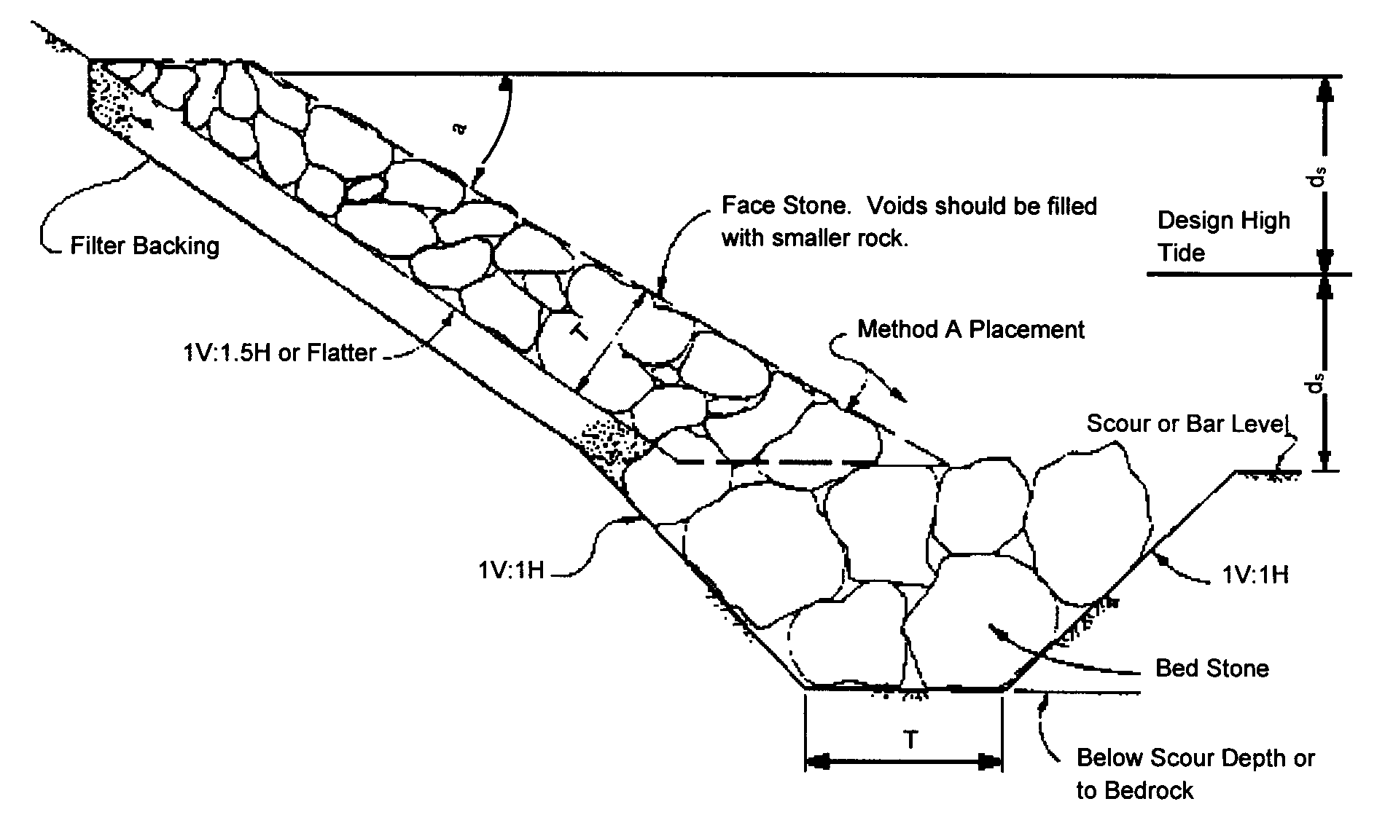
Figure 13-7. Riprap Rock Shore Protection Typical Design Configuration

Wave run-up is reduced by the rough surface of rock slope protection. In order that the wash will not top the rock, it should be carried up to an elevation of twice the maximum depth of water plus the deep-wave height (d_{s} + H_{b}), whichever is lower. Consideration should also be given to protecting the bank above the rock slope protection from splash and spray.
Thickness of the protection must be sufficient to accommodate the largest stones. Except for toes on questionable foundation, as explained above, additional thickness will not compensate for undersized stones. When properly constructed, the largest stones will be on the outside, and if the wave forces displace these, additional thickness will only add slightly to the time of complete failure. As the lower portion of the slope protection is subjected to the greater forces, it will usually be economical to specify larger stones in this portion and smaller stones in the upper portion. The important factor in this economy is that a thinner section may be used for the smaller stones. If the section is tapered from bottom to top, the larger stones can be selected from a single graded supply.
An alternate procedure for designing riprap protection from wave action due to wind or boat traffic is presented in the FHWA’s publication Design of Riprap Revetment (HEC-11). It is applicable in situations where wave heights are less that 5.0 ft and there is no major overtopping of the embankment and is defined by Equation 13.5.
(13.5)
Where:
W₅₀ = Weight of the 50% size stone, lbs
H = Wave height, ft.
θ = Angle of the embankment with respect to horizontal,
deg.
Expressing the equation in terms of median grain diameter produces

$D_{\text{50}}=0\text{.}\text{57}\frac{H}{{{}^{{}^{{}_{\text{cot}} \frac{1}{3}}}}^{{}_{{}_{{}_{{}_{θ}}}}}}$ (13.6)
Where:
D₅₀ = Mean spherical diameter of the 50% size stone, ft.
Equation 13.6 can be solved with the Hudson relationship nomograph in Appendix 13B*-6.

References
Highway Drainage Guidelines Fourth edition 2007*
National Academy of Sciences. Methodology for Calculating Wave Action Effects Associated with Storm Surges. 1977. Washington, D.C.
State of California, Department of Transportation (Caltrans) Bank and Shore Protection in California Highway Practice. 1970.
U.S. Army Corps of Engineers. Coastal Engineering Manual 2002, EM 1110-2-1100, U.S. Army Corp of Engineers, Washington D.C. (in 6 parts)
Voight, B. 1998. Glossary of Coastal Terminology. Washington State Department of Ecology, Coastal Monitoring and Analysis Program, Publication 98-105.
State of California, Department of Transportation (Caltrans) Highway Design Manual, Chapter 870, 9/1/06
Federal Highway Administration, HEC-25 – Highways in the Coastal Environment, June 2008
U.S. Army Corps of Engineers, Design of Coastal Revetments, Seawalls and Bulkheads, EM 1110-2-1614, Washington D.C. 30 June 1995

* Rev 9/09
* Rev 9/09
* Rev 9/09
* Rev 9/09
* Rev 9/09
* Rev 9/09
* Rev 9/09
* Rev 9/09
* Rev 9/09
* Rev 9/09
* Rev 9/09
* Rev 9/09
* Rev 9/09
* Rev 9/09
* Rev 9/09

