Chapter 11 – Stormwater Management
TABLE OF CONTENTS
Chapter 11 - Stormwater Management 11-1
11.1 Introduction 11-1
11.1.1 Objective 11-1
11.2 Design Policy 11-2
11.2.1 General 11-2
11.3 Design Criteria 11-4
11.3.1 General 11-4
11.3.2 Water Quality 11-4
11.3.3 Water Quantity 11-6
11.3.4 Exemptions 11-7
11.3.5 Compensatory Treatment 11-7
11.3.6 Embankment (Dam) 11-8
11.3.7 Basin Grading 11-9
11.3.8 Fencing 11-11
11.3.9 Sediment Forebay 11-11
11.3.10 Maintenance 11-13
11.4 Design Concepts 11-14
11.4.1 Water Quality 11-14
11.4.2 Water Quantity 11-15
11.4.3 Extended Detention vs. Retention 11-16
11.4.4 Detention Time 11-16
11.4.5 Release Rates 11-17
11.4.5.1 Channel Erosion Control – Q₁ Control 11-17
11.4.6 Hydrology 11-17
11.4.7 Outlet Hydraulics 11-17
11.4.7.1 Orifice 11-17
11.4.7.2 Weirs 11-18
11.4.7.3 Types of Outlet Structures 11-18
11.4.7.3.1 General 11-18
11.4.7.4 SWM-1 (VDOT Standard) 11-19
11.4.7.5 Weir Wall (Stormwater Management Dam) 11-20
11.4.8 Routing 11-20
11.4.8.1 Data Required 11-20
11.4.9 PLAN DETAILS 11-21
11.4.9.1 Stormwater Management Drainage Structure Standard SWM-1 11-21
11.4.9.2 Stormwater Management Dam 11-21
11.4.9.3 Stormwater Management Details Standard SWM-DR 11-21
11.4.9.4 Access 11-21
11.4.9.5 Method of Measurement – Basis of Payment 11-21
11.5 Design Procedures and Sample Problems 11-23
11.5.1 Documentation Requirements 11-23
11.5.2 Water Quality Volume Computation and BMP Selection Procedure 11-23
11.5.2.1 Water Quality Volume Computation and BMP Selection Sample Problem 11-24
11.5.3 Detention Time Computation and Orifice Sizing 11-25
11.5.3.1 Average Hydraulic Head Method (DCR Method #2)-VDOT Preferred Method 11-25
11.5.3.1.1 Average Hydraulic Head Sample Problem 11-26
11.5.3.2 Maximum Hydraulic Head Method (DCR Method #1) 11-26
11.5.3.2.1 Maximum Hydraulic Head Sample Problem 11-26
11.5.3.2.2 WQV Hydrograph (HYG) 11-27
11.5.3.2.3 Alternative Method of Routing WQV to Find Drawdown Time 11-27
11.5.3.3 Channel Erosion Control Volume – Q1 Control 11-27
11.5.3.3.1 Channel Erosion Control Volume, (Q1 Control) Sample Problem: 11-28
11.5.4 Preliminary Detention Volume Computation 11-29
11.5.4.1 Modified Rational Method, Simplified Triangular Hydrograph Routing 11-29
11.5.4.2 DCR Critical Storm Duration Method 11-31
11.5.4.3 Pagan Volume Estimation Method 11-32
11.5.4.4 Sample Problems – Using 3 Methods to Estimate Volume of Storage for Quantity Control 11-33
11.5.5 Determine Preliminary Basin Size 11-35
11.5.6 Final Basin Sizing-Reservoir Routing 11-36
11.5.6.1 Storage – Indication Method Routing Procedure 11-36
11.5.6.2 Storage – Indication Method Routing Sample Problem 11-39
11.5.6.3 SWM Basin Design: Sample Problem 11-45
11.6 References 11-51
List of Tables
Table 11-1. BMP Selection Table 11-6
Table 11-2. Summary of Design Criteria for Dry and Wet Basins 11-10
Table 11-3. Functional Goals of Stormwater BMPs 11-15
Table 11-4. WQV Orifice Sizes 11-25
Table 11-5. Storage Characteristics 11-38
Table 11-6. Runoff Hydrographs 11-40
Table 11-7. Stage-Discharge-Storage Data 11-41
Table 11-8. Storage Routing for the 2-Year Storm 11-43
Table 11-9. Storage Routing for the 10-Year Storm 11-43
List of Figures
Figure 11-1. Typical SWM Basin Dam 11-9
Figure 11-2. Typical Sediment Forebay Plan and Section 11-12
Figure 11-3. Removal Rates vs. Detention Time 11-16
Figure 11-4. Simplified Triangular Hydrograph Method 11-31
Figure 11-5. Pagan Method Curve 11-33
Figure 11-6. Stage-Storage Curve 11-37
Figure 11-7. Stage-Discharge Curve 11-37
Figure 11-8. Storage Characteristics Curve 11-38
Figure 11-9. Runoff Hydrographs 11-44

List of Appendices
Appendix 11A-1 Definitions and Abbreviations
Appendix 11A-2 Symbols
Appendix 11B-1 SWM Design Checklist
Appendix 11C-1 Equivalent Runoff Curve Numbers (RCN) for Rational ‘C’
Appendix 11C-2 Runoff Depth for Runoff Curve Number (RCN)
Appendix 11C-3 24-hr Rainfall Depths
Appendix 11D-1 SWM and TSB Summary Table
Appendix 11E-1 SWM Facility Tabulation Sheet
Appendix 11G-1 Extended Detention Basin – Plan and Section
Appendix 11G-2 Enhanced-Extended Detention Basin – Plan and Section
Appendix 11G-3 Retention Basin – Plan and Section
Appendix 11H-1 A and B Factors that define Intensity Duration – Frequency (IDF) Curves for use only with the Critical Storm Duration Determination
Appendix 11H-2 Regression Constants > “a” and “b” for Virginia.

Stormwater Management

Introduction
Development of watersheds has the potential for causing generally causes an increase in the peak flow rate of stormwater runoff. This increase is often assoiciated with* flood damage, erosion, and siltation control problems. Urban development has been identified as having a direct impact on the hydrologic cycle by reducing, or even eliminating, the natural storage capacity of the land. These natural storage areas are then replaced with impervious and managed pervious surfaces. Impervious cover prevents the infiltration of rainfall into the soil and increases the speed and quantity of rainfall runoff to the outfall. Increased stormwater runoff impacts water quality, stream channel erosion, and localized flooding. For a watershed with no defined, or inadequate, outfall, the total volume of runoff is critical and storage facilities can be used to store the increases in volume and control peak discharge rates.

Objective
The goal of stormwater management is to inhibit the deterioration of the aquatic environment by instituting a program that maintains both water quantity and quality post-development runoff characteristics, as nearly as practicable, equal to or better than pre-development runoff characteristics, and to limit the post development peak discharge flow rates to match the predevelopment peak discharge flow rates.
Stormwater Quality Control
Stormwater quality control pertains to reducing the amount of pollutants discharged by land development projects.
Stormwater Quantity Control
Stormwater quantity control, or flooding and erosion control, pertains to replicating the water quantity post-development runoff characteristics, as nearly as practicable, equal to or better than the pre-development runoff characteristics.

Design Policy

General
Acts of the General Assembly have resulted in the issuance of Stormwater Management Regulations (SWMR) and Erosion and Sediment Control Regulations (VESCR). The SWMR regulations* can be obtained at the Department of Conservation and Recreation (DCR) SWMR website, http://www.dcr.virginia.gov/soil_&_water/stormwat.shtml. The VESCR regulations can be obtained at their web site, http://www.dcr.virginia.gov/soil_&_water/e&s.shtml. The general application to highway drainage design associated with these regulations is addressed here and also in the latest version of VDOT Location & Design Instructional & Informational Memorandum IIM-LD-195. Water quantity control is governed by the Virginia Erosion and Sediment Control Regulations Minimum Standard 19 (MS-19), which requires an adequate receiving channel for stormwater outflows from all regulated land disturbing activities http://www.dcr.virginia.gov/soil_&_water/e&s.shtml.
- Land disturbing activities, including both linear development projects, such as roadways, and site development projects, such as parking lots, buildings and weigh stations, shall comply with SWMR and VESCR. [4 VAC 50-60-50* (L)] [4 VAC (50-30-40)]
- State projects within the Chesapeake Bay Preservation Area complying with SWMR and VESCR must comply with the Chesapeake Bay Preservation Act (CBPA).
- Stormwater management plans prepared for state projects shall comply with the criteria specified in SWMR and to the maximum extent practicable, and when requested any local stormwater management requirements adopted pursuant to the SWMR.
- For land disturbing activities, the post-development stormwater runoff from the impervious cover should be treated with the most appropriate best management practice (BMP). [4 VAC 50-60-60 (C)]
- Outflows from the stormwater management facilities should be discharged into adequate receiving channels. [4 VAC 50-60-60 (G)]
- Downstream properties and waterways should be protected from erosion and damages from localized flooding due to increases in volume, velocity, and peak flow rate of stormwater runoff. [4 VAC 50-60-70 (A) and 4 VAC 50-60-80 (A)]
- Stormwater discharges in environmentally sensitive areas may be subject to additional stormwater requirements.
- Impounding structures (dams) that are not covered by the Virginia Dam Safety Regulations should be checked for structural integrity and floodplain impacts for the 100-year storm event. [4 VAC 50-60-50* (E)]
- Construction of stormwater management facilities within FEMA designated 100-year floodplains should be avoided to the extent possible. When this is unavoidable, the construction of stormwater management facilities in floodplains should be in compliance with all applicable regulations under the National Flood Insurance Program (NFIP). [4 VAC 50-60-50 (J)]

Design Criteria

General
The design criteria for stormwater management facility design addresses the following:
- Water quality volume
- Water quantity volume
- Allowable peak discharges
- Grading and depth requirements for excavated basins and embankments
- Sediment forebays
- Physical requirements
- Environmental impacts
- Integration with roadway
- Maintenance requirements

Water Quality
Stormwater management design for water quality control is to be in accordance with the latest revisions to the Virginia Stormwater Management Regulations. The regulations state that the water quality volume (WQV) is equal to the first one half-inch of runoff multiplied by the area of new impervious surface associated with* the land development project. (pg. 14 regulation
The following comments represent the significant points of the current regulations (the page numbers referenced are those in the DCR SWM Handbook):

- BMP (Best Managenment Practice) requirements for quality control are “Technology Based” (4VAC-50-60-60). The type of BMP required is determined by the percent of area within the project site (right of way and permanent easement) with new impervious cover, per outfall. Table 11-1 shows the relationship of the new impervious cover to the type of BMP required.
- BMP requirements for flooding or quantity control are determined by the ESC Regulation MS-19 for adequate receiving channels.

- Extended Detention Basins and Extended Detention Basins Enhanced require a Water Quality Volume (WQV) of 2 x the standard WQV or 1” of runoff from the new impervious area.

- Extended Detention Basins and Extended Detention Basins Enhanced require a 30 hour drawdown time for the required WQV. If the required orifice size is found to be significantly less than 3”, an alternative water quality BMP should be investigated for use, such as a linear facility that treats the first flush and allows larger storms to bypass. The calculation procedure for drawdown time and orifice sizing is shown on in the Virginia SWM Handbook.

- Suggested details for the Extended Detention Basin are shown on Pages 3.07-4 and 5 (Virginia SWM Handbook). The riprap lined low flow channel through the basin is not recommended due to maintenance concerns.

- Suggested details for the Extended Detention Basin Enhanced are shown on Pages 3.07-6 and 7 (Virginia SWM Handbook). The geometric design may need to be more symmetrical than that shown in order to construct the basin to the dimensions needed.
See the current version of IIM-LD-195 for further details.
Table 11-1. BMP Selection Table
Water Quality BMP | Treatment Volume | Target Phosphorus Removal  Efficiency | Percent Impervious  Cover**
Vegetated filter strip  Grassed swale |  | 10%  15% | 16-21%
Constructed wetlands  Extended detention  Retention basin I | 2xWQV  3xWQV | 20%  35%  40% | 22-37%
Bioretention basin  Bioretention filter  Extended detention-enhanced  Retention basin II  Infiltration | 4xWQV  1xWQV | 50%  50%  50%  50%  50% | 38-66%
Sand filter  Infiltration  Retention basin III with  aquatic bench | 2xWQV  4xWQV | 65%  65%  65% | 67-100%
* Innovative or alternate BMPs not included in this table may be allowed at the discretion of DCR and VDOT.
** Percent Impervious Cover: The ratio of the new impervious area and the area within the right-of-way and easements per project outfall.

Water* Quantity
The Virginia Erosion and Sediment Control Regulations Minimum Standard 19 (MS-19) and Virginia Stormwater Management Regulations shall govern water quantity control. The following criteria apply:
- Pre-development conditions should be that which exist at the time the road plans are approved for right-of-way acquisition.
- All land cover should be assumed to be in good condition regardless of actual existing conditions at the time design begins.
- An adequate receiving channel is required for stormwater outflows from all projects with more than 10,000 square feet of land disturbance.
- The receiving channel at a pipe or storm drain outlet should be analyzed by use of a 2-year storm for natural channels or the 10-year storm for man made channels to verify that stormwater will not overtop the banks.

Exemptions
Regulated Land Disturbance Activities are defined as those activities that disturb one* acre or greater except in those areas designated as a Chesapeake Bay Preservation Area in which case the land disturbance threshold is 2,500 square feet or greater.
A water quality control plan for Regulated Land Disturbance Activity shall be developed for each outfall or watershed unless it meets one of the following exemptions:
- Linear development projects (i.e., highway construction projects) where all of the following conditions are met:
  - Less than one acre will be disturbed per outfall or watershed
  - There will be insignificant increases in peak flow rates downstream of the discharge point.
  - There is no exiting or anticipated flooding or erosion problemsdownstream of the discharge point.
- Routine maintenance activities that are performed to maintain the original line and grade, hydraulic capacity or original construction of the project and that disturbs less than five acres of land.
The designer must consider that linear development projects are not exempt from VESCR and must meet MS-19 criteria.
For locations where water quality control is required and there is an adequate receiving channel, the BMP may not need to be designed for quantity control. In these situations, the dam and the emergency spillway should be designed to safely pass the 100-year storm.
Where two or more outfalls flow directly into an adjacent waterway or where two or more outfalls converge into one waterway a short distance downstream of the project, the combined additional impervious area of all affected outfalls should be considered when determining whether treatment is required.

Compensatory Treatment
Compensatory treatment for water quality requirements (overtreating at one outfall in a local watershed to compensate for not treating at an adjacent outfall in the same watershed) can be considered for meeting the requirements provided:
- The SWM facilities at the treated outfall are designed to account for the water quality volumes for those areas where SWM facilities are determined to be impractical or unacceptable.
- The downstream impacts, if any, which would occur as a result of discharging untreated runoff at the untreated outfall, must be documented. The documentation should note that compensating treatment of SWM facilities has been incorporated.
- The channel at the untreated outfall must be analyzed to determine its adequacy to convey the additional runoff in accordance with the requirements of MS-19 of the VESCR and any necessary channel protection or improvements must be provided.
- The project is to be reviewed either by the State Hydraulics Engineer or his assistant when the project reaches the Field Inspection stage.

Embankment (Dam)
The following details are to be incorporated into the design of dams for VDOT stormwater management (SWM) basins.
- The design of the dam and the basin should provide only a relatively shallow depth of ponded water in order to prevent the basin from being a hazard. It is desirable to have the ponded depth no more that about 2 feet for water quality and about 4 feet for the 10-year storm (Q₁₀) quantity control.
- Foundation data for the dam is to be secured from the Materials Division in order to determine if the native material will support the dam and not allow ponded water to seep under the dam.
- The foundation material under the dam and the material used for the embankment of the dam should be an ML or CL Type in accordance with the Unified Soil Classification System (ASTM D2487)(type A-4 or finer in accordance with the AASHTO Classification System M145) and/or meet the approval of the Materials Division. If the native material is not adequate, the foundation of the dam is to be undercut a minimum of 4 feet or to a depth recommended by the Materials Division. The backfill and embankment material must meet the above soil classification, or the design of the dam may incorporate a trench lined with a membrane such as bentonite penetrated fabric, HDPE, or LDPE liner, to be approved by the Materials Division.
- The pipe culvert under or through the dam is to be concrete pipe with rubber gaskets. For physical requirements of the pipe, refer to Pipe Specifications: 232 (AASHTO M170), Gasket Specification: 212 (ASTM C443)
- A concrete cradle is to be used under the pipe to prevent seepage through the dam barrel. The concrete cradle extends from the riser or inlet end of the pipe to the outlet of the pipe. See special design drawing number 2209 for details of the concrete cradle.*
- If the height of the dam is greater than 15 feet, or if the basin includes a permanent waterpool, the design of the dam is to include a homogenous embankment with seepage controls or zoned embankment or similar design conforming to DCR design standards for earth dams and is to be approved by the Materials Division.
The minimum top width should be 10 feet. This helps facilitate both construction and maintenance and allows the embankment to be used for access. The side slopes should also be a minimum of 3:1, to permit mowing and maintenance access. The design of the design should include a seepage analysis as well as a slope stability analysis (minimum Factor of Safety of 1.5 (checked with normal pool level on storage side and rapid drawdown conditions). A typical cross-section of a SWM basin dam is shown in Figure 11-1.

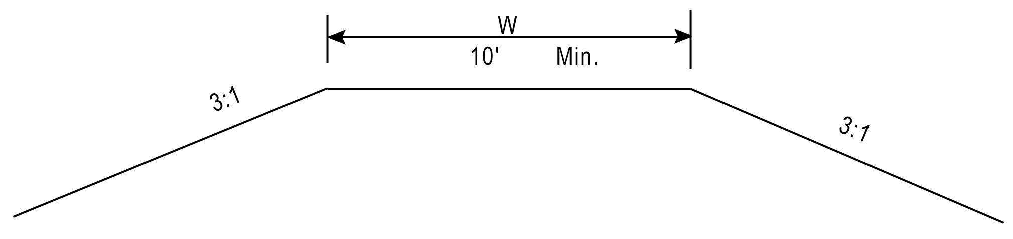
Figure 11-1. Typical SWM Basin Dam

Basin Grading
The layout and grading of a basin has a major influence on how effective the basin will be in removing pollutants. The designer should try to blend the basin into the surrounding topography while keeping several criteria in mind. First, the basin should be designed and graded so that the desirable length-to-width ratio is about 3:1 with a minimum ratio of 2:1. This helps prevent short-circuiting of the basin’s storage areas. The basin’s longest dimension should run parallel to the contours, which helps minimize cut and fill. The wider dimension should also be located at the outlet end. If the length to width ratio is less than about 2:1, and there is concern that the velocity of flow through the basin is high, the designer should consider using baffles within the basin to reduce velocity and prevent short-circuiting by increasing travel length. Baffles should be constructed of a pervious type material such as snow fence, rather than earth berms, which do not reduce the velocity.
- Basin side slopes should be no steeper than 3:1 to permit mowing and maintenance access*
- The bottom slope of dry detention basins should be no more than 2 percent and no less than 0.5 percent
- Where safety is a concern, and fencing is not practical, use 4:1 side slope
- The depth of basin from the bottom to the primary outflow point (crest of riser, or invert of weir) should be no more than 3 feet if possible, in order to reduce the hazard potential. If the depth needs to be more than 3 feet, fencing should be considered and a safety ledge considered around the perimeter to prevent people from falling in and to facilitate their escape from the basin
Table 11-2 summarizes the design criteria for dry and wet basin designs:
Table 11-2. Summary of Design Criteria for Dry and Wet Basins
Design Requirement | Dry Basin Design | Wet Basin Design
Quality control | Detain WQV for  30-hour minimum | Permanent pool volume is a function of the BMP selected ( Table 11-1)
Quantity control | Control 2- and 10-year  peak flows and maintain  a non-erosive outfall velocity | Control 2- and 10-year  peak flows and maintain  a non-erosive outfall velocity
Shape | 3:1 length-to-width ratio; wedge shaped  (wider at the outlet) | 3:1 length-to-width ratio; wedge shaped  (wider at the outlet);  permanent pool depth to 3 feet max, if possible
Safety |  | Fence around basin if depth is greater than 3 feet; shallow safety ledge around basin. See following notes on fencing. (Section 11.3.8)
Other Considerations | 3:1 side slopes for easy  maintenance access;  0.5-2% bottom slope to prevent ponding;  sediment forebay to reduce maintenance requirements | 3:1 side slopes for easy  maintenance access;  sediment forebay to reduce maintenance requirements;  provide valve to drain pond for maintenance
Source: VDOT Manual of Practice for Planning Stormwater Management, March 1992.

Fencing
Fencing of stormwater management basins may occasionally be needed and should be used when:
- The basin is deep with a ponded depth greater than about 3 feet and/or has steep side slopes with two or more side slopes steeper than 3:1
- The basin is in close proximity to schools, playgrounds or similar areas where children may be expected to frequent
- Recommended by the Field Inspection Report, the Resident Engineer or the City/County (where City/County will take over maintenance responsibility)
- A chain or gate may be needed on some basins to prohibit vehicular access if there is concern with dumping or other undesirable access
“No Trespassing” signs should be considered for use on all basins, whether fenced or unfenced, and should be recommended as needed on the Field Inspection Report.

Sediment Forebay
A sediment forebay is a settling basin or plunge pool constructed at the incoming discharge points of a stormwater BMP. The purpose of a sediment forebay is to allow sediment to settle from the incoming stormwater runoff before it is delivered to the balance of the BMP. It is an essential component of most impoundment and infiltration BMPs including retention, detention, extended-detention, constructed wetlands, and infiltration basins. A sediment forebay also helps to isolate the sediment deposition in an accessible area, which facilitates BMP maintenance efforts.
A sediment forebay should be located at each inflow point in the stormwater BMP. Storm drain piping or other conveyances may be aligned to discharge into one forebay or several, as appropriate for the particular site. Sediment forebays should always be installed in a location that is accessible by maintenance equipment. Figure 11-2 shows a typical sediment forebay.
Sediment Forebays should be used on Extended Detention Basins and Extended* Detention Basins Enhanced. The volume of the Forebay should be 0.1” – 0.25” x the new impervious area or 10% of the required detention volume. See Pages 3.04-1 through 5 (SWM Handbook) for details. The overflow spillway shall be stabilized utilizing rip rap, concrete or other non-erodible material.
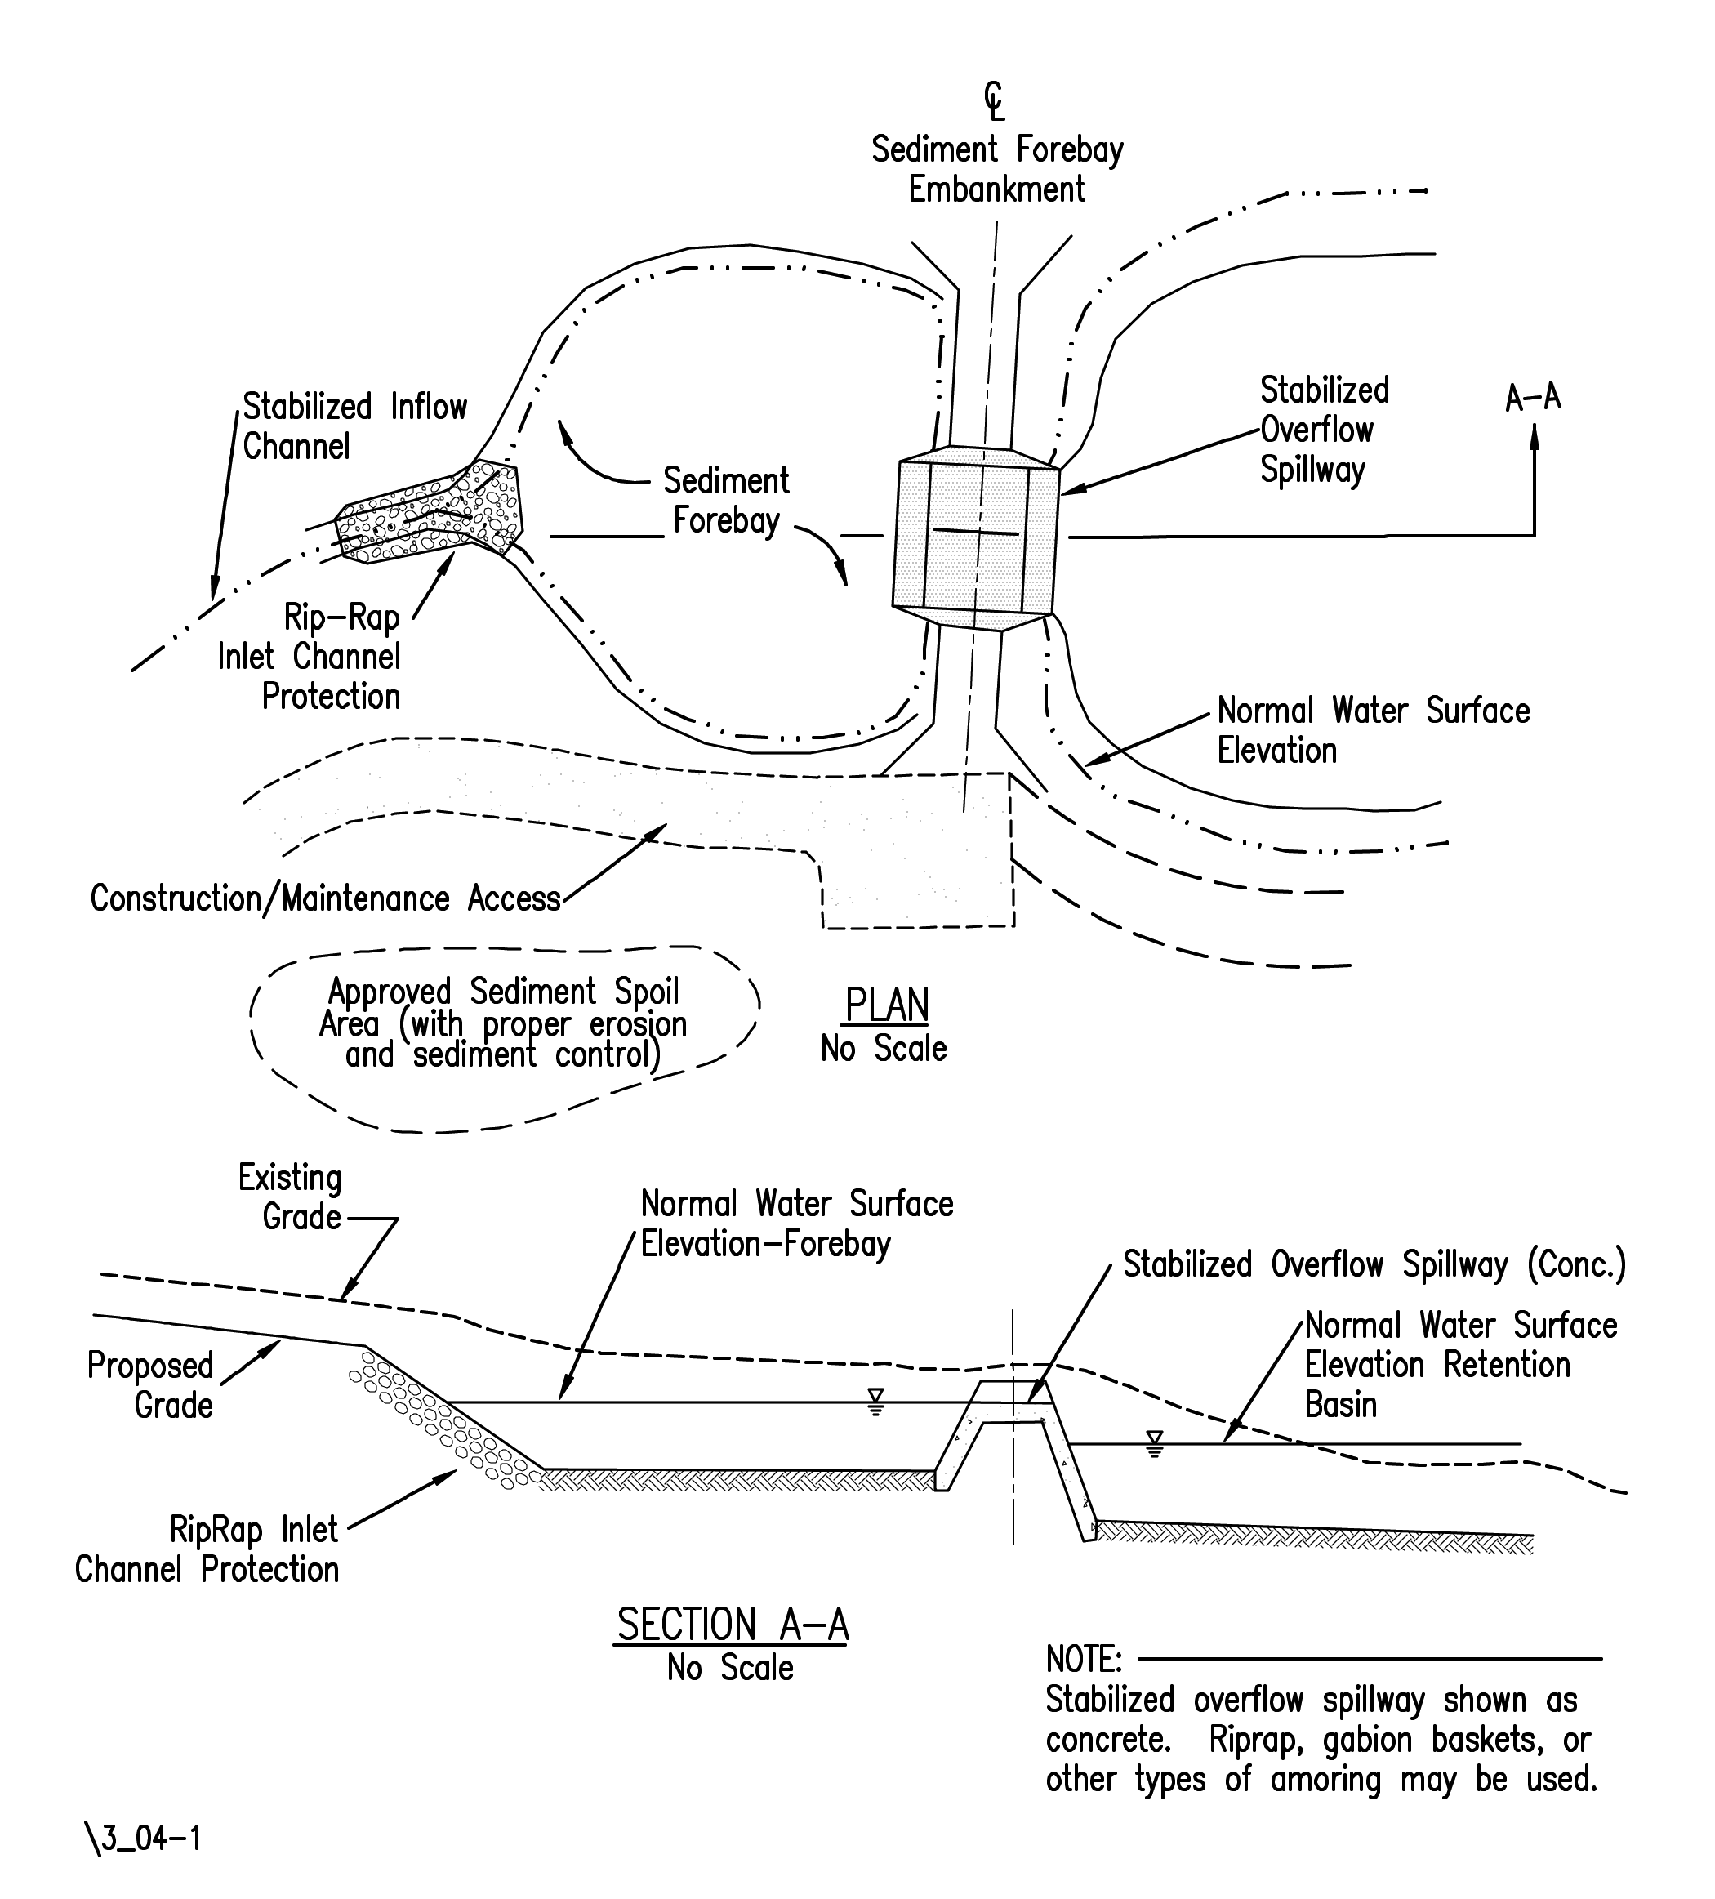
Figure 11-2. Typical Sediment Forebay Plan and Section

Maintenance
An important step in the design process is identifying whether special provisions are warranted to properly construct or maintain proposed storage facilities. To assure acceptable performance and function, storage facilities that require frequent maintenance are discouraged.
Proper design should focus on the elimination or reduction of maintenance requirements by addressing the following potential problems:
- Both weed growth and grass maintenance may be addressed by constructing side slopes no steeper than 3:1 so that they can be maintained using available power-driven equipment, such as tractor mowers.

- Sedimentation may be controlled by constructing forebays to contain sediment for easy removal.

- Bank deterioration can be controlled with protective lining, vegetation, or by limiting bank slopes.

- Standing water or soggy surfaces may be eliminated by sloping basin bottoms toward the outlet, or by constructing underdrain facilities to lower water tables. These measures also assist in mosquito control.

- Outlet structures should be selected to minimize the possibility of blockage. Very small pipes tend to block quite easily and should be avoided.

- Locate the facility for easy access so that maintenance associated with litter and damage to fences and perimeter plantings can be conducted on a regular basis.

- Access for inspection and maintenance personnel should be provided at each SWM facility. A turnaround should be provided on vehicular entrances when needed based upon accessibility and traffic volume. Appropriate surface material should be provided for each vehicular entrance. The designer should seek input as appropriate from the District Roadside Manager to determine the vehicular access requirements.*

- VDOT maintenance procedures include inspecting each stormwater management facility on a semiannual basis, and inspecting each stormwater management facility after any storm that causes the capacity of the principal spillway to be exceeded. Basins should also have accumulated sediment removed about every 5 to 10 years.

Design Concepts

Water* Quality
Stormwater runoff can have a significant impact on the aquatic ecosystem. Various soluble and particulate pollutants are found in stormwater runoff. Studies have shown that the source of these pollutants is atmospheric deposition, urban and agricultural lands, and natural spaces. The impervious surfaces, such as parking lots, rooftops and roads, which are associated with land development, serve to accumulate and transport these pollutants to receiving stream channels.
Control of stormwater quality offers the following potential benefits:
- Control of sediment deposition
- Improved water quality through stormwater filtration
- Settling out of roadway runoff pollutants
Ideally, the pollutant removal mechanism should dictate the treatment volume or storm frequency for water quality BMPs. The sizing of BMPs, which uses gravitational settling of pollutants as the removal mechanism, can be based on a volume of runoff. The Virginia Stormwater Management Regulations require that the first flush of runoff be captured and treated to remove pollutants. The first flush, or water quality volume (WQV) is generally defined as the first one-half inch of runoff from impervious surfaces. Table 11-1 specifies the required treatment volume for each type of BMP based upon the WQV.
One of the first considerations in selecting a stormwater BMP is the functional goal of the BMP. The main components of stormwater management are: quality, stream channel erosion, and stormwater quantity or flooding. Any one or a combination of these components will dictate the functional goal of the BMP. In general, stormwater BMPs can be categorized into water quality BMPs and water quantity (stream channel erosion and flooding) BMPs.
Table 11-3 provides a general categorization of BMPs by functional goal. Note, that some BMPs can be designed to satisfy both quality and quantity goals while others are specifically suited for only one.
The use of some BMPs is limited by site or watershed feasibility factors such as environmental impacts, drainage area or watershed size, and topographic constraints.
The BMPs designed for water quality control provide varying levels of pollutant removal and are suitable for specific development densities. Table 11-1 also provides a generic list of water quality BMPs and their target phosphorus removal efficiency. Phosphorus is the keystone pollutant targeted for removal in Virginia.
Table 11-3. Functional Goals of Stormwater BMPs

Stormwater  BMP | Quality | Stream Channel Erosion | Quantity/  Flooding
Vegetated filter strip | +++
Grasses Swale (w/check dams) | +++ | +
Constructed wetlands | +++ | +
Extended detention | ++ | +++ | +
Extended detention enhanced | +++ | ++ | +
Bioretention | +++
Retention basin | +++ | ++ | +++
Sand filter | +++
Infiltration | +++
Infiltration Basin | ++ | + | +
Detention |  | ++ | +++
Manufactured BMPs (Water Quality Structures) | +++
Legend: +++ Primary functional goal
++ Potential secondary functional goal
+ Potential secondary functional goal with design modifications or additional storage
Source: Virginia Stormwater Management Handbook, Vol. 1, 1st Ed.

Water* Quantity
Controlling the quantity of stormwater can provide the following potential benefits:
- Prevention or reduction of peak runoff rate increases caused by urban development
- Decrease downstream channel erosion
- Mitigation of downstream drainage capacity problems
- Recharge of groundwater resources
- Reduction or elimination of the need for downstream outfall improvements
- Maintenance of historic low flow rates by controlled discharge from storage
One concept that can be used to control the quantity of stormwater is to consider the use of offsite improvements or regional stormwater management facilities.

Extended Detention vs. Retention
When evaluating the relative merits of extended dry detention versus wet retention basins, there are several factors to consider. Extended detention basins generally require much less storage volume than retention basins. However, wet basins generally provide more pollutant removal and are usually considered an amenity if designed properly. Wet basins require a reliable water/groundwater source and sometimes a significant size drainage area in order to maintain the desired permanent pool level and to prevent the basin from being objectionable. A typical extended detention basin plan is shown in Appendix 11G-1. A typical retention basin plan is shown in Appendix 11G-3.

Detention Time
Settling or sedimentation is limited to particulate pollutants that drop out of the water column by means of gravitational settling. Pollutants attach themselves to heavier sediment particles or suspended solids and settle out of the water. Laboratory and field studies indicate that significant settling of urban pollutants occurs in the first 6 to 12 hours of detention. Figure 11-3 shows removal rate versus detention time for selected pollutants.
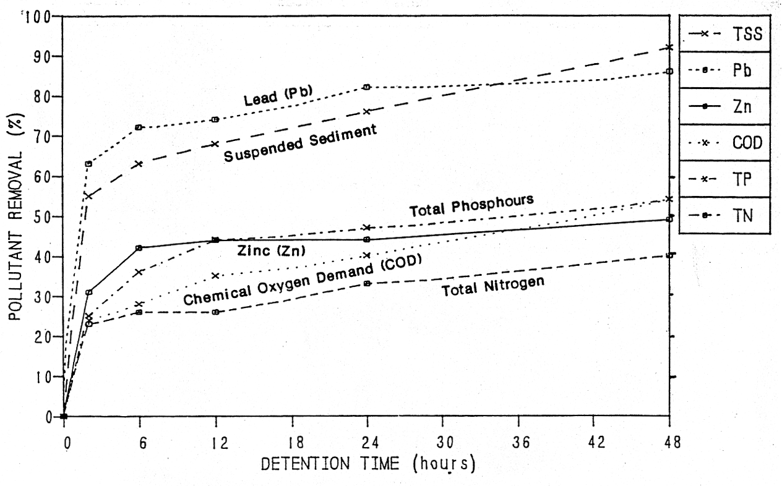
Figure 11-3. Removal Rates vs. Detention Time

The brim drawdown requirement for water quality for extended detention design is 30 hours. The additional time is required to allow for ideal settling conditions to develop within the stormwater management facility. In addition, the added time will allow for settling of smaller particle sizes and nutrients, as well as increasing the opportunity for biological processes to take place. Stormwater BMPs that utilize settling are usually suited for dual purposes that include providing storage volume for peak rate control, channel erosion, and flood control.

Release Rates
Control structure release rates are usually designed to approximate pre-developed peak runoff rates for the 2- and 10-year design storms with an emergency spillway capable of handling the 100-year peak discharge. Design calculations are required to demonstrate that the post-development release rates for the 2- and 10-year design storms are equal to or less than the pre-development release rates. If it can be shown that the 2- and 10-year design storms are controlled, then runoff from intermediate storm frequencies are assumed to be adequately controlled as well.
Multi-stage control structures may be required to control runoff from both the 2- and 10-year storms. This can be accomplished through the use of orifices and weirs and is discussed in Section 11.4.7.

Channel Erosion Control – Q₁ Control
Water quantity control for the 1-year design storm (in lieu of the 2-year design storm required by MS-19) may be needed if there is existing or anticipated erosion downstream. Control of the 1-year design storm requires detaining the volume of runoff from the entire drainage area and releasing that volume over a 24-hour period.
When the 1-year design storm is detained for 24 hours there will be no need to provide additional or separate storage for the WQV if it can be demonstrated that the WQV will be detained for approximately 24 hours. The control of the 1-year design storm may require a basin size that is 1.5 to 2 times larger than a basin used to control the increase in runoff from a 2- or 10-year design storm.

Hydrology
Hydrology should be performed using the appropriate hydrograph procedures presented in Chapter 6, Hydrology.

Outlet Hydraulics

Orifice
An orifice is an opening into a standpipe, riser, weir, or concrete structure. Openings smaller than 12 inches may be analyzed as a submerged orifice if the headwater to depth ratio (HW/D) is greater than 1.5. An orifice for water quality is usually small (less than 6 inches) and round. VDOT has determined that the orifice is less prone to clogging when located in a steel plate rather than a 6- or 8-inch hole in a concrete wall. Details are shown in the latest version of VDOT Location & Design Instructional &* Informational Memorandum IIM-LD-195. For square-edged entrance conditions, the orifice equation is expressed as:
(11.1)
Where:
Q = Discharge, cfs
C = Orifice entrance coefficient (generally 0.6)
A = Cross-sectional area of orifice, sq. ft.
g = Acceleration due to gravity, 32.2 ft/s²
h = Head on orifice, ft

Weirs
The most common type of weir associated with stormwater management is the broad-crested weir as is defined by Equation 11.2:
(11.2)
Where:
Q = Discharge, cfs
C = Broad-crested weir coefficient (Range from 2.67 to 3.33 and is generally assumed to be 3.0.) For additional information, refer to King and Brater, Handbook of Hydraulics, 1976, which lists coefficients and instructions on determining an appropriate coefficient.
L = Broad-crested weir length, ft.
H = Head above weir crest, ft.

If the upstream edge of a broad-crested weir is rounded so as to prevent contraction and if the slope of the crest is as great as the headless due to friction, flow will pass through critical depth at the weir crest; this gives the maximum entrance coefficient (C) of 3.00. For sharp corners on the broad-crested weir; however, a minimum (C) of 2.67 should be used. The designer should also check to make certain the weir or orifice is not submerged by the downstream tailwater.

Types of Outlet Structures

General
Outlet structures typically include a principal spillway and an emergency overflow, and must accomplish the design functions of the facility. Outlet structures can take the form of combinations of drop inlets, pipes, weirs, and orifices. The principal spillway is intended to convey the design storm without allowing flow to enter an emergency outlet. If site restrictions prevent the use of an emergency spillway, then the principal spillway should be sized to safely pass the 100-year design storm without overtopping the facility. The designer should consider partial clogging (50%) of the principal spillway during the 100-year design storm to ensure the facility would not be overtopped. For large storage facilities, selecting a flood magnitude for sizing the emergency outlet should be consistent with the potential threat to downstream life and property if the basin embankment were to fail. The minimum flood to be used to size the emergency spillway is the 100-year design storm flood. The sizing of a particular outlet structure should be based on results of hydrologic routing calculations.
A principal spillway system that controls the rate of discharge from a stormwater facility will often use a multi-stage riser for the drop inlet structure, such as the VDOT standard SWM-1. A multi-stage riser is a structure that incorporates separate openings or devices at different elevations to control the rate of discharge from a stormwater basin during multiple design storms. Permanent multi-stage risers are typically constructed of concrete to help increase their life expectancy. The geometry of risers will vary from basin to basin. The designer can be creative to provide the most economical and hydraulically efficient riser design possible.
The primary control structure (riser or weir) should be designed to operate in weir flow* conditions for the full range of design flows. Where this is not possible or feasible and the control structure will operate in orifice flow conditions at some point within the design flow range, an anti-vortex device, consistent with the design recommendations in the DCR SWM Handbook, shall be utilized.
In a stormwater management basin design, the multi-stage riser is of utmost importance because it controls the design water surface elevations. In designing the multi-stage riser, many iterative routings are usually required to arrive at a minimum structure size and storage volume that provides proper control. Each iterative routing requires that the facility’s size and outlet shape be designed and tested for performance.
Two types of outlet structures are discussed below:

SWM-1 (VDOT Standard)
The VDOT standard riser outlet structure is identified as a stormwater management drainage structure (VDOT Standard SWM-1). This structure should be used at all applicable locations where a drop inlet type control structure is desired. Water quality orifices and additional orifices and weirs can be designed for use with the SWM-1. In addition, the SWM-1 can be modified during construction to serve as the outlet for a temporary sediment basin. The subsurface base of a SWM-1 is typically loaded with Class I stone to counter buoyancy forces. Anti-vortex vanes are usually not needed on risers for SWM basins due to the VDOT practice of designing relatively shallow basins with emergency spillways. A small trash rack in front of the water quality orifice is included in the SWM-1 details. SWM-1 details can be found in VDOT Road and Bridge Standards Volume I.*

Weir Wall (Stormwater Management Dam)
Another type of outlet structure that can be used is a weir wall. The weir wall may be constructed either in place of a riser or as part of a pipe culvert’s wingwalls.
A weir wall in lieu of a riser may be used in areas of shallow basins where the weir wall is no higher than about 5 feet. The weir wall will have an outlet channel instead of a pipe and will operate efficiently with fewer maintenance concerns than a riser and pipe configuration.
In conjunction with a culvert, the weir is created by building a wall between the culvert’s wingwalls. A concrete apron extends from the pipe to the weir wall at a distance of approximately 1.5 times the culvert diameter. The top of the wall is used to provide the required storage volume and flow attenuation. Notches can also be used in the weir wall to attenuate various storms, and a water quality orifice can be installed at the base in order to drain the basin and provide quality treatment. In addition, the weir wall can be modified during construction to serve as the outlet for a sediment basin. Weir wall outfall structures have proven useful in providing online stormwater management facilities at culvert crossings with dry, intermittent drainage swales by providing the required storage on the upstream side of the crossing. Online facilities should not be used in live streams.

Routing

Data Required
The following data is needed to complete storage design and routing calculations using the appropriate computer program:
- Inflow hydrographs for all selected design storms
- Allowable release rates
- Stage-storage curve or data for proposed storage facility
- Stage-discharge curve or data for the outlet control structures based upon the preliminary design of the outlet control structure and emergency spillway
- Receiving channel performance curve or data

11.4.9 PLAN DETAILS*

11.4.9.1 Stormwater Management Drainage Structure Standard SWM-1
- To be used at all applicable locations where a riser type of control structure is desired.

11.4.9.2 Stormwater Management Dam
- To be used at locations where a wall type control structure is desired (includes modifications to standard endwalls). Normally used for shallow depths of ponding.

- Details to be provided for individual locations.

Copies of the control structures other than those above shall be submitted to the office of the State Hydraulics Engineer to facilitate future development or modification of standard details.

11.4.9.3 Stormwater Management Details Standard SWM-DR
- Specify at each location requiring a water quality orifice and/or where modifications are required in order to provide for a temporary sediment basin during the construction phase of the project. The size opening for the water quality orifice or other required openings in the control structure shall be specified in the description for the control structure for each basin.

11.4.9.4 Access
- A means of access for inspection and maintenance personnel shall be provided at each SWM facility location. The Standard PE-1 details shown in VDOT’s Road and Bridge Standards should be used for vehicular entrances.
- A turnaround should be provided on each vehicular entrance.
- Appropriate all weather surface material shall be provided for each vehicular entrance.

11.4.9.5 Method of Measurement – Basis of Payment
1. Stormwater Management Drainage Structure (SWM-1):
- Basis of payment to be linear feet (meters) measured from invert of structure to top of concrete.
2. Stormwater Management Dam (weir wall):
- Basis of payment to be cubic yards (m³) of Concrete Class A3 Miscellaneous and pounds (kilograms) of Reinforcing Steel.

3. Grading:
- Excavation for stormwater management basins will be measured and paid for as* cubic yards (m³) of Stormwater Management Basin Excavation.

- Fill material needed for dams or berms will be measured and paid for as cubic yards (m³) of Regular Excavation, Borrow Excavation or Embankment.

- The Grading Diagram is to reflect how the cubic yards (m³) of Stormwater Management Basin Excavation and cubic yards (m³) of Embankment or Borrow is to be distributed.

Design Procedures and Sample Problems

Documentation Requirements
The following documentation will be required for stormwater management facility design:
- Documentation requirements presented in Chapter 6, Hydrology
- Computations for determination of the pre- and post-development peak runoff rates for the design storms
- Receiving channel adequacy to include Q₂ velocity and Q₁₀ capacity
- Water quality volume based on new impervious area calculation and BMP selection
- WQV orifice size
- Drawdown time for WQV
- Compensatory treatment for uncontrolled new impervious areas
- Project stormwater management accountability.
The designer will complete the SWM and TSB Summary Sheet as provided in Appendix 11D-1
- SWM Facility Tabulation Sheet when submitting final plans
- Provide all documentation from routing. This would generally include inflow and outflow hydrographs and storage computations for sizing the primary spillway. This information would be generated by various computer modeling software.
- Basin grading and primary spillway details and specifications

Water Quality Volume Computation and BMP Selection Procedure
Step 1: Determine the new impervious area within that area at the outfall being evaluated.
Step 2: Determine the area within the right-of-way and easement(s) at the outfall being evaluated.
Step 3: Compute the percentage new impervious (Step 1/Step 2)
Step 4: Compute the WQV by multiplying ½ inch by the new impervious area and convert the units to cubic feet.
Step 5: Refer to Table 11-1 to determine which type of BMP is best suited for the percentage of impervious area
Step 6: Multiply the WQV by the basin treatment factor based (Table 11-1)* on the BMP determined from Step 5. This provides the required treatment volume.

Water Quality Volume Computation and BMP Selection Sample Problem
Assume the basin is to be an extended detention basin based upon 35 percent new impervious area within the right-of-way.
Step 1: Determine the new impervious area within that area at the outfall being evaluated.
New Impervious Area = 2.4 acres
Step 2: Determine the area within the right-of-way and easement(s) at the outfall being evaluated.
Step 3: Compute the percentage new impervious (Step 1/Step 2).
Given in the problem statement as 35%.
Step 4: Compute the WQV by multiplying ½ inch by the new impervious area and convert the units to cubic feet.
WQV = ½ inch x New Impervious Area

$12(\frac{1\text{ft}\text{.}}{\text{12}\text{in}\text{.}})=\text{.}\text{04167}\text{ft}$

1 ac. = 43,560 sq. ft.

WQV = .04167 x 43,560 x 2.4 ac. = 4,356 cu. Ft. (say 4360 cu. Ft.)

Step 5: Refer to Table 11-1 to determine which type of BMP is best suited for the percentage of impervious area
For 35% impervious cover, an extended detention basin will be used.
Step 6: Multiply the WQV by the basin treatment factor based on the BMP determined from Step 4. This provides the treatment volume.
Required Treatment Volume =

Detention Time Computation and Orifice Sizing
A water quality extended-detention basin treats the water quality volume by detaining it and releasing it over a specified amount of time. In theory, extended-detention of the water quality volume will allow the particulate pollutants to settle out of the first flush of runoff, functioning similarly to a permanent pool. Virginia’s Stormwater Management Regulations pertaining to water quality specify a 30-hour draw down time for the water quality volume. This is a brim draw down time, beginning at the time of peak storage of the water quality volume. Brim drawdown time means the time required for the entire calculated volume to drain out of the basin. This assumes that the brim volume is present in the basin prior to any discharge. In reality, however, water is flowing out of the basin prior to the full or brim volume being reached. The extended detention orifice can be sized using either of the following methods:
- Using the average hydraulic head associated with the water quality volume (WQV) and the required drawdown time. This is the VDOT preferred option.
- Using the maximum hydraulic head associated with the water quality volume (WQV, calculate the orifice size needed to achieve the required draw down time and route the water quality volume through the basin to verify the actual storage volume used and the drawdown time.
Table 11-4. WQV Orifice Sizes
Diameter
Inches | Square Feet
½ | 0.0013
¾ | 0.003
1 | 0.005
1 ½ | 0.012
2 | 0.022
2 ½ | 0.0034
3 | 0.049
3½ | 0.067
4 | 0.087
4 ½ | 0.110
5 | 0.136
5 ½ | 0.165
6 | 0.196
After calculating the needed orifice size the designer should select the nearest nominal size opening from Table 11-4.

Average Hydraulic Head Method (DCR Method #2)-VDOT Preferred Method
The average hydraulic head method is the preferred method for determining the required orifice size. It is quicker and easier than the maximum hydraulic head method, which requires a routing to verify the drawdown time. It is also noted that the difference in orifice size produced by the two different methods is insignificant, (i.e. 2 inches versus 2½ inches.

Average Hydraulic Head Sample Problem
Find the orifice size for the required treatment volume using the average hydraulic head method.
h_{max} = 1.1 ft.
Volume = 8,720 cu. ft. (From Sample Problem 11.5.2.1)
Note: Actual h on orifice is to the center of the orifice. Since the size of this orifice is unknown and assumed small, use h_{max} = 1.1 ft.
Calculate the discharge through the orifice based on the required treatment volume.
Calculate the orifice area by rearranging Equation 11.1.
From Table 11-4, select a 2-inch orifice with A = 0.022 sq. ft.

Maximum Hydraulic Head Method (DCR Method #1)
The maximum hydraulic head method uses the maximum discharge and results in a slightly larger orifice than the same procedure using the average hydraulic head method. The routing allows the designer to verify the performance of the calculated orifice size. As a result of the routing effect however, the actual basin storage volume used to achieve the drawdown time will be less than the computed brim drawdown volume.

Maximum Hydraulic Head Sample Problem
Using the data provided in sample problem 11.5.3.1.1, determine the orifice size using the maximum hydraulic head method: Use the maximum hydraulic head (not the average) and the maximum Q (Q_{avg} x 2). The WQV hydrograph (HYG) should then be routed through the basin to determine if the residence time is approximately 30 hours.
Find the orifice size for the required treatment volume using the maximum hydraulic head method.
h_{max} = 1.1 ft.
Calculate the orifice area by rearranging Equation 11.1.
$$A=\frac{Q}{\sqrt[C]{2{\text{gh}}_{\text{max}}}}=\frac{0\text{.}\text{16}}{\sqrt[0\text{.}6]{2(\text{32}\text{.}2)(1\text{.}1)}}=0\text{.}\text{0320} \text{sq}\text{.} \text{ft}\text{.}$$
From Table 11-4, select a 2½-inch orifice with A = 0.034 sq. ft.

Next step: Route the WQV hydrograph thru the basin using the 2½-inch orifice.
COMMENTS: The routing of the WQV hydrograph thru a basin may not be possible with some routing software. The problem can be due to the need for using a hydrograph for a minimum of about 30 hours and with possibly the last 29-hours inflow of 0.0 or 0.01 cubic feet per second. The problem could also be due to the need for small orifice sizes such as 2 inches.

WQV Hydrograph (HYG)
To develop a hydrograph for the WQV following the sample problem in Section 11.5.3.2.1, you need only to calculate the hydrograph for the new impervious area and use the time of concentration that applies to the new impervious area and its proximity to the basin. The TR-55 hydrograph will probably be the easiest hydrograph to provide the required treatment volume of 1 inch of runoff for an extended detention basin. The time of concentration (t_{c}) may be found by methods discussed in Chapter 6, Hydrology, since the t_{c} has the same definition in the Rational Method as in TR-55. The process will involve using a CN= 98 (Appendix 11C-1) for the impervious area, Rainfall (RF) = 1.2 inches to produce RUNOFF (RO) = 1 inch (Appendix 11C-2) and the NRCS 24-hour Type II storm distribution. All VDOT designers should have the TR-55 software and the above values can be used to produce the hydrograph.

Alternative Method of Routing WQV to Find Drawdown Time
The Stormwater Management Handbook, Vol. II, defines brim drawdown time as from the time the WQV elevation is reached until the basin is emptied. This is based upon a treatment volume storm producing only the amount of runoff required for the WQV.
The normally required routing of the 2-year storm for quantity control can also be used for drawdown time with some slight adjustment providing that the routing software will accommodate a 30-hour duration and a small size orifice. The receding limb of the inflow hydrograph will need to be showing either 0.0 or 0.01 cubic feet per second inflow up to a time of about 30 hours. By this method the drawdown time for WQV is actually from the time that the ponded depth recedes to the treatment volume elevation (with no more inflow) until the basin is empty. For practical purposes, if the routing shows that the basin is empty at about 30 hours, the design is adequate.

Channel Erosion Control Volume – Q1 Control
Extended detention of a specified volume of stormwater runoff can also be incorporated into a basin design to protect downstream channels from erosion. Virginia’s Stormwater Management Regulations recommend 24-hour extended detention of the runoff from the 1-year frequency storm as an alternative to the 2-year peak discharge reduction required by MS-19 of the VESCR.
The design of a channel erosion control extended-detention orifice is similar to the design of the water quality orifice in that previous orifice sizing methods can be used:
- Using the average hydraulic head method (VDOT Preferred Method), approximate the orifice size associated with the channel erosion control volume (V_{ce}) and the drawdown time.
- Using the maximum hydraulic head method, approximate the orifice size associated with the channel erosion control volume (V_{ce}) and the required drawdown time and route the 1-year frequency storm through the basin to verify the storage volume and drawdown time.
The routing procedure takes into account the discharge that occurs before maximum or brim storage of the channel erosion control volume (V_{ce}). The routing procedure provides a more accurate accounting of the storage volume used while water is flowing into and out of the basin, and may result in less storage volume being used than the calculated brim storage volume associated with the maximum hydraulic head. The actual storage volume needed for extended detention of the runoff generated by the 1-year frequency storm will be approximately 60 percent of the calculated volume (V_{ce}) of runoff for curve numbers between 75 and 95 and with times of concentration between 0.1 and 1 hour.

Channel Erosion Control Volume, (Q1 Control) Sample Problem:
The following sample problem illustrates the design of the extended-detention orifice for channel erosion control volume using the average hydraulic head method.
Drainage Area = 25 ac.
1-year rainfall = 2.7 in.
CN = 75
1-year rainfall depth of runoff = 0.8 in.
Step 1 Determine the rainfall amount (inches) of the 1-year frequency storm for the local area where the project is located.
Step 2: With the rainfall amount and the runoff curve number (CN), determine the corresponding runoff depth using the runoff equation.
Step 3: Calculate the channel erosion control volume (V_{ce})
To account for the routing effect, reduce the channel erosion control volume by 60%:
Step 4: Determine the average hydraulic head (h_{avg}) corresponding to the required channel erosion control volume.
Note: When considering the maximum depth of ponding, the WQV is generally limited to 2 feet.
Step 5: Determine the average discharge (Q_{avg}) resulting from the 24-hour drawdown requirement.
Step 6: Determine the required orifice diameter by rearranging the Equation 11.1.

Calculate the orifice diameter:
The designer can also use Table 11-4 to determine a 4½-inch diameter extended detention orifice for channel erosion control.

Preliminary Detention Volume Computation
Three methods are presented for estimating the volume of storage needed for peak flow attenuation (quantity control). The estimated storage volumes are approximate and the designer will need to select the most appropriate volume in order to determine the preliminary basin size.

Modified Rational Method, Simplified Triangular Hydrograph Routing
Information needed includes the hydrology and hydrographs for the watershed or drainage area to be controlled, calculated by using one of the methods as outlined in Chapter 6, and the allowable release rates for the facility, as established by ordinance or downstream conditions.
Step 1: Determine BMP requirements
Determine the percent of new impervious area within the right-of-way. Select the type of BMP needed from Table 11-1. Calculate the water quality volume.
Some considerations for BMP selection include:
- Water Quality Extended-Detention Basin: The water quality volume must be detained and released over 30 hours. The established pollutant removal efficiency is based on a 30-hour drawdown.
- Water Quality Retention Basin: The volume of the permanent pool is established by the site impervious cover or the desired pollutant removal efficiency.
- Channel Erosion Control Extended-Detention Basin: The channel erosion control volume based upon Q₁, for the entire drainage area, must be detained and released over 24 hours.
Step 2: Compute allowable release rates
Compute the pre- and post-developed hydrology for the watershed. Sometimes, the pre-developed hydrology will establish the allowable release rate from the basin. Other times, the release rate will be established by downstream conditions. In either case, the post-developed hydrology will provide the peak discharge into the basin, as a peak discharge (cfs) or a runoff hydrograph. Refer to Chapter 6, Hydrology, on developing runoff hydrographs and peak discharge.
Step 3: Estimate the required storage volume
The information required includes the developed condition peak rate of runoff, or runoff hydrograph, and the allowable release rates for each of the appropriate design storms. These methods provide a preliminary estimate of the storage volume required for peak flow attenuation.
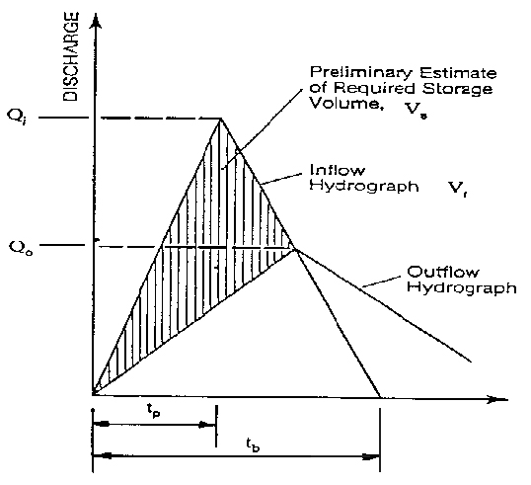
Figure 11-4. Simplified Triangular Hydrograph Method

The required storage volume may be estimated from the area above the outflow hydrograph and inside the inflow hydrograph, expressed as:
(11.3)
Where:
V_{s} = Storage volume estimate, cu. ft.
Q_{i} = Peak inflow rate, cfs
Q_{o} = Peak outflow rate, cfs
T_{b} = Duration of basin inflow, sec.

DCR Critical Storm Duration Method
The critical storm duration method is used to calculate the maximum storage volume for a detention facility. This critical storm duration is the storm duration that generates the greatest volume of runoff and, therefore, requires the most storage. The required storage volume is represented by the area between the inflow hydrograph and the outflow hydrograph. The area can be approximated using the following equation:
(11.4)
Where:
V = Required storage volume, cu. ft.
Q_{i} = Inflow peak discharge, cfs, for the critical storm duration, T_{d}
T_{c} = Time of concentration, min.
q_{o} = Allowable peak outflow, cfs
T_{d} = Critical storm duration, min.

The first derivative of the critical storage volume equation with respect to time is an equation that represents the slope of the storage volume curve plotted versus time. When Equation 11.4 is set to equal zero, and solved for T_{d}, it represents the time at which the slope of the storage volume curve is zero, or at a maximum. Equation 11.5 for the critical storm duration is:
(11.5)
Where:
T_{d} = Critical storm duration, min.
C = Runoff coefficient
A = Drainage area, ac.
a &b = Rainfall constants developed for storms of various recurrence intervals and various geographic locations (Refer to Chapter 11*, Appendix 11 H-2)‡
t_{c} = Time of concentration, min.
q_{o} = Allowable peak outflow, cfs

‡ The a & b rainfall constants are not to be used for any other purpose.

The Department has developed a computer program entitled “CRITSTRM” for* performing these computations. Access is available upon request at the following web address: http://www.virginiadot.org/business/locdes/notification.asp.

Pagan Volume Estimation Method
This method is appropriate for use with small basins serving watersheds of 200 acres or
less. For this method, data from many small basins was compiled and the curve in Figure 11-5 was developed. This curve is used to determine the storage volume for a given drainage area by dividing the pre-development peak inflow by the post-development peak inflow.
Knowing the percentage of peak inflow, the storage parameter (peak storage in cubic feet over peak inflow in cubic feet per second) can be found by moving horizontally over the y-axis to the curve and down to the x-axis.
By multiplying the storage parameter by the peak inflow, the approximate peak storage can be found. This method should be used only as a first trial. Experience has shown that this method is conservative.
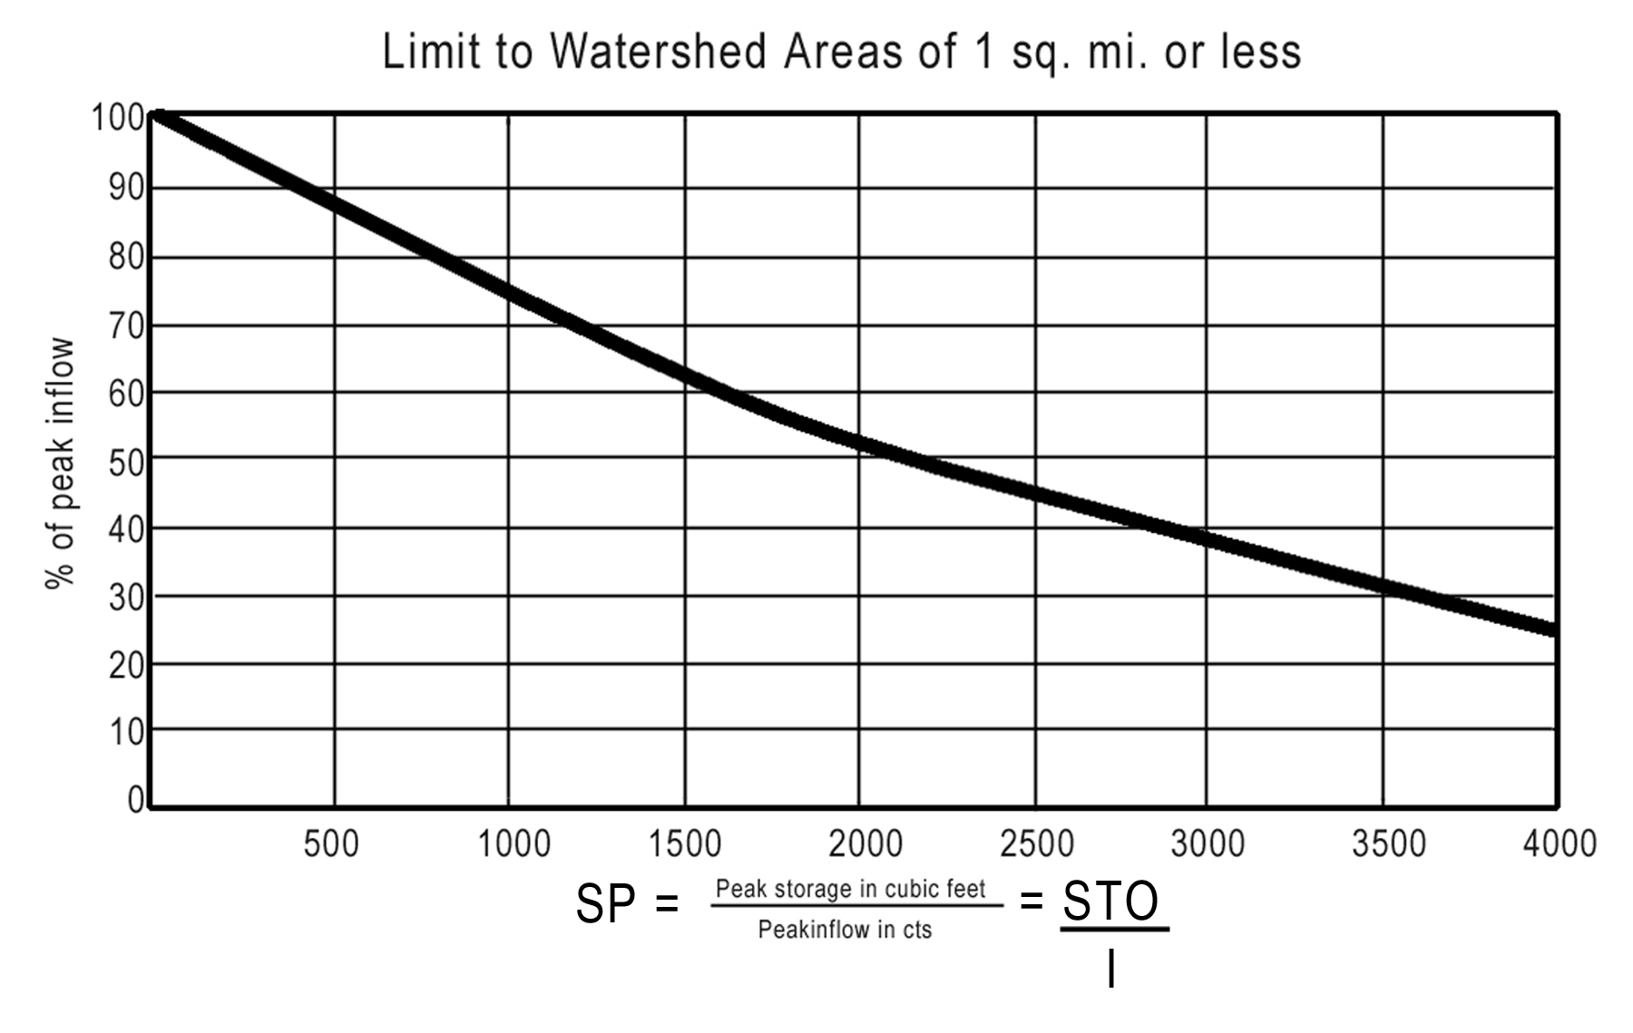
Figure 11-5. Pagan Method Curve
Step 1: Determine pre- and post-development peak discharges.
Step 2: Determine the Storage Parameter (SP).
SP is determined from Figure 11-5 drawing a line from the percentage of peak inflow (Q_{o}/Q_{i}) to the line and reading the factor along the base of the figure.
Step 3: Compute the Maximum Storage Volume (STO):

Sample Problems – Using 3 Methods to Estimate Volume of Storage for Quantity Control

Condition | Rational Method
Condition | D.A | C | T_{c} | Q₁₀
Pre-developed | 25ac. | 0.38 | 52 min. | 24 cfs
Post-developed | 25 ac | 0.59 | 21 min. | 65 cfs

Method 1: Modified Triangular Hydrograph Method
Based on the methodology from 11.5.4.1, solve for V_{s10} as follows:
Where:
V_{s10} = Storage volume estimate, cu. ft.
Q_{i} = 65 cfs
Q_{o} = 24 cfs
T_{b} = 2520 sec. = 42 min.

Method 2: DCR Critical Storm Duration Method
Based on the methodology in 11.5.4.2, determine the 10-year critical storm duration T_{d10} as follows:
a* = 189.2
b = 22.1
C = 0.59 (Post-development)
A = 25 acres
t_{c} = 21 min (Post-development)
q_{o10} = 24 cfs (Allowable outflow based on pre-development)

Solve for the 10-year critical storm duration intensity (I₁₀)
Determine the 10-year peak inflow (Q₁₀) using the Rational Equation and the critical storm duration intensity (I₁₀)
Determine the required 10-year storage volume (V₁₀) for the 10-year critical storm duration (T_{d10})
Method 3: Pagan Method
Based on the methodology in 11.5.4.3, solve for the storage volume as follows:
SP = 3100 seconds.

Determine Preliminary Basin Size
Based upon the estimated storage volume requirements calculated by the three methods in Section 11.5.4.4, determine the preliminary size of the basin. Assume the basin will have a rectangular shaped base, about 2:1 length to width ratio and optimum depth for Q₁₀ about 4 feet. The basin will have 3:1 side slopes, but for the first size estimate, the size of the base using vertical sides will provide an adequate first estimate.

From Method 1: Simplified Triangular Hydrograph Method
V₁₀ = 51,660 cu. ft.
For a 4-ft depth,
About 80’x160’
From Method 2: DCR Critical Storm Duration Method
V₁₀ = 70,300* cu. ft.
For 4’ depth,
About 90’x195’
From Method 3: Pagan Method
V₁₀ = 201,500 cu. ft.
For a 4’ deep,
About 150’x335’
Summary: Preliminary trial size basin would be recommended about 100’x200’

Final Basin Sizing-Reservoir Routing

Storage – Indication Method Routing Procedure
The following procedure presents the basic principles of performing routing through a reservoir or storage facility (Puls Method of storage routing). Routing is most often completed with computer software, which develops the stage-discharge and stage-storage curves within the program.
Step 1: Develop an inflow hydrograph, stage-discharge curve, and stage-storage curve for the proposed storage facility. Example stage-storage and stage-discharge curves are shown in Figure 11-6 and Figure 11-7 respectively.

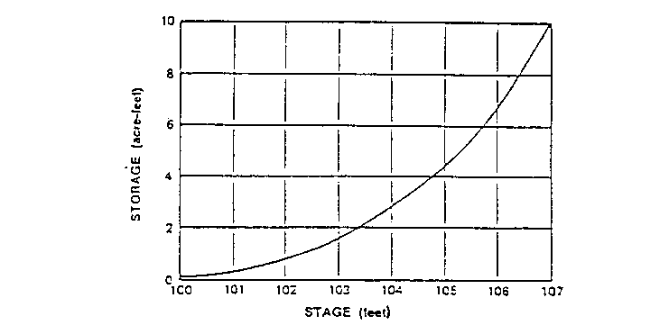
Figure 11-6. Stage-Storage Curve
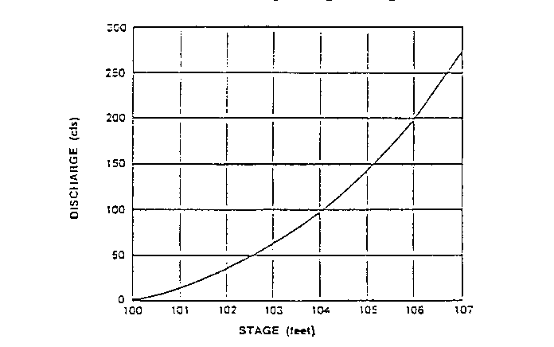
Figure 11-7. Stage-Discharge Curve
Step 2: Select a routing time period (Δt) to provide at least five points on the rising limb of the inflow hydrograph. Use t_{p} divided by 5 to 10 for Δt.
Step 3: Use the storage-discharge data from Step 1 to develop storage characteristics curves that provide values of versus stage. An example tabulation of storage characteristics curve data is shown in Table 11-5.

Table 11-5. Storage Characteristics
(1) | (2) | (3) | (4) | (5) | (6)
Stage  (H)  (ft.) | Storage¹  (S)  (ac-ft) | Discharge²  (Q)  (cfs) | Discharge²  (Q)  (ac-ft/hr) | (ac-ft) | (ac-ft)
100 | 0.05 | 0 | 0 | 0.05 | 0.05
101 | 0.05 | 15 | 1.24 | 0.20 | 0.40
102 | 0.05 | 35 | 2.89 | 0.56 | 1.04
103 | 1.6 | 63 | 5.21 | 1.17 | 2.03
104 | 2.8 | 95 | 7.85 | 2.15 | 3.45
105 | 4.4 | 143 | 11.82 | 3.41 | 5.39
106 | 6.6 | 200 | 16.53 | 5.22 | 7.98
¹ Obtained from the Stage-Storage Curve.
² Obtained from the Stage-Discharge Curve.

Note: t = 10 minutes = 0.167 hours and 1 cfs = 0.0826 ac-ft/hr.
Step 4: For a given time interval, I₁ and I₂ are known. Given the depth of storage or stage (H₁) at the beginning of that time interval, can be determined from the appropriate storage characteristics curve, Figure 11-8.
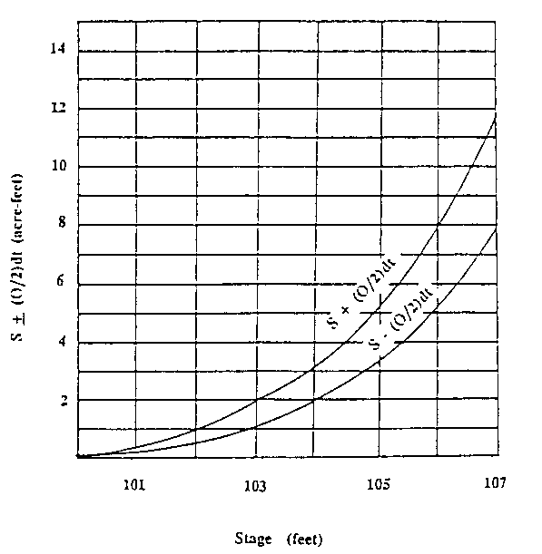
Figure 11-8. Storage Characteristics Curve

Step 5 Determine the value of from the following equation:
$S_{2}$ + $\frac{O_{2}}{2}$ $ΔT$ = $S_{1}$ - $\frac{O_{1}}{2}$ $ΔT$ + $\frac{I_{1}+I_{2}}{2}$ $ΔT$* (11.6)
Where:
S₂ = Storage volume at time 2, cu. ft.
O₂ = Outflow rate at time 2, cfs.
ΔT = Routing time period, sec
S₁ = Storage volume at time 1, cu. ft.
O₁ = Outflow rate at time 1, cfs
I₁ = Inflow rate at time 1, cfs
I₂ = Inflow rate at time 2, cfs
Other consistent units are equally appropriate.
Step 6: Enter the storage characteristics curve at the calculated value of determined in Step 5 and read off a new depth of water (H₂).
Step 7: Determine the value of O₂, which corresponds to a stage of H₂ determined in Step 6, using the stage-discharge curve.
Step 8: Repeat Steps 1 through 7 by setting new values of I₁, O₁, S₁, and H₁ equal to the previous I₂, O₂, S₂, and H₂, and using a new I₂ value. This process is continued until the entire inflow hydrograph has been routed through the storage basin.

Storage – Indication Method Routing Sample Problem
This example demonstrates the application of the methodology presented for the design of a typical detention storage facility used for water quantity control.
Storage facilities shall be designed for runoff from both the 2- and 10-year design storms and an analysis done using the 100-year design storm runoff to ensure that the structure can accommodate runoff from this storm without damaging adjacent and downstream property and structures.
The peak discharges from the 2- and 10-year design storms are as follows:
- Pre-developed 2-year peak discharge = 150 cfs
- Pre-developed 10-year peak discharge = 200 cfs
- Post-development 2-year peak discharge = 190 cfs
- Post-development 10-year peak discharge = 250 cfs
Since the post-development peak discharge must not exceed the pre-development peak discharge, the allowable design discharges are 150 and 200 cfs for the 2- and 10-year design storms, respectively.
Step 1: Develop an inflow hydrograph, stage-discharge curve, and stage-storage curve for the proposed storage facility.
Runoff hydrographs are shown in Table 11-6 below. Inflow durations from the post-development hydrographs are about 1.2 and 1.25 hours, respectively, for runoff from the 2- and 10-year storms.
Table 11-6. Runoff Hydrographs
 | Pre-Development Runoff |  | Post-Development Runoff
(1) | (2) | (3) | (4) | (5)
Time  (hrs) | 2-year  (cfs) | 10-year  (cfs) | 2-year  (cfs) | 10-year  (cfs)
0 | 0 | 0 | 0 | 0
0.1 | 18 | 24 | 38 | 50
0.2 | 61 | 81 | 125 | 178
0.3 | 127 | 170 | 190 >150 | 250 >200
0.4 | 150 | 200 | 125 | 165
0.5 | 112 | 150 | 70 | 90
0.6 | 71 | 95 | 39 | 50
0.7 | 45 | 61 | 22 | 29
0.8 | 30 | 40 | 12 | 16
0.9 | 21 | 28 | 7 | 9
1.0 | 13 | 18 | 4 | 5
1.1 | 10 | 15 | 2 | 3
1.2 | 8 | 13 | 0 | 1

Preliminary estimates of required storage volumes are obtained using the simplified triangular hydrograph method outlined in Section 11.5.4.1. For runoff from the 2- and 10-year storms, the required storage volumes, V_{S}, are computed using Equation 11.3:
$V_{S_{\text{10}}}=\frac{\frac{1 }{2 }(1\text{.}\text{25})(\text{3600})(\text{250}−\text{200})}{\text{43},\text{560}}=2\text{.}\text{58} \text{ac}\text{.} \text{ft}\text{.}$*
Stage-discharge and stage-storage characteristics of a storage facility that should
provide adequate peak flow attenuation for runoff from both the 2- and 10-year design storms are presented below in Table 11-7. The storage-discharge relationship was developed and required that the preliminary storage volume estimates of runoff for both the 2-and 10-year design storms to coincide with the occurrence of the corresponding allowable peak discharges.

Discharge values were computed by solving the broad-crested weir equation for head (H) assuming a constant discharge coefficient of 3.1, a weir length of 4 feet, and no tailwater submergence. The capacity of storage relief structures was assumed to be negligible.

Step 2: Select a routing time period (Δt) to provide at least five points on the rising limb of the inflow hydrograph. Use t_{p} divided by 5 to 10 for Δt.

Step 3: Use the storage-discharge data from Step 1 to develop storage characteristics curves (Stage-Discharge-Storage) that provide values of versus stage.
Table 11-7. Stage-Discharge-Storage Data
(1) | (2) | (3) | (4) | (5)
Stage  (H)  (ft) | Discharge  (Q)  (cfs) | Storage  (S)  (ac-ft) | (ac-ft) | (ac-ft)
0.0 | 0 | 0.00 | 0.00 | 0.00
0.9 | 10 | 0.26 | 0.30 | 0.22
1.4 | 20 | 0.42 | 0.50 | 0.33
1.8 | 30 | 0.56 | 0.68 | 0.43
2.2 | 40 | 0.69 | 0.85 | 0.52
2.5 | 50 | 0.81 | 1.02 | 0.60
2.9 | 60 | 0.93 | 1.18 | 0.68
3.2 | 70 | 1.05 | 1.34 | 0.76
3.5 | 80 | 1.17 | 1.50 | 0.84
3.7 | 90 | 1.28 | 1.66 | 0.92
4.0 | 100 | 1.40 | 1.81 | 0.99
4.5 | 120 | 1.63 | 2.13 | 1.14
4.8 | 130 | 1.75 | 2.29 | 1.21
5.0 | 140 | 1.87 | 2.44 | 1.29
5.3 | 150 | 1.98 | 2.60 | 1.36
5.5 | 160 | 2.10 | 2.76 | 1.44
5.7 | 170 | 2.22 | 2.92 | 1.52
6.0 | 180 | 2.34 | 3.08 | 1.60

Storage routing was conducted for runoff from both the 2- and 10-year design storms to confirm the preliminary storage volume estimates and to establish design water surface elevations. Routing results are shown below for runoff from the 2- and 10- year design storms, respectively. The preliminary design provides adequate peak discharge attenuation for both the 2- and 10-year design storms.
Step 4: For a given time interval, I₁ and I₂ are known. Given the depth of storage or stage (H₁) at the beginning of that time interval, can be determined from the appropriate storage characteristics curve.
Step 5 Determine the value of from the following equation:
$S_{2}$ + $\frac{O_{2}}{2}$ $ΔT$ = $S_{1}$ - $\frac{O_{1}}{2}$ $ΔT$ + $\frac{I_{1}+I_{2}}{2}$ $ΔT$* (11.7)
Summarized in Table 11-8 and Table 11-9 for the 2-year and 10-year storms.
Step 6 Enter the storage characteristics curve at the calculated value of determined in Step 5 and read off a new depth of water (H₂).
Summarized in Table 11-8 and Table 11-9 for the 2-year and 10-year storms.
Step 7 Determine the value of O₂, which corresponds to a stage of H₂ determined in Step 6, using the stage-discharge curve.
Summarized in Table 11-8 and Table 11-9 for the 2-year and 10-year storms.
Step 8 Repeat Steps 1 through 7 by setting new values of I₁, O₁, S₁, and H₁ equal to the previous I₂, O₂, S₂, and H₂, and using a new I₂ value. This process is continued until the entire inflow hydrograph has been routed through the storage basin.
Summarized in Table 11-8 and Table 11-9 for the 2-year and 10-year design storms.
Table 11-8. Storage Routing for the 2-Year Storm
(1) | (2) | (3) | (4) | (5) | (6) | (7) | (8)
Time  (T)  (hrs) | Inflow  (I)  (cfs) | (ac-ft) | Stage  (H₁)  (ft) | (6)-(8)  (ac-ft) | (3)+(5)  (ac-ft) | Stage  (H)  (ft) | Outflow  (O)  (cfs)
0.0 | 0 | 0.00 | 0.00 | 0.00 | 0.00 | 0.00 | 0
0.1 | 38 | 0.16 | 0.00 | 0.00 | 0.16 | 0.43 | 3
0.2 | 125 | 0.67 | 0.43 | 0.10 | 0.77 | 2.03 | 36
0.3 | 190 | 1.30 | 2.03 | 0.50 | 1.80 | 4.00 | 99
0.4 | 125 | 1.30 | 4.00 | 0.99 | 2.29 | 4.80 | 130<150 OK
0.5 | 70 | 0.81 | 4.80 | 1.21 | 2.02 | 4.40 | 114
0.6 | 39 | 0.45 | 4.40 | 1.12 | 1.57 | 3.60 | 85
0.7 | 22 | 0.25 | 3.60 | 0.87 | 1.12 | 2.70 | 55
0.8 | 12 | 0.14 | 2.70 | 0.65 | 0.79 | 2.02 | 37
0.9 | 7 | 0.08 | 2.08 | 0.50 | 0.58 | 1.70 | 27
1.0 | 4 | 0.05 | 1.70 | 0.42 | 0.47 | 1.03 | 18
1.1 | 2 | 0.02 | 1.30 | 0.32 | 0.34 | 1.00 | 12
1.2 | 0 | 0.01 | 1.00 | 0.25 | 0.26 | 0.70 | 7
1.3 | 0 | 0.00 | 0.70 | 0.15 | 0.15 | 0.40 | 3

Table 11-9. Storage Routing for the 10-Year Storm
(1) | (2) | (3) | (4) | (5) | (6) | (7) | (8)
Time  (T)  (hrs) | Inflow  (I)  (cfs) | (ac-ft) | Stage  (H₁)  (ft) | (6)-(8)  (ac-ft) | (3)+(5)  (ac-ft) | Stage  (H)  (ft) | Outflow  (O)  (cfs)
0.0 | 0 | 0.00 | 0.00 | 0.00 | 0.00 | 0.00 | 0
0.1 | 50 | 0.21 | 0.21 | 0.00 | 0.21 | 0.40 | 3
0.2 | 178 | 0.94 | 0.40 | 0.08 | 1.02 | 2.50 | 49
0.3 | 250 | 1.77 | 2.50 | 0.60 | 2.37 | 4.90 | 134
0.4 | 165 | 1.71 | 4.90 | 1.26 | 2.97 | 2.97 | 173<200 OK
0.5 | 90 | 1.05 | 5.80 | 1.30 | 2.35 | 4.00 | 137
0.6 | 50 | 0.58 | 4.95 | 1.25 | 1.83 | 4.10 | 103
0.7 | 29 | 0.33 | 4.10 | 1.00 | 1.33 | 3.10 | 68
0.8 | 16 | 0.19 | 3.10 | 0.75 | 0.94 | 2.40 | 46
0.9 | 9 | 0.10 | 2.40 | 0.59 | 0.69 | 1.90 | 32
1.0 | 5 | 0.06 | 1.90 | 0.44 | 0.50 | 1.40 | 21
1.1 | 3 | 0.03 | 1.40 | 0.33 | 0.36 | 1.20 | 16
1.2 | 1 | 0.02 | 1.20 | 0.28 | 0.30 | 0.90 | 11
1.3 | 0 | 0.00 | 0.90 | 0.22 | 0.22 | 0.60 | 6

Since the routed peak discharge is lower than the maximum allowable peak discharges for both design storms, the weir length could be increased or the storage decreased. If revisions are desired, routing calculations should be repeated.
Although not shown for this sample problem, runoff from the 100-year frequency storm should be routed through the storage facility to establish freeboard requirements and to evaluate emergency overflow and stability requirements. In addition, the preliminary design provides hydraulic details only. Final design should consider site constraints such as depth to water, side slope stability, maintenance, grading to prevent standing water, and provisions for public safety.
An estimate of the potential downstream effects (i.e., increased peak flow rate and recession time) of detention storage facilities may be obtained by comparing hydrograph recession limbs from the pre-development and routed post-development runoff hydrographs. Example comparisons are shown below for the 10-year design storms.
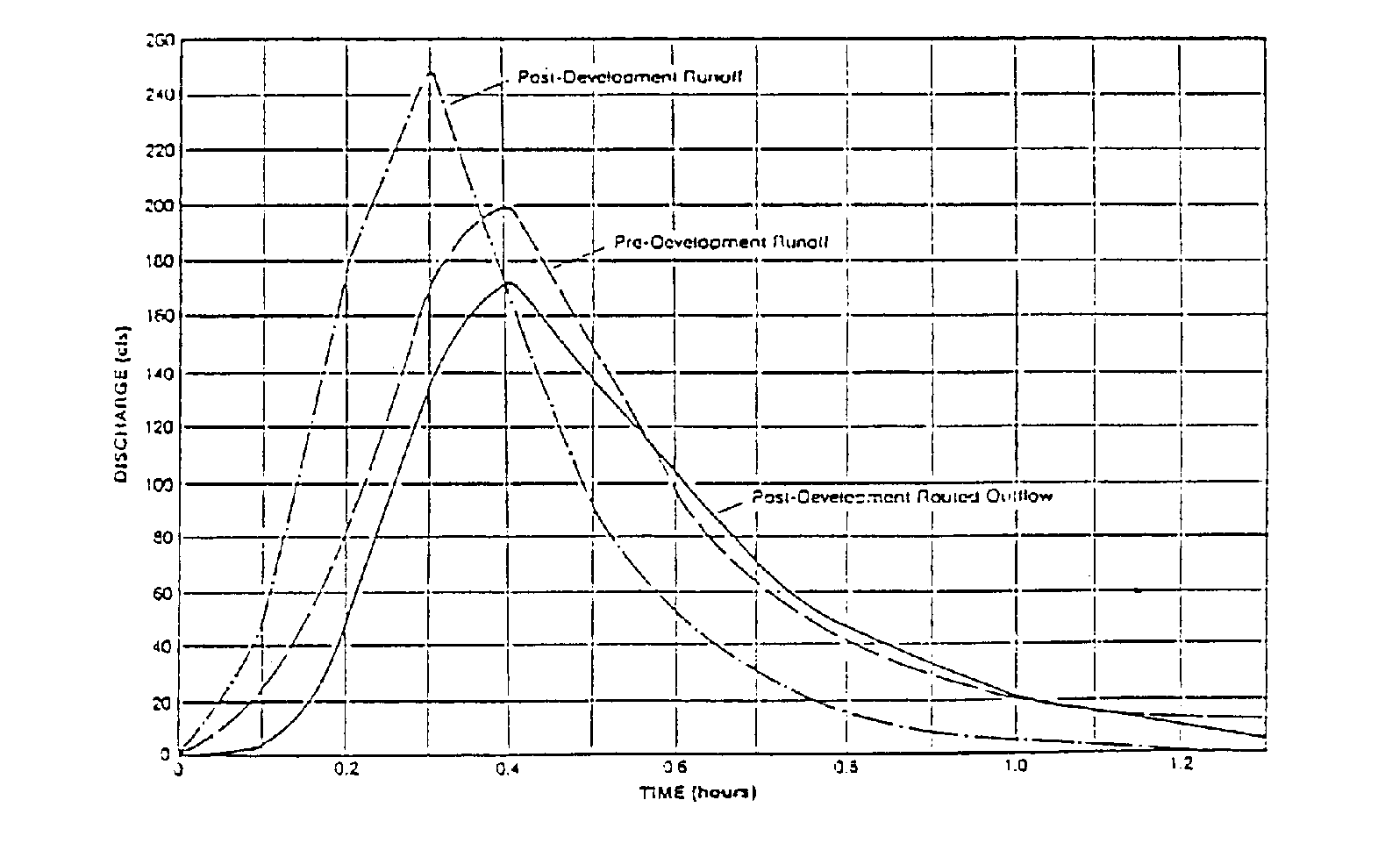
Figure 11-9. Runoff Hydrographs
Potential effects on downstream facilities should be minor when the maximum difference between the recession limbs of the pre-developed and routed outflow hydrographs is less than about 20 percent. As shown in Figure 11-9, the sample problem results are well below 20 percent; downstream effects can thus be considered negligible and downstream flood routing or Q₁ control omitted.

SWM Basin Design: Sample Problem
Step 1: Determine the type of BMP required:
- New impervious area draining to this outfall = 2.98 ac.
- Total drainage area at the outfall within the R/W and easements = 9.03 ac.
- Percentage Impervious Cover
From Table 11-1 – Select an extended detention basin
Step 2: Determine Quantity Control Requirements:
- The receiving channel is a natural channel that was determined not to be adequate. The post construction Q₂ will overtop the banks of the channel. The pre-construction Q₂ is also above the banks of the channel, but that is not a factor.
- In accordance with MS-19 of the VESCR, the BMP will need to attenuate the post-development Q₂ to not be greater than pre-development Q₂. The design of the dam and the emergency spillway will need to provide protection of the dam for Q₁₀₀.
- The Q_{2pre} = 20.5 cfs and the Q_{2post} = 29.6 cfs. The usual design process would be to now estimate the quantity control volume needed for the basin.
Step 3. Determine if quantity control for Q₁ is required:
- Flood control for the 1-year frequency storm in lieu of the 2-year frequency storm may be needed if there is existing or anticipated erosion downstream.
- A field review of the receiving channel has shown no significant erosion and none is anticipated.
Therefore, the alternative Q₁ control is not needed.
Step 4. Determine the required water quality volume and treatment volume:
- From Table 11-1 the required treatment volume for an extended detention basin is 2 x WQV. The WQV being equal to ½ inches x New Impervious area. 2 x ½ inch = 1 in or 0.083 ft
- New pavement within the drainage area for this outfall = 2.98 ac or 129,809 sq. ft.
Step 5. Determine the temporary sediment storage requirements:
- The total drainage area to this outfall from a storm drain system is 12.98 ac.
- All of the drop inlets in the storm drain will have erosion control measures.
- Temporary sediment storage is not required because all of the inlets can be protected from sediment. However, temporary sediment storage will be provided with the volume equal to the treatment value due to the convenience of the basin and as a supplement to the erosion and sediment controls.
- If a temporary sediment basin were needed, the quantities would be:
67 cu. yd. x 13 ac = 23,517 cu. ft. for wet storage
67 cu. yd. x 13 ac = 23,517 cu. ft. for dry storage
The total volume required for temporary sediment storage, wet plus dry = 47,034 cu. ft. This is much larger than the 10,817 cu. ft. required for the WQV.

Step 6. Determine the size of the sediment forebay:
- A sediment/debris forebay is recommended for extended detention basins and the volume should be between 0.1 to 0.25 inches per acre of new impervious area or 10 percent of the required detention volume. This range establishes the minimum to maximum desirable sediment storage volumes needed. The actual size of the forebay is dependent upon the site conditions. It is desirable to size the forebay as near to the maximum sediment storage volume as possible.
- Compute the sediment forebay volume and determine its dimensions:
If forebay is 1 ft deep: Size = 33 ft x 33 ft.

For 0.25 inch, volume = 2,704 cu. ft.
If basin is 1 ft deep: Size = 50 ft x 50 ft.

The shape of the forebay does not need to be square and should be shaped to fit the site. The volume of the forebay that cannot be drained should not be considered as part of the required storage volume for the basin.
The established design parameters for the basin

1. An extended detention basin is required for this site.
2. QUANTITY CONTROL FOR Q₂ PEAK IS REQUIRED. The required volume will be estimated in the design process.
3. Alternative Q₁ control is not needed.
4. The required WQV is 10,817 cu. ft.
5. The temporary sediment volume (if needed) is 47,034.
6. The estimated forebay volume is 1,082 to 2,704 cu. ft.
Determining the Water Quality Volume
Calculate required WQV (for extended detention) = 10,817 cu. ft.
From Preliminary Elevation/Storage Table:
The WQV required is met @ Elev. 423.25
Depth = 1.95 ft
Actual Volume = 11,051 cu. ft. @ Elev. 423.25
WQV Computations – Determining the Orifice Size Required
Using DCR Method #2 Average Hydraulic Head (VDOT Preferred)
- Assume depth, h = 1.95 ft (Say 2.0 ft)
- Compute the Q_{avg} for the WQV using the required 30-hour drawdown time:
- Orifice sizing computations:
The depth (h) used in the orifice equation would normally be measured from the center of the orifice. Due to the small size of the water quality orifice it is acceptable to consider the h as the depth to the invert of the orifice.
From Table 11-4, use a 2-inch orifice with an area = 0.022 sq. ft.
Q₁ Control – Alternative Quantity Control
Assume that a field review of the receiving channel shows that there is significant erosion and it has been decided that the channel should be protected from the Q₁ instead of the Q₂ as required by MS-19. Control of the Q₁ requires containing the entire volume of the Q₁ from the total drainage area and releasing that volume over a 24-hour period. The computations are similar to those used for WQV storage and released over a 30-hour period. When Q₁ is detained and released over the 24-hour period, there will be no need to provide additional or separate storage for the WQV if it can be demonstrated that the treatment volume will be detained for approximately 24 hours.

Determine the Q₁ Control Volume:
Use (DCR) Method #2 – Average Hydraulic Head (Recommended Method)
Find the Q₁ Control volume.
Given from design computations:
DA = 12.98 ac
C = 0.67
T_{c} = 16 min
Q₂ = 29.6 cfs.
- Use TR-55 to find the volume for Q₁:
- Convert the runoff coefficient, C = 0.67 from the Rational Method to CN = 80. Refer to Appendix 11C-1.
- Find the 1-year frequency 24-hour rainfall (RF) for the appropriate county from Appendix 11C-3.
RF = 2.8 inches.
- Find the runoff depth for CN= 80 and RF = 2.8 inches from Appendix 11C-2 or use TR-55.
Runoff (RO) = 1.1 inches
- Compute the Q₁ Control volume:
To account for the routing effect, reduce the channel erosion control volume by 60%:
Sizing the Basin for the Q₁ Volume
1. Use the Rational Method triangular hydrograph (HYG) to estimate the volume needed:
  - From 24 hour rainfall (RF) table (Appendix 11C-3):
RF₁ = 2.8 inches
RF₂ = 3.5 inches
Thus Q₁ = 80% of Q₂
Q₂ = 29.6 cfs
  - Compute the volume from a triangular HYG:
Using t_{c} = 16 min., T_{b} = 2t_{C} = 32 min.
$\begin{aligned}V_{1}=0\text{.}5 (Q_{1})(T_{b}) (\text{60}\frac{\text{sec}}{\text{min}}) \\ = 0\text{.}5 (\text{23}\text{.}7 \text{cfs})(\text{32}\text{min}\text{.})(\text{60}\frac{\text{sec}}{\text{min}}) \\ =\text{22},\text{752} \text{cu}\text{.} \text{ft}\text{.} \end{aligned}$*
  - Compute the volume from a trapezoidal HYG:
Using t_{c} = 16 min. and determining the critical storm duration, T_{d} = 22 min.
T_{b} = t_{c} +T_{d}= 38 min.
$$\begin{aligned}V_{1}=0\text{.}5 (Q_{1}) [(T_{d}−t_{c}) +T_{b}] \text{60} \frac{\text{sec}}{\text{min}} \\ =0\text{.}5 (\text{23}\text{.}7 \text{cfs})[(\text{22}\text{min}−\text{16}\text{min}) +\text{38}\text{min}] \text{60}\frac{\text{sec}}{\text{min}} \\ =\text{31},\text{284} \text{cu}\text{.} \text{ft}\text{.}\end{aligned}$$
NOTE: Calculation is for entire volume of hydrograph
It is noted that this drainage area is sensitive to the critical storm duration of 22 minutes. For the Q₁ = 23.7 cfs with t_{c} = 16 minutes and the duration = 22 minutes, the volume of the HYG = 31,284 cubic feet which is very close to the volume of 31,097 cubic feet as calculated using the average hydraulic head method.
2. Determine the required orifice size:
    - To achieve the Q₁ volume at a safe ponded depth, assume a depth, h = 3.0 ft.
    - Find Q_{avg} for the required 24-hour drawdown for Q₁ Control:
3 Determine the orifice size:
- Determine h_{avg}
- Using the rearranged orifice equation:
From Table 11-4, use a 3 ½-inch orifice with an area = 0.067 sq. ft.

References
Department of Conservation and Recreation, Virginia Stormwater Management Handbook, 1st Edition, Vol. 1 and Vol. II, 1999
Brater, E. F. and H. W. King. Handbook of Hydraulics, 6th Edition, New York: McGraw Hill Book Company, 1976
Chow, C. N. Open Channel Hydraulics, New York: McGraw Hill Book Company, 1959
Sandvik, A. March, Proportional Weirs for Stormwater Pond Outlets, Civil Engineering, ASCE, pp. 54-56, March 1985*
Spangler, M.G. and R. L. Handy, Geotechnical Engineering, 5th Edition, McGraw-Hill Professional Publishing, October 2006
Metropolitan Government of Nashville and Davidson County, Stormwater Management Manual – Volume 2 Procedures, Cump Dresser & Mckee, Inc May 2000
Wycoff, R. L. and U. P. Singh, “Preliminary Hydrologic Design of Small Flood Detention Reservoirs, JAWRA, Vol. 12, No. 2, pp 337-344, 11 June 2007

* Rev 9/09
* Rev 9/09
* Rev 9/09
* Rev 9/09
Rev 9/09
* Rev 9/09
* Rev 9/09
* Rev 9/09
* Rev 9/09
* Rev 9/09
* Rev 9/09
* Rev 9/09
* Rev 9/09
* Rev 9/09
* Rev 9/09
* Rev 9/09
* Rev 9/09
* Rev 9/09
* Rev 9/09
* Rev 9/09
* Rev 9/09
* Rev 9/09
* Rev 9/09
* Rev 9/09
* Rev 9/09
* Rev 9/09
* Rev 9/09

