Appendix 11G-3 Retention Basin - Plan and Section

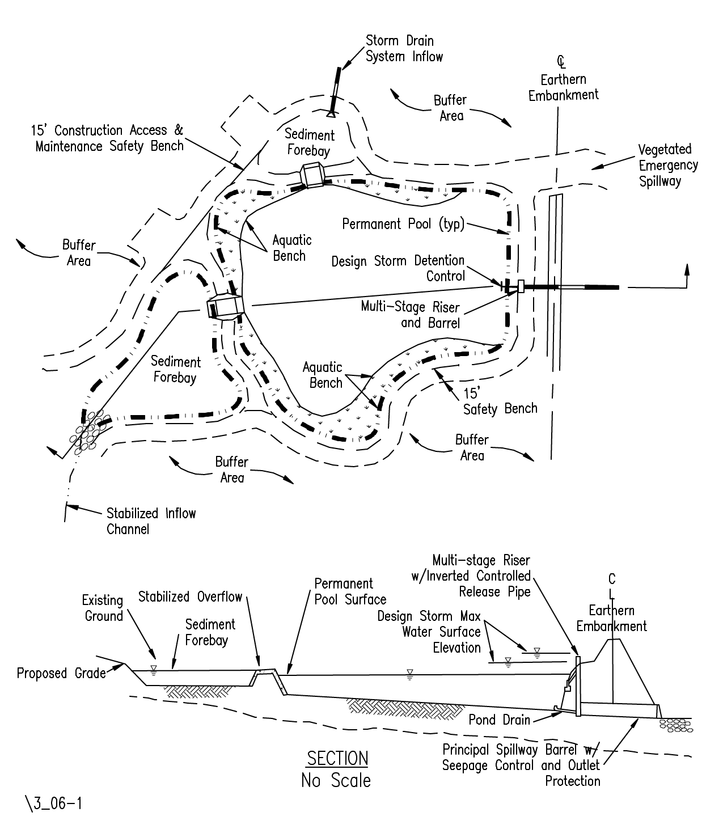

Source: Virginia Stormwater Management Handbook, 1st Ed., Vol. I, 1999.

