Appendix 11G-1 Extended Detention Basin –

Plan and Section
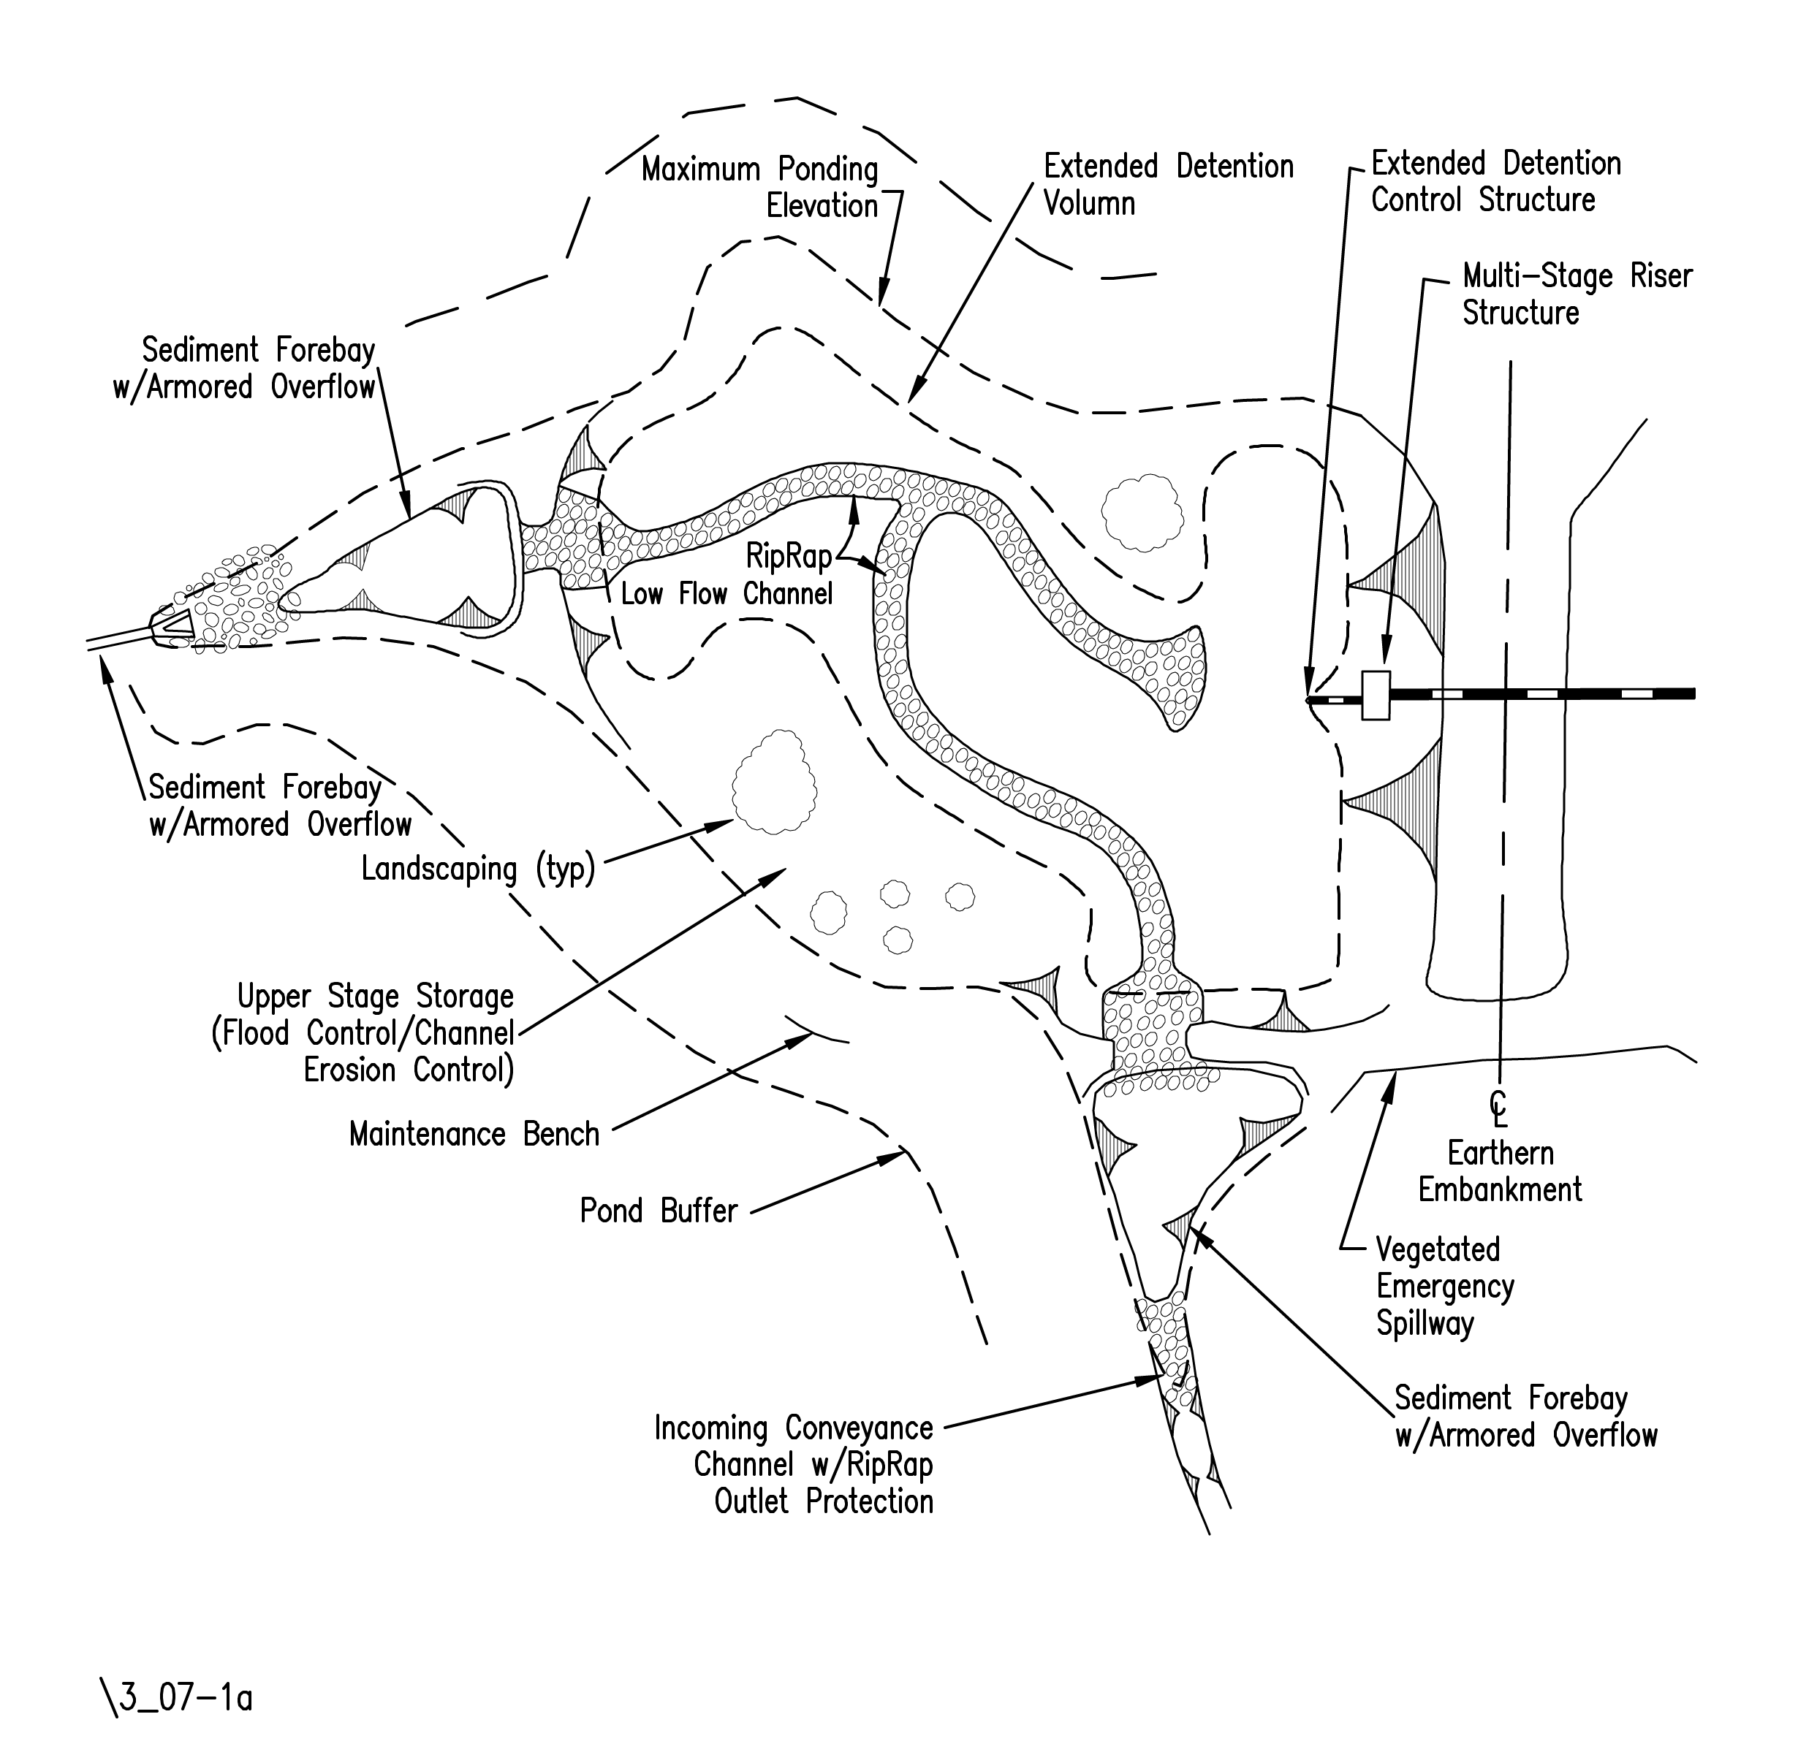
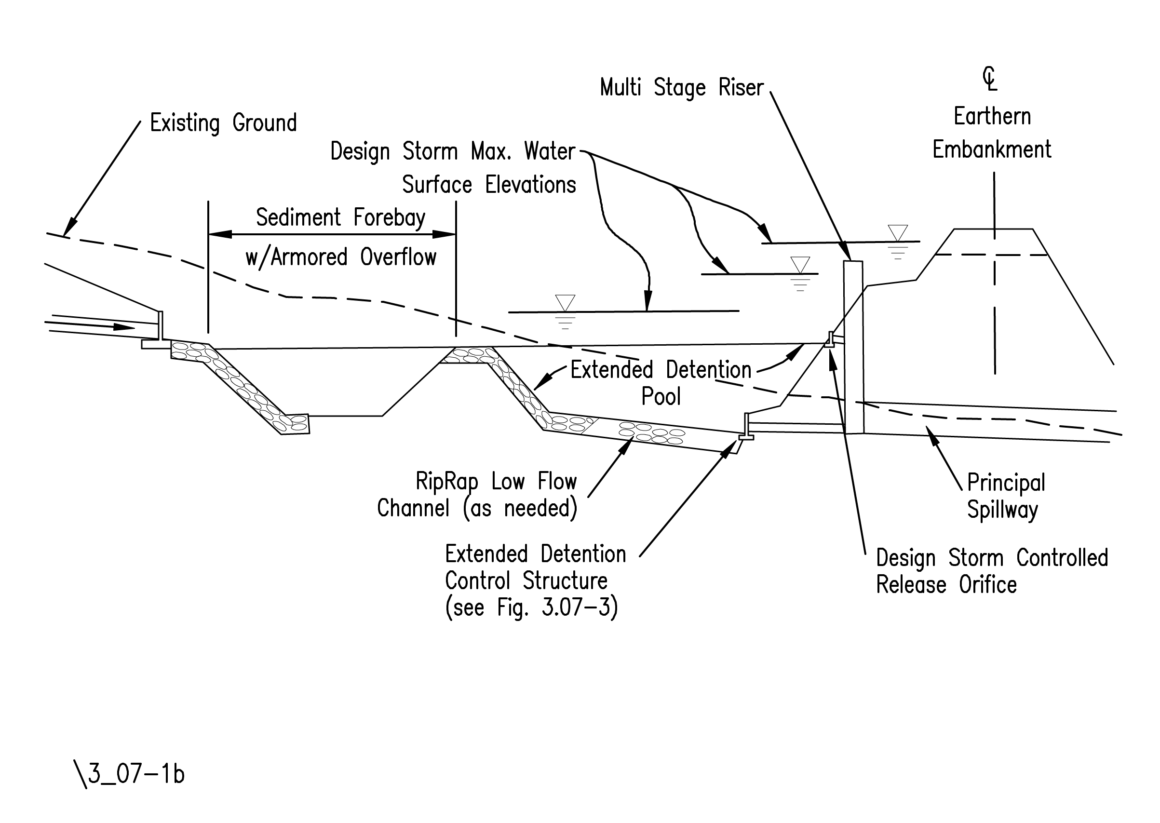
Source: Virginia Stormwater Management Handbook, 1st Ed., Vol. I, 1999.

