Appendix 9C-26 Values of Hydraulic Elements of

Circular Section for

Various Depths of Flow

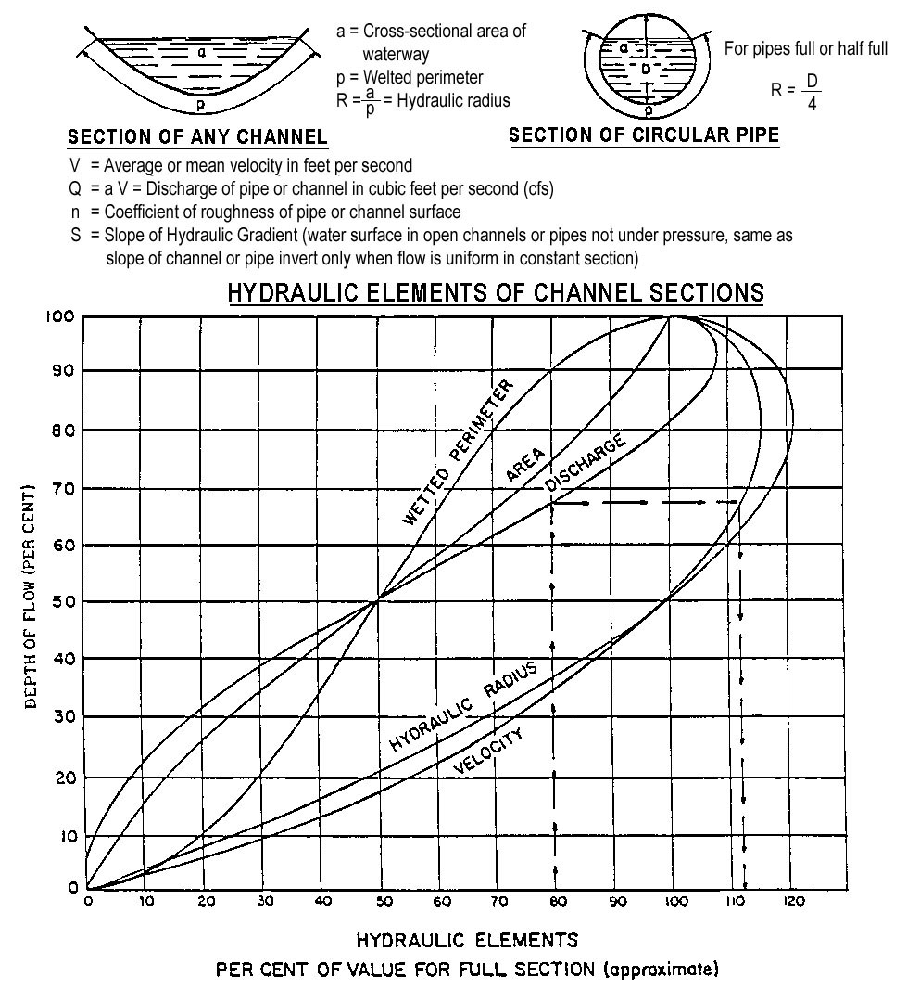

Source: HEC No. 22

