Appendix 9C-20 Undepressed Curb-Opening Inlet Capacity in

Sump Locations

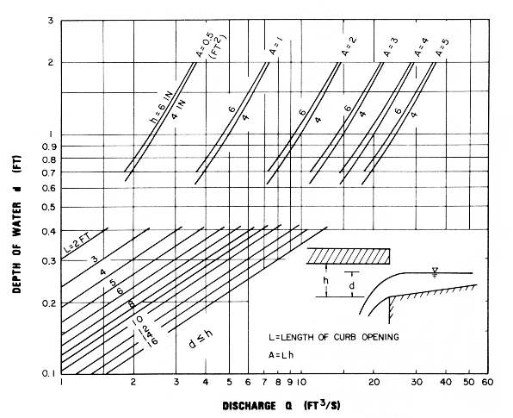

Source: HEC No. 22, FHWA

