Appendix 9C-18 Curb-Opening and Slotted Drain Inlet

Interception Efficiency

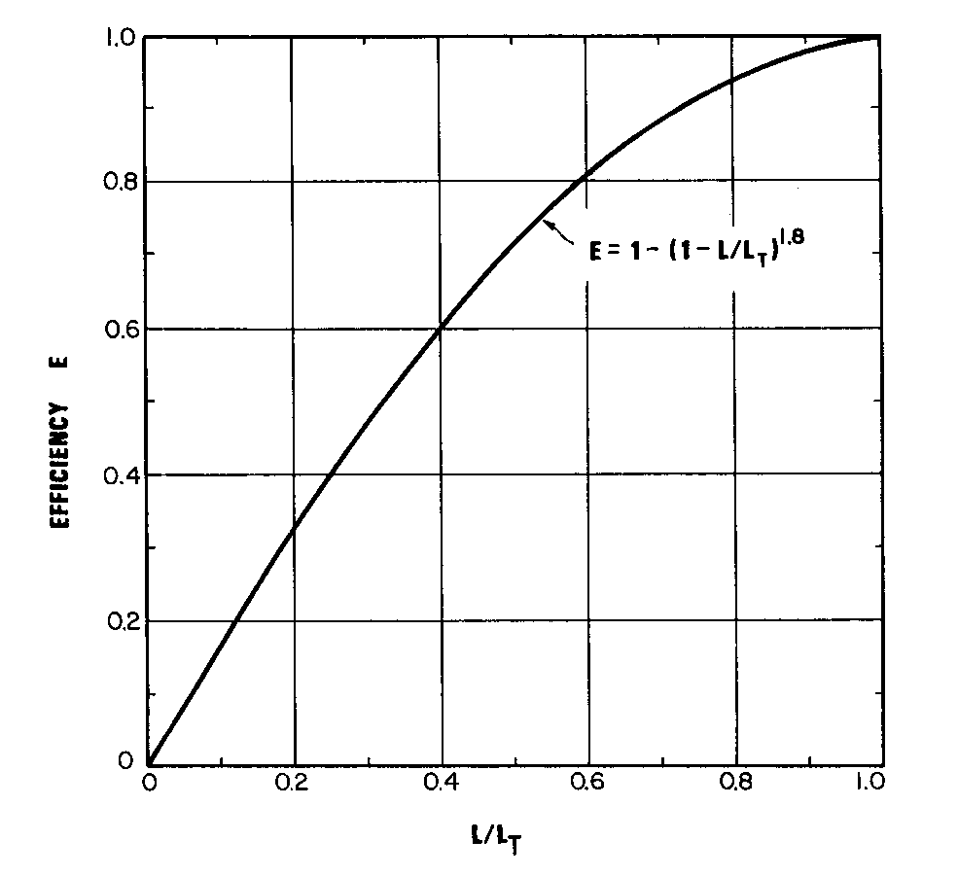

Source: HEC No. 22, FHWA

