Appendix 9C-17 Curb-Opening and Slotted Drain

Inlet Length for Total Interception

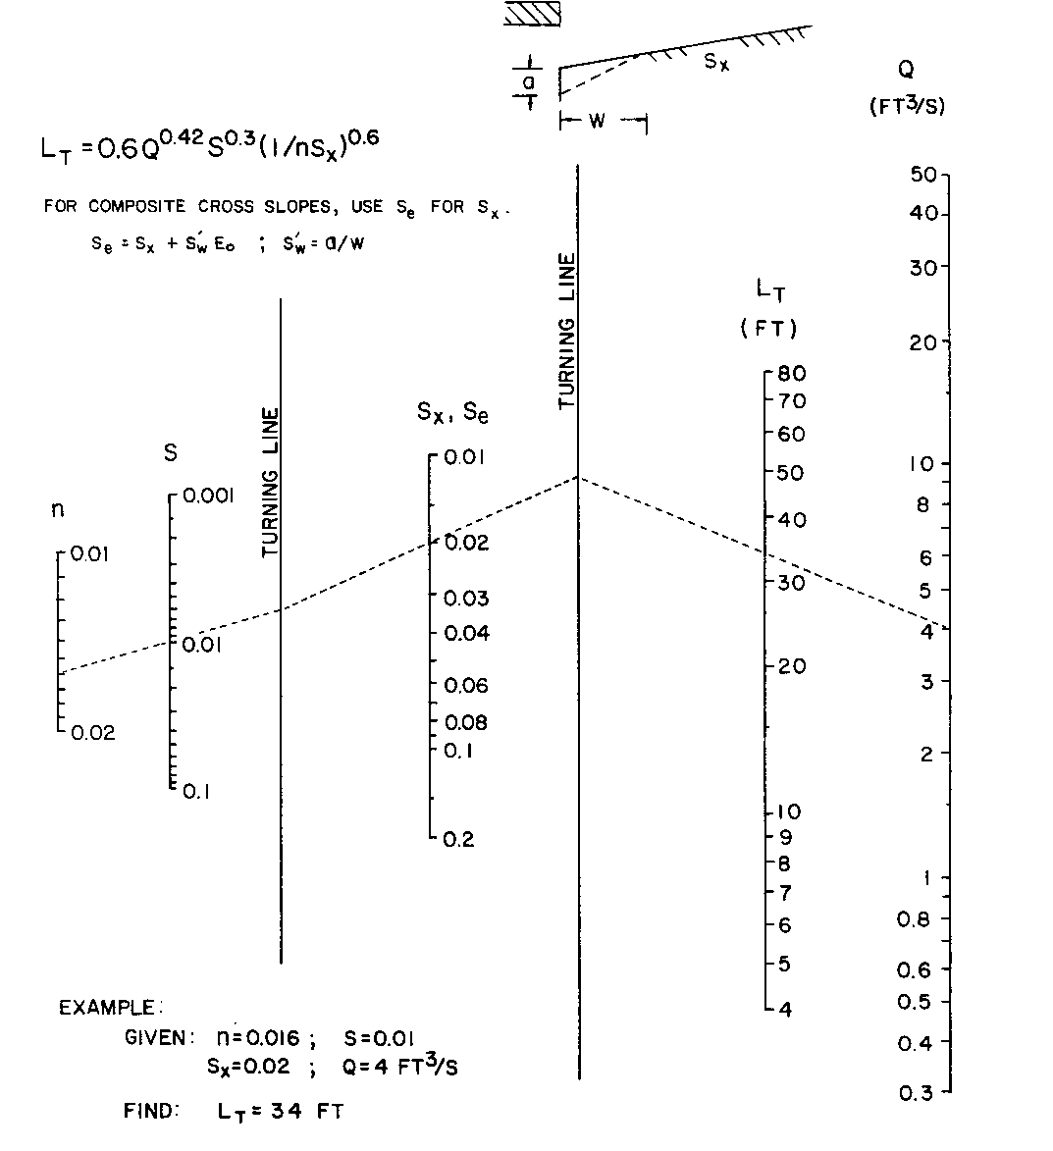

Source: HEC No. 22, FHWA

