Appendix 9C-15 Performance Curve DI-12 in a Sump

(Side Slope 3:1)

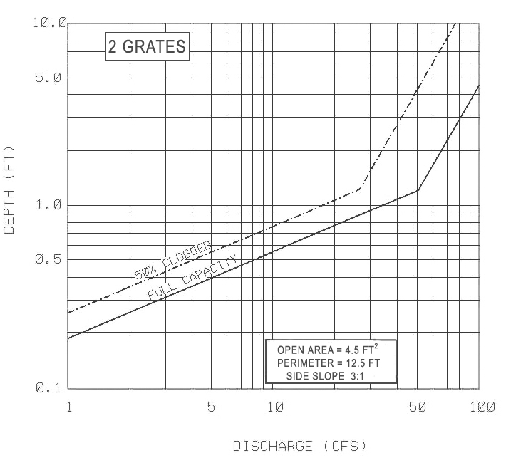

Comments and/or Source:

Source: VDOT Transportation Research Council publication “HYDRAULIC EFFICIENCY OF GRATE INLET”, 1988

