Appendix 9C-14 Performance Curve DI-7 in a Sump

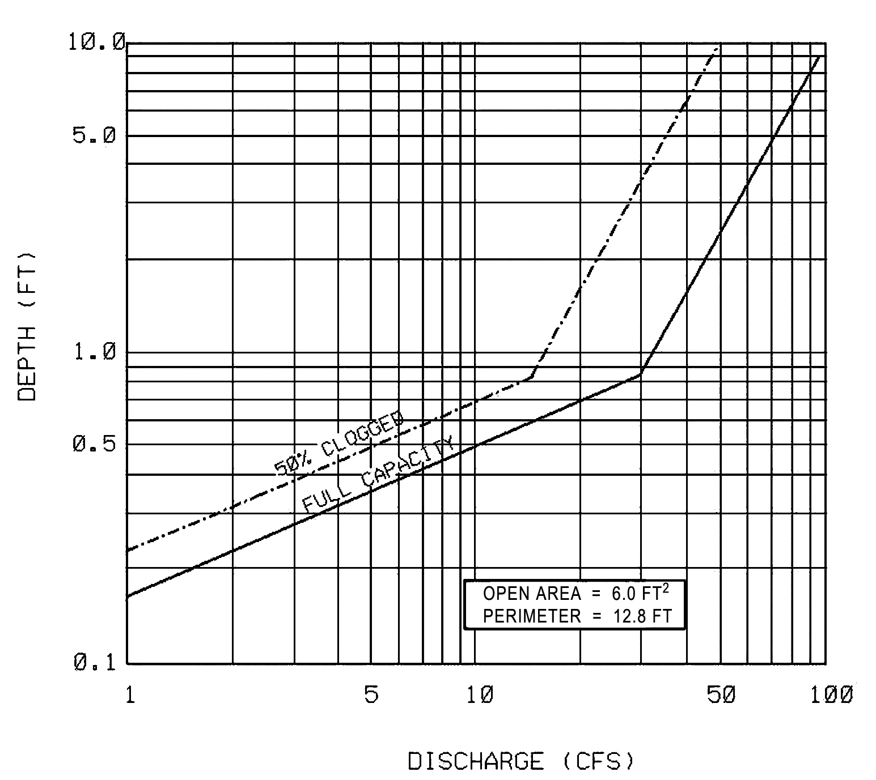

Source: VDOT Transportation Research Council publication “HYDRAULIC EFFICIENCY OF GRATE INLET”, 1988

