Appendix 9C-13 Performance Curve DI-1 in a Sump

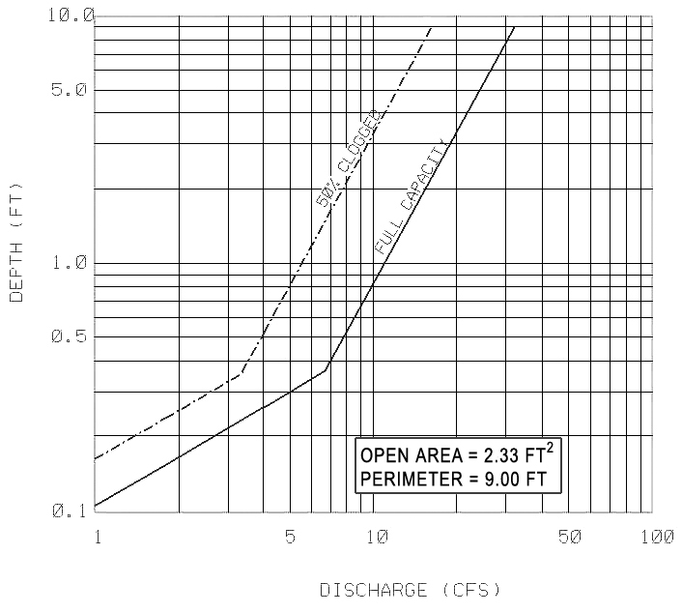

Source: VDOT Transportation Research Council publication “HYDRAULIC EFFICIENCY OF GRATE INLET”, 1988

