Appendix 9C-11 Grate Inlet Side Flow

Interception Efficiency

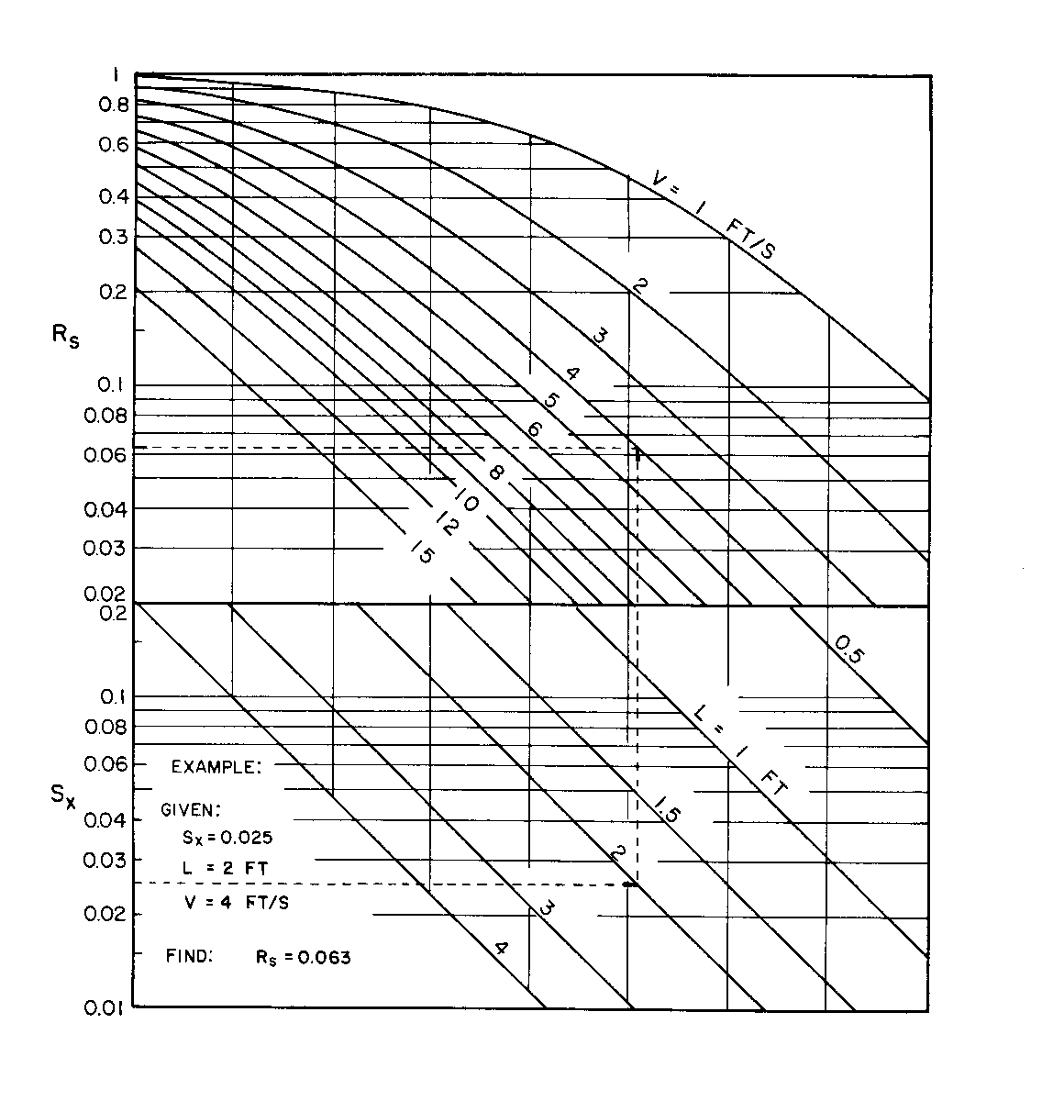

Source: HEC No. 22, FHWA

