Appendix 9C-8 Ratio of Frontal Flow to Total Gutter Flow

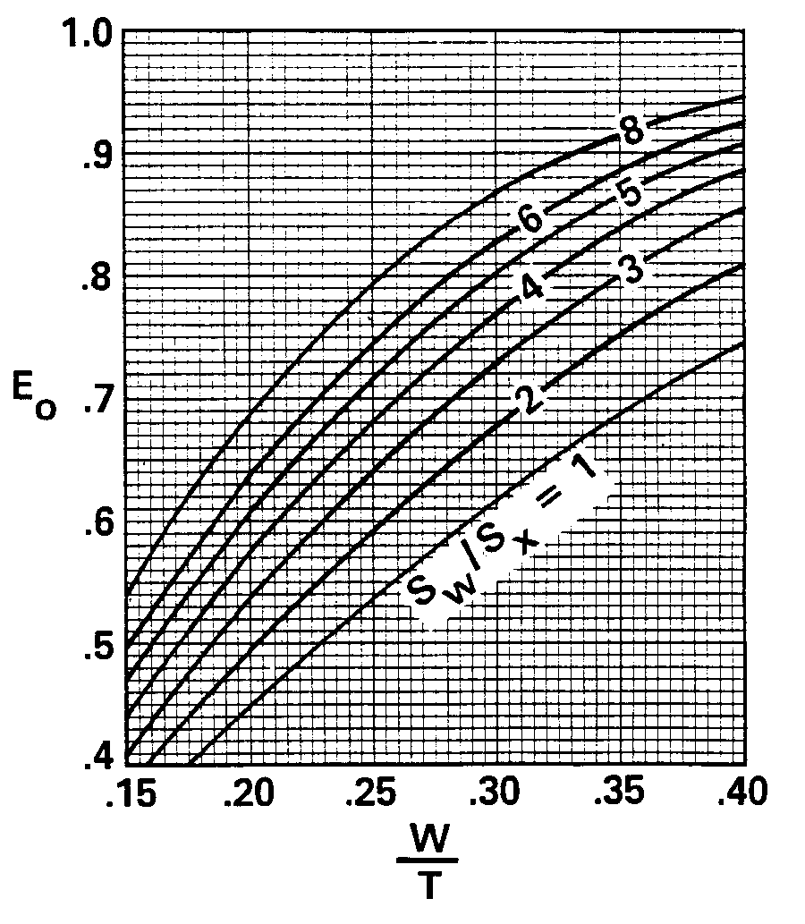

For values of W/T greater than 0.4, use the chart on page 2 of this appendix.

Source: HEC No. 12, FHWA

Appendix 9C-8 Ratio of Frontal Flow to Total Gutter Flow

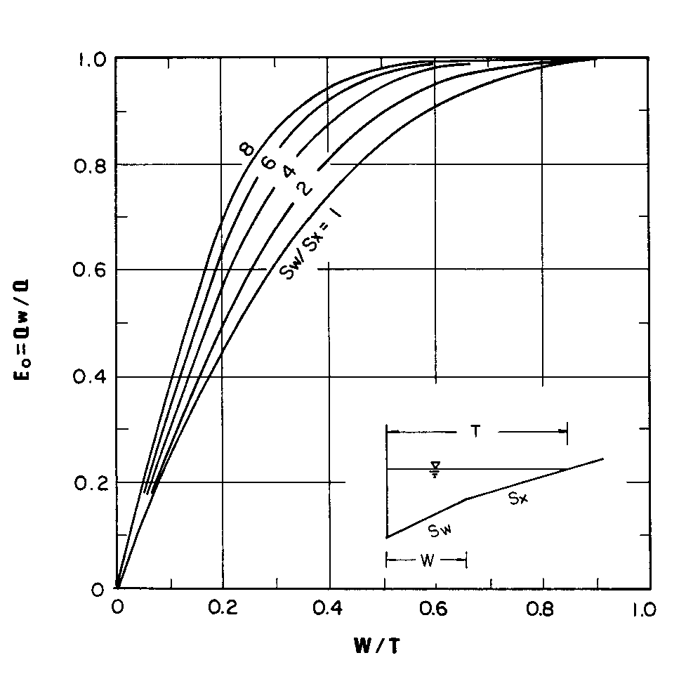

If W/T is greater than 1.0, use W/T equal to 1.0.

Source: HEC No. 22, FHWA

