Appendix 9C-6 Flow Characteristic Curve

(Roll Type Gutter)

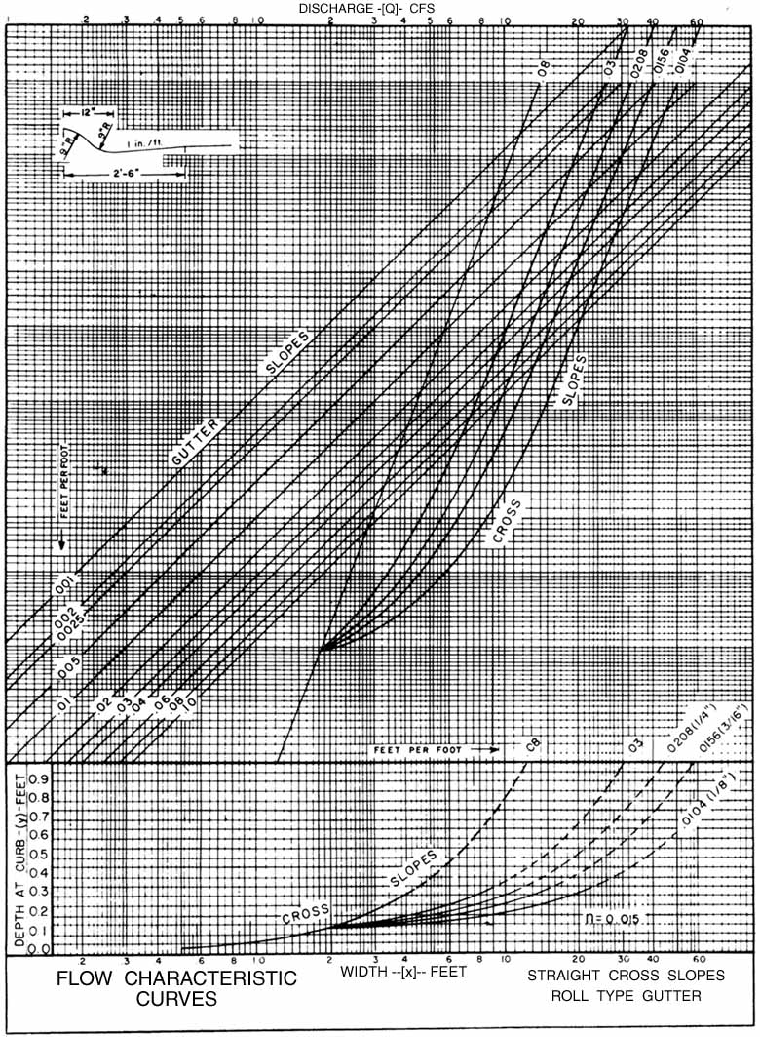

Source: VDOT
Comment: REV 6/85

Source:

