Appendix 8F-3 Dimension and Weight

of Minimum Size Counterweight

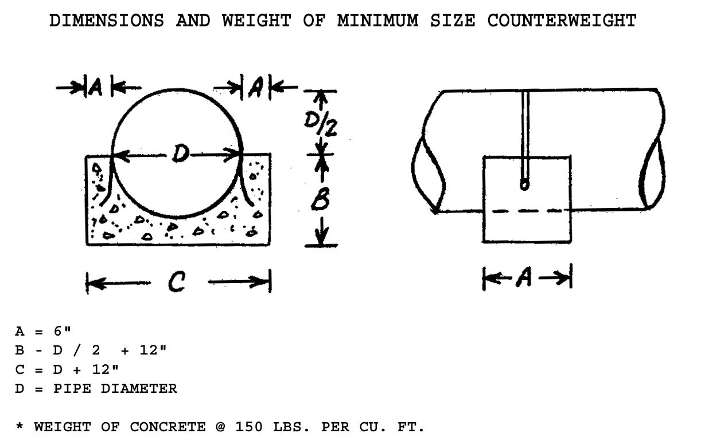

Pipe Diameter  (inches) | Dimensions  (inches) |  |  | Concrete
D | A | B | C | Volume  (cu. ft.) | Weight*  (lbs.)
12 | 6 | 18 | 24 | 1.30 | 195
15 | 6 | 19.5 | 27 | 1.52 | 228
18 | 6 | 21 | 30 | 1.75 | 263
24 | 6 | 24 | 36 | 2.22 | 333
30 | 6 | 27 | 42 | 2.71 | 407
36 | 6 | 30 | 48 | 3.23 | 485
42 | 6 | 33 | 54 | 3.78 | 567
48 | 6 | 36 | 60 | 4.36 | 654
54 | 6 | 39 | 66 | 4.96 | 744
60 | 6 | 42 | 72 | 5.59 | 839
66 | 6 | 45 | 78 | 6.25 | 938
72 | 6 | 48 | 84 | 6.93 | 1040

Source:

