Appendix 8F-1 Handling Weight for Corrugated Steel Pipe

(2⅔”x½” Corrugations)

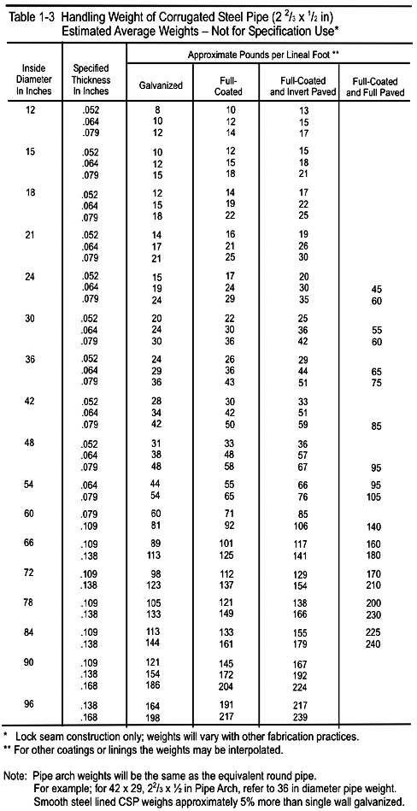
Source:

