Appendix 8C-91 Rectangular Channel Flow Chart (B=20’)
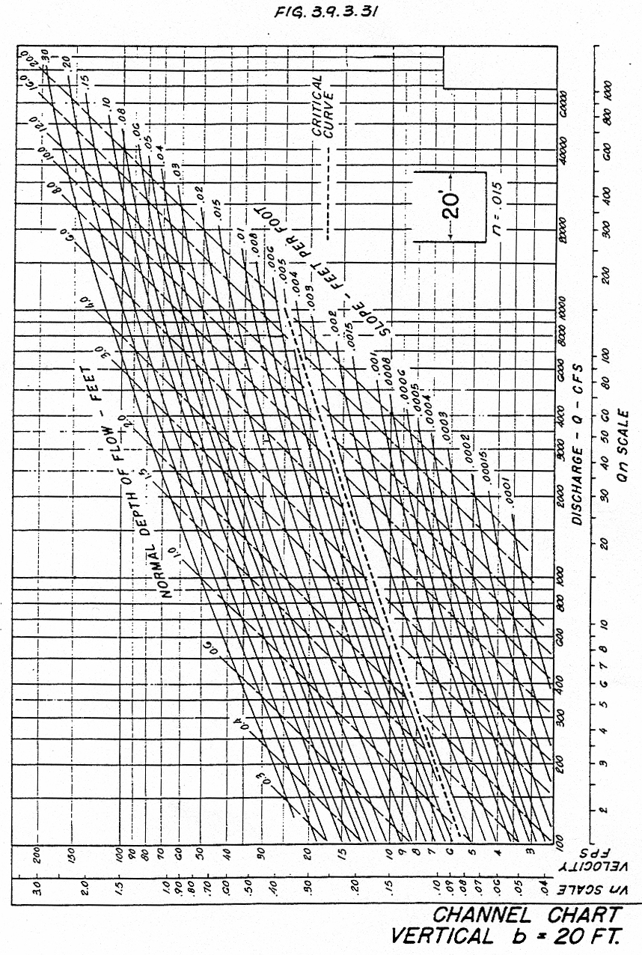

Source: HDS-3

