Appendix 8C-90 Rectangular Channel Flow Chart (B=18’)
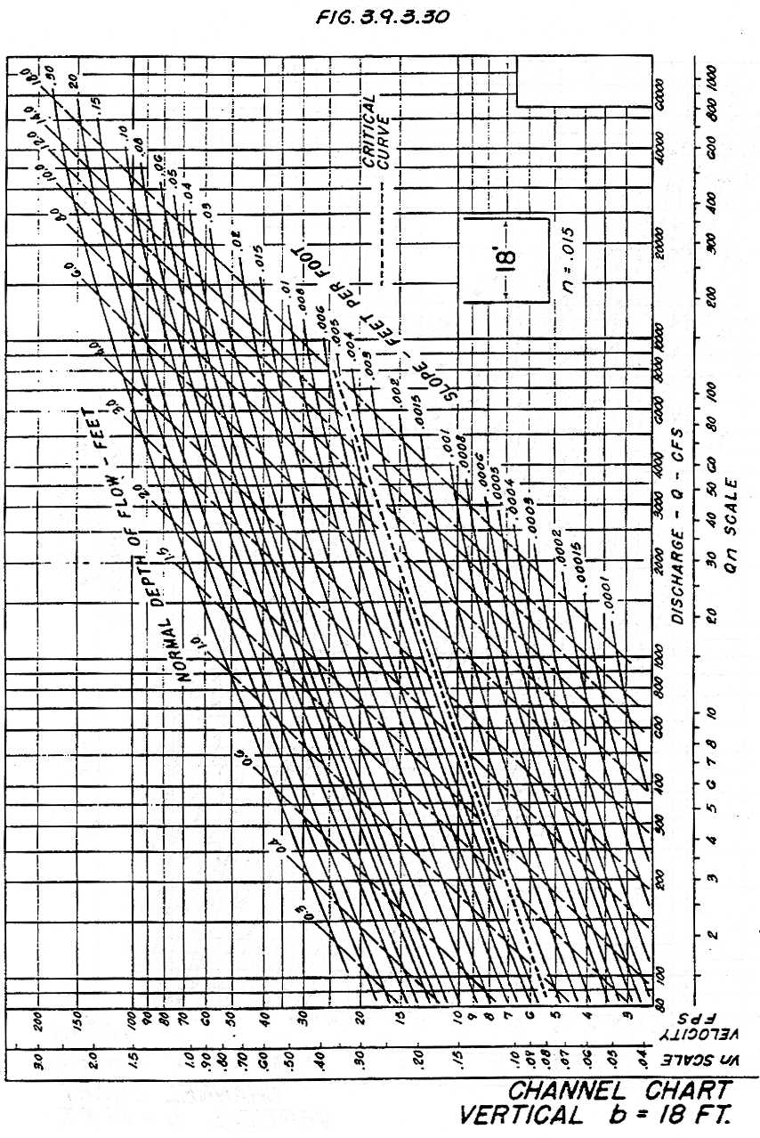

Source: HDS-3

