Appendix 8C-89 Rectangular Channel Flow Chart (B=16’)
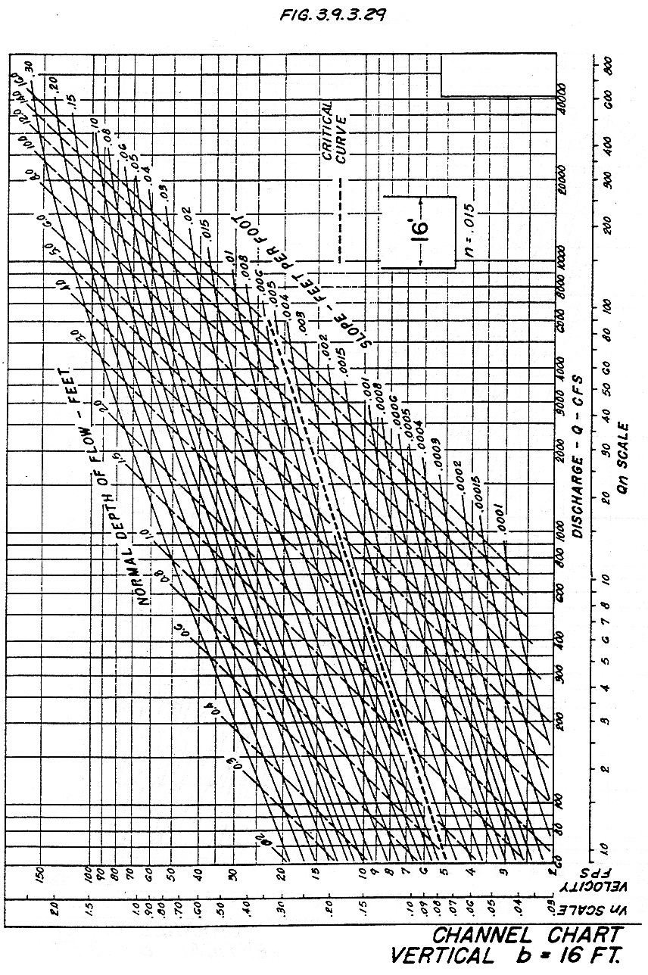

Source: HDS-3

