Appendix 8C-88 Rectangular Channel Flow Chart (B=14’)
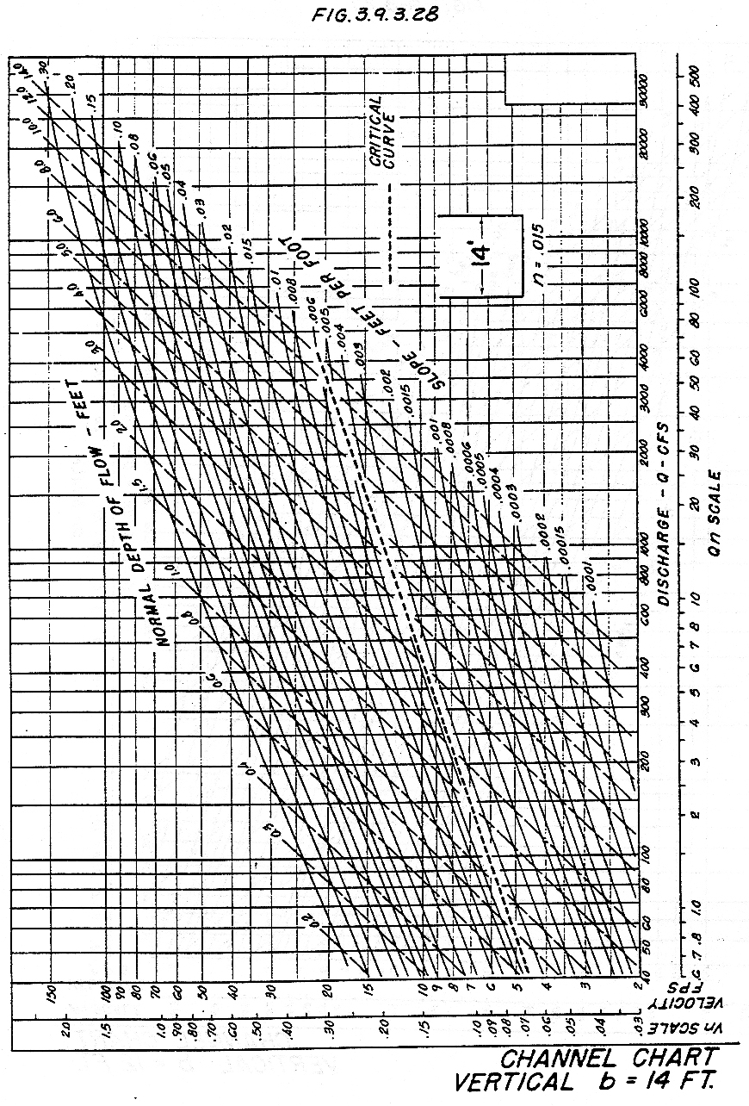

Source: HDS-3

