Appendix 8C-87 Rectangular Channel Flow Chart (B=12’)
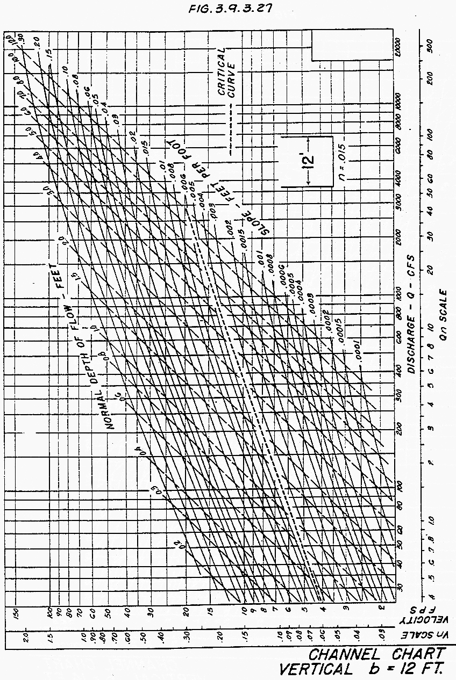

Source: HDS-3

