Appendix 8C-86 Rectangular Channel Flow Chart (B=10’)
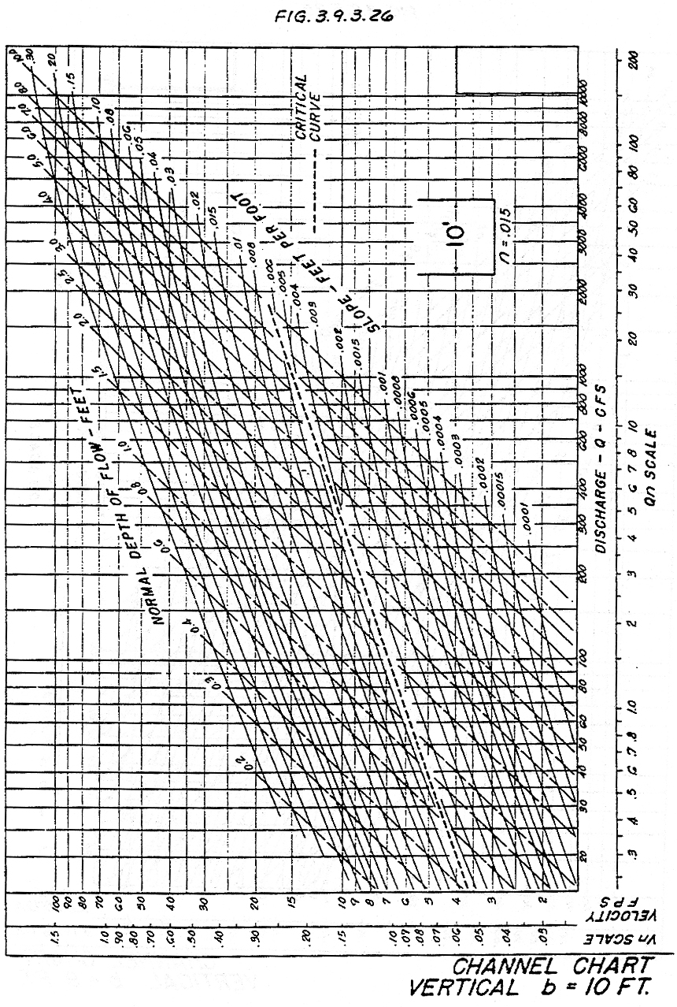

Source: HDS-3

