Appendix 8C-85 Rectangular Channel Flow Chart (B=9’)
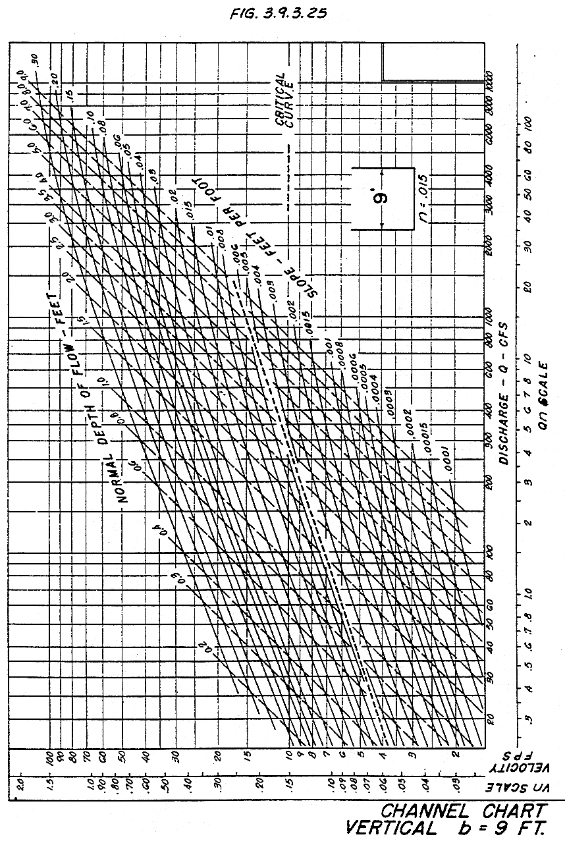

Source: HDS-3

