Appendix 8C-84 Rectangular Channel Flow Chart (B=8’)
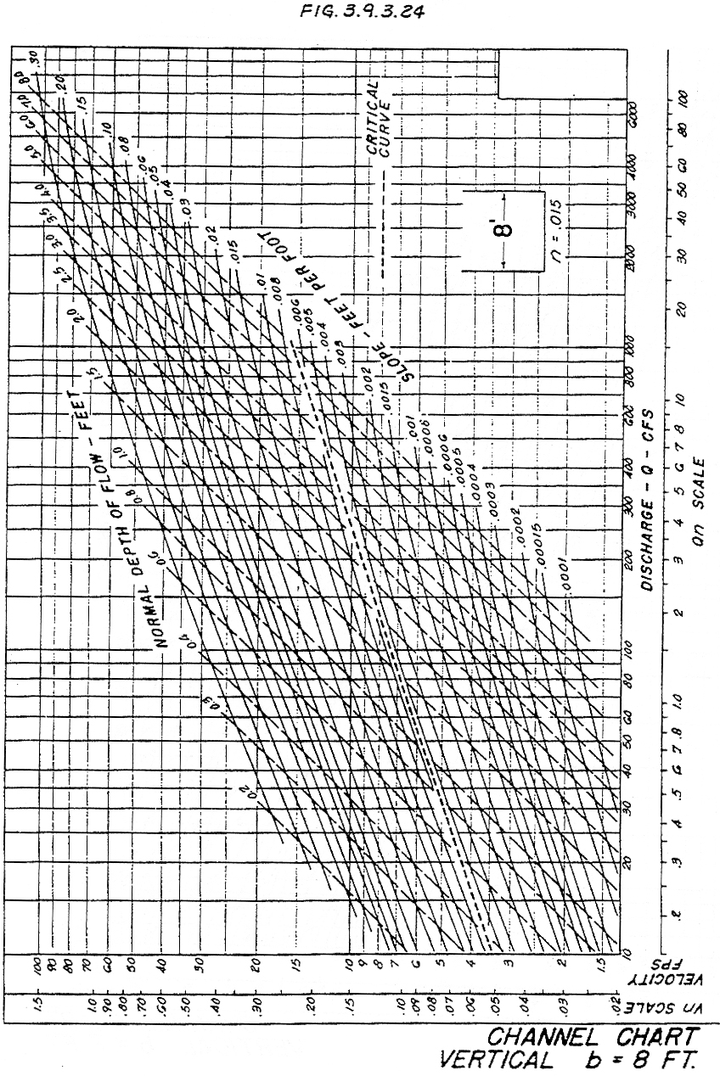

Source: HDS-3

