Appendix 8C-83 Rectangular Channel Flow Chart (B=7’)
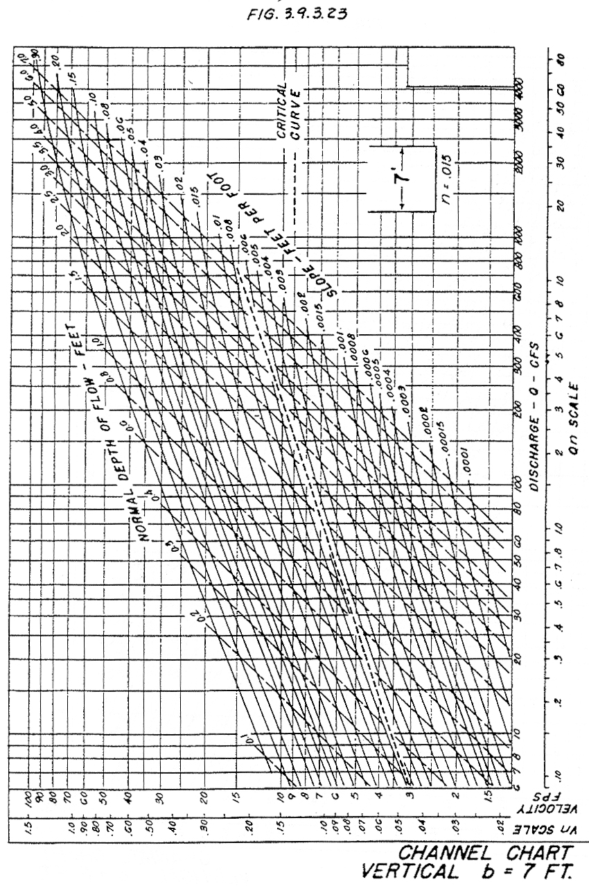

Source: HDS-3

