Appendix 8C-81 Rectangular Channel Flow Chart (B=5’)
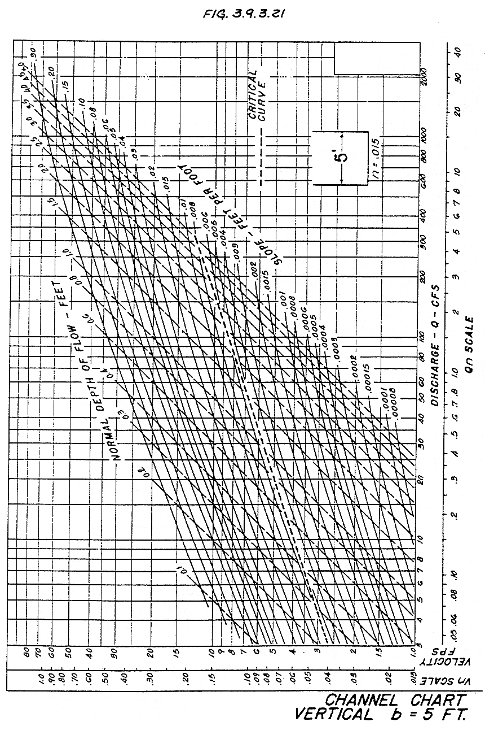
Source: HDS-3

