Appendix 8C-80 Rectangular Channel Flow Chart (B=4’)
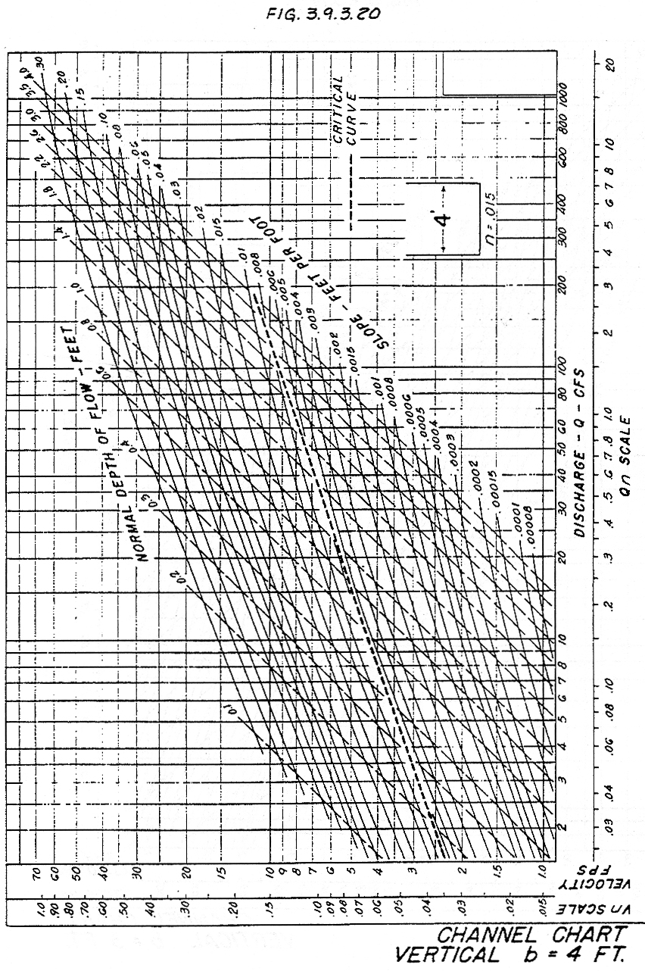

Source: HDS-3

