Appendix 8C-79 Rectangular Channel Flow Chart (B=3’)

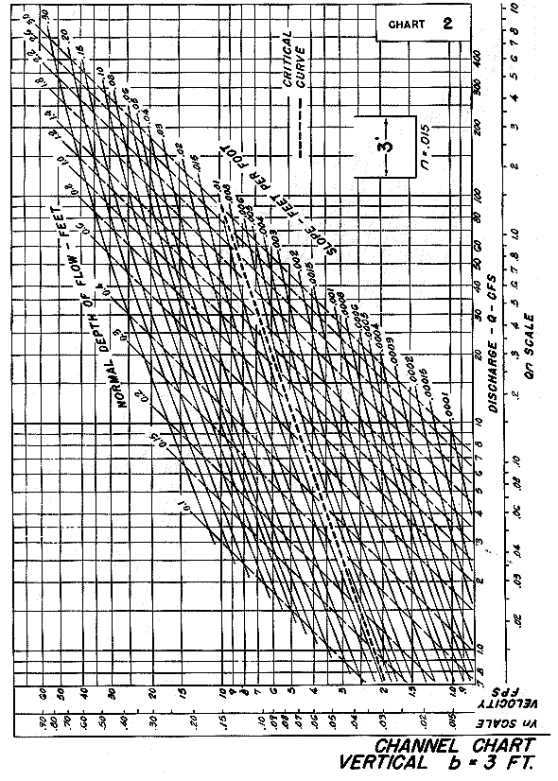
Source: HDS-3

