Appendix 8C-77 Circular Pipe Flow Chart (Diameter = 96”)
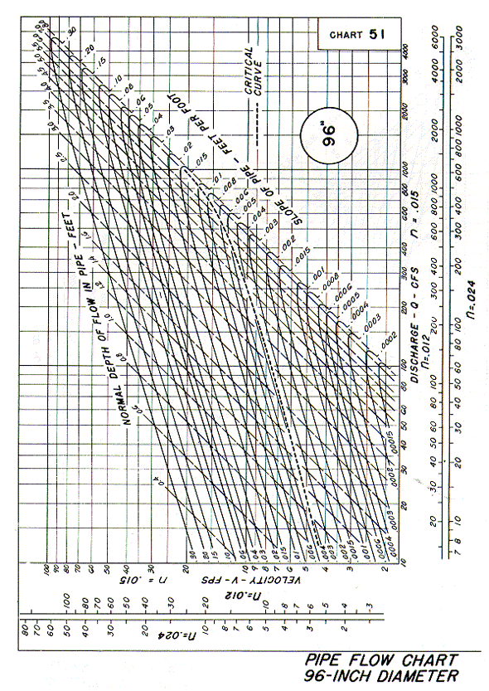
Source: HDS-3

