Appendix 8C-73 Circular Pipe Flow Chart (Diameter = 60”)
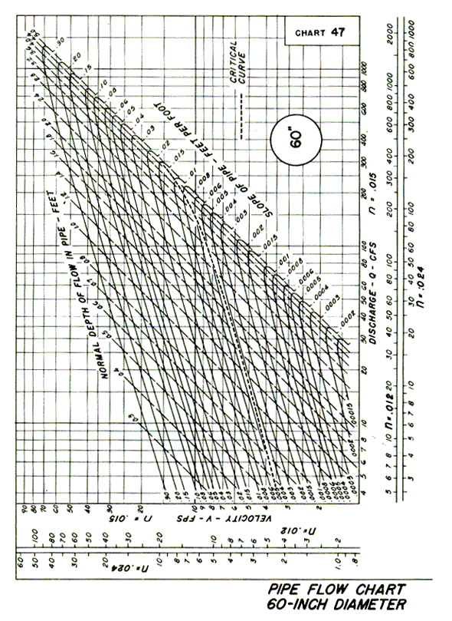

Source: HDS-3

