Appendix 8C-70 Circular Pipe Flow Chart (Diameter = 42”)
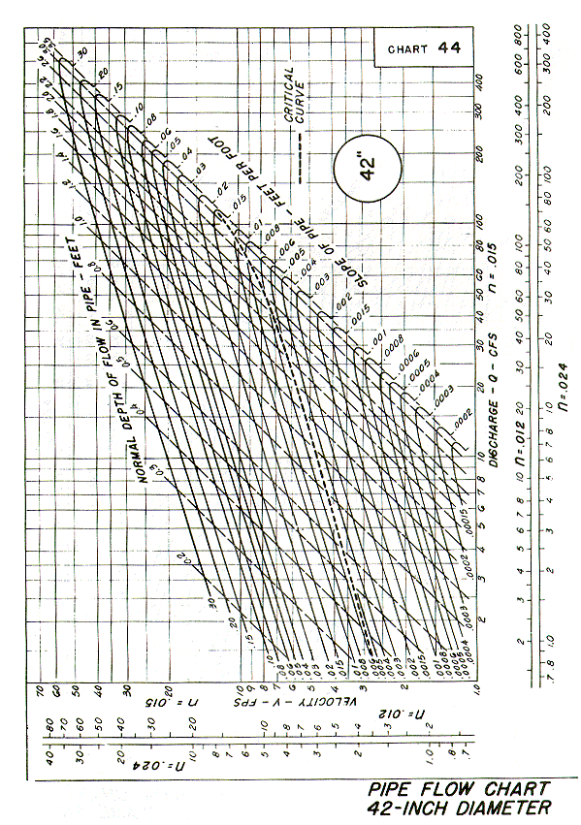
Source: HDS-3

