Appendix 8C-68 Circular Pipe Flow Chart (Diameter = 33”)
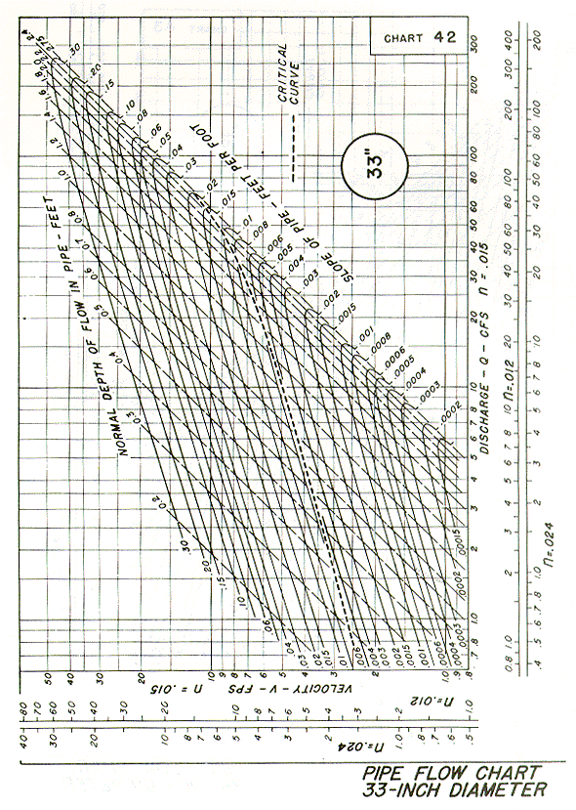
Source: HDS-3

