Appendix 8C-67 Circular Pipe Flow Chart (Diameter = 30”)
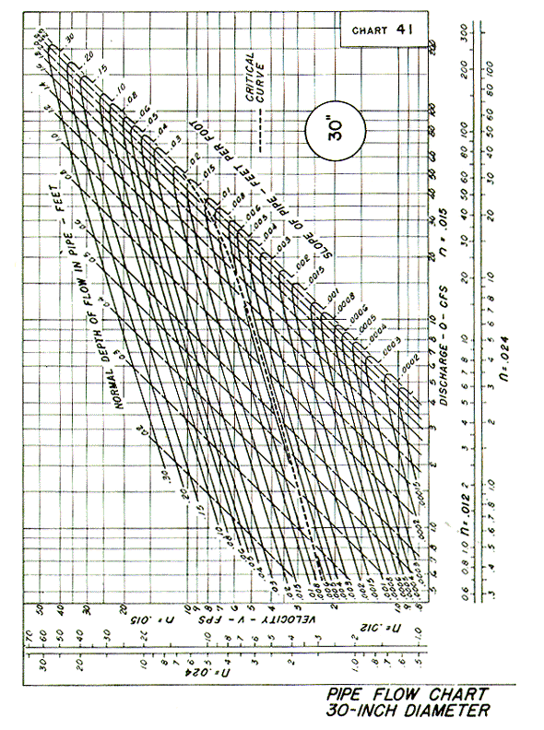

Source: HDS-3

