Appendix 8C-66 Circular Pipe Flow Chart (Diameter = 27”)
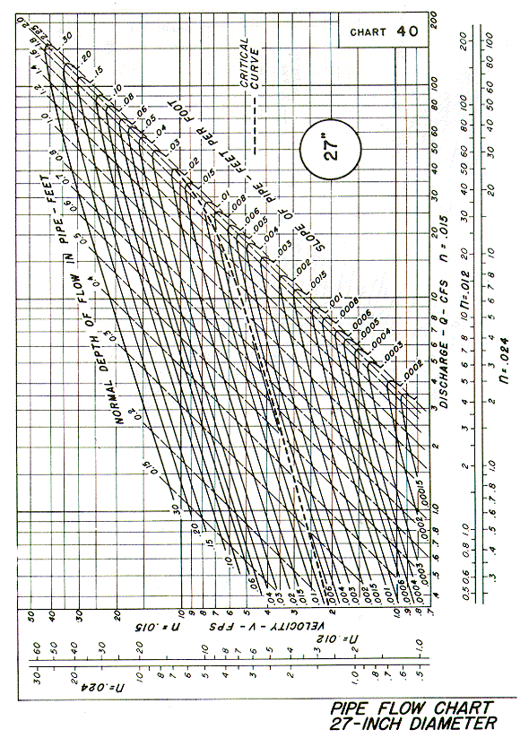
Source: HDS-3

