Appendix 8C-63 Circular Pipe Flow Chart (Diameter = 18”)
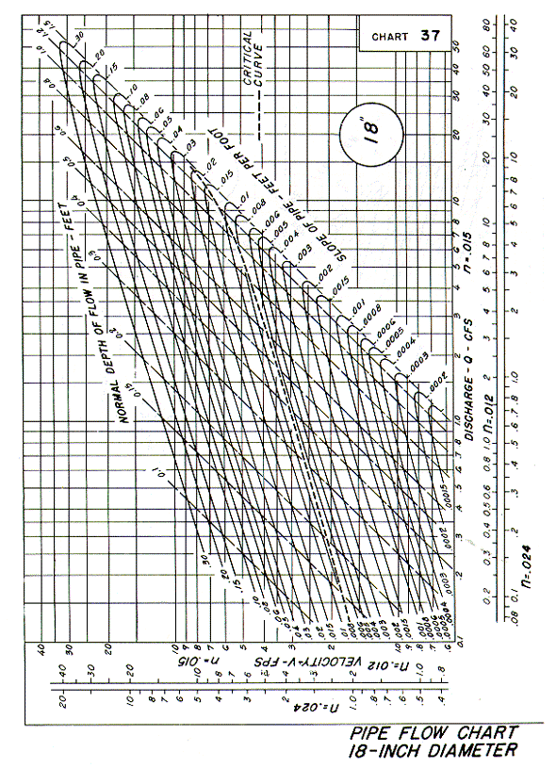
Source: HDS-3

