Appendix 8C-62 Circular Pipe Flow Chart (Diameter = 15”)
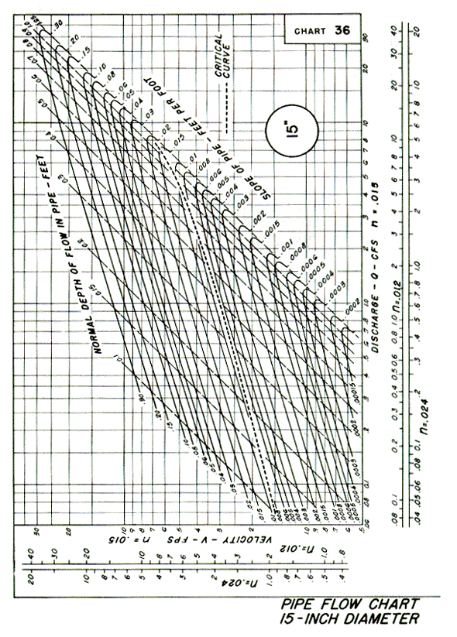
Source: HDS-3

