Chart 8C-60 Discharge Coefficients for Roadway Overtopping
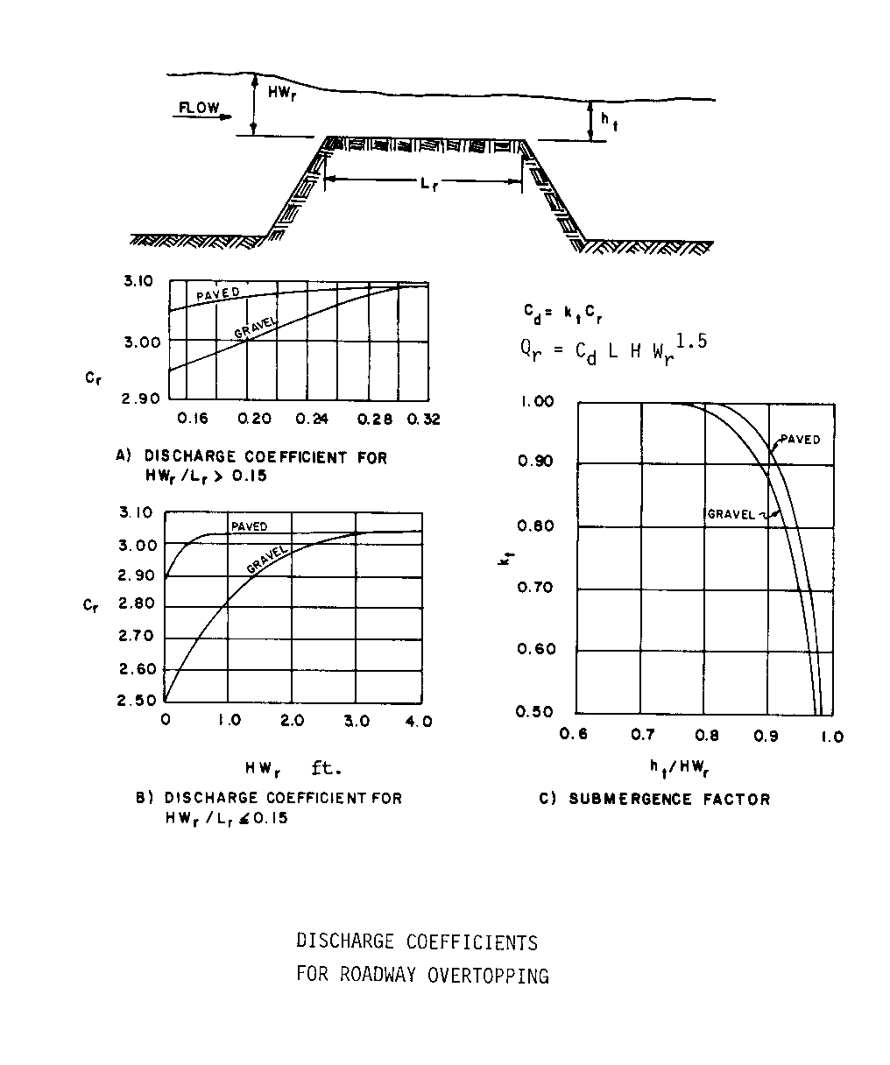

Source: HDS-5

