Chart 8C-57 Throat Control, Box Section, Tapered Inlet
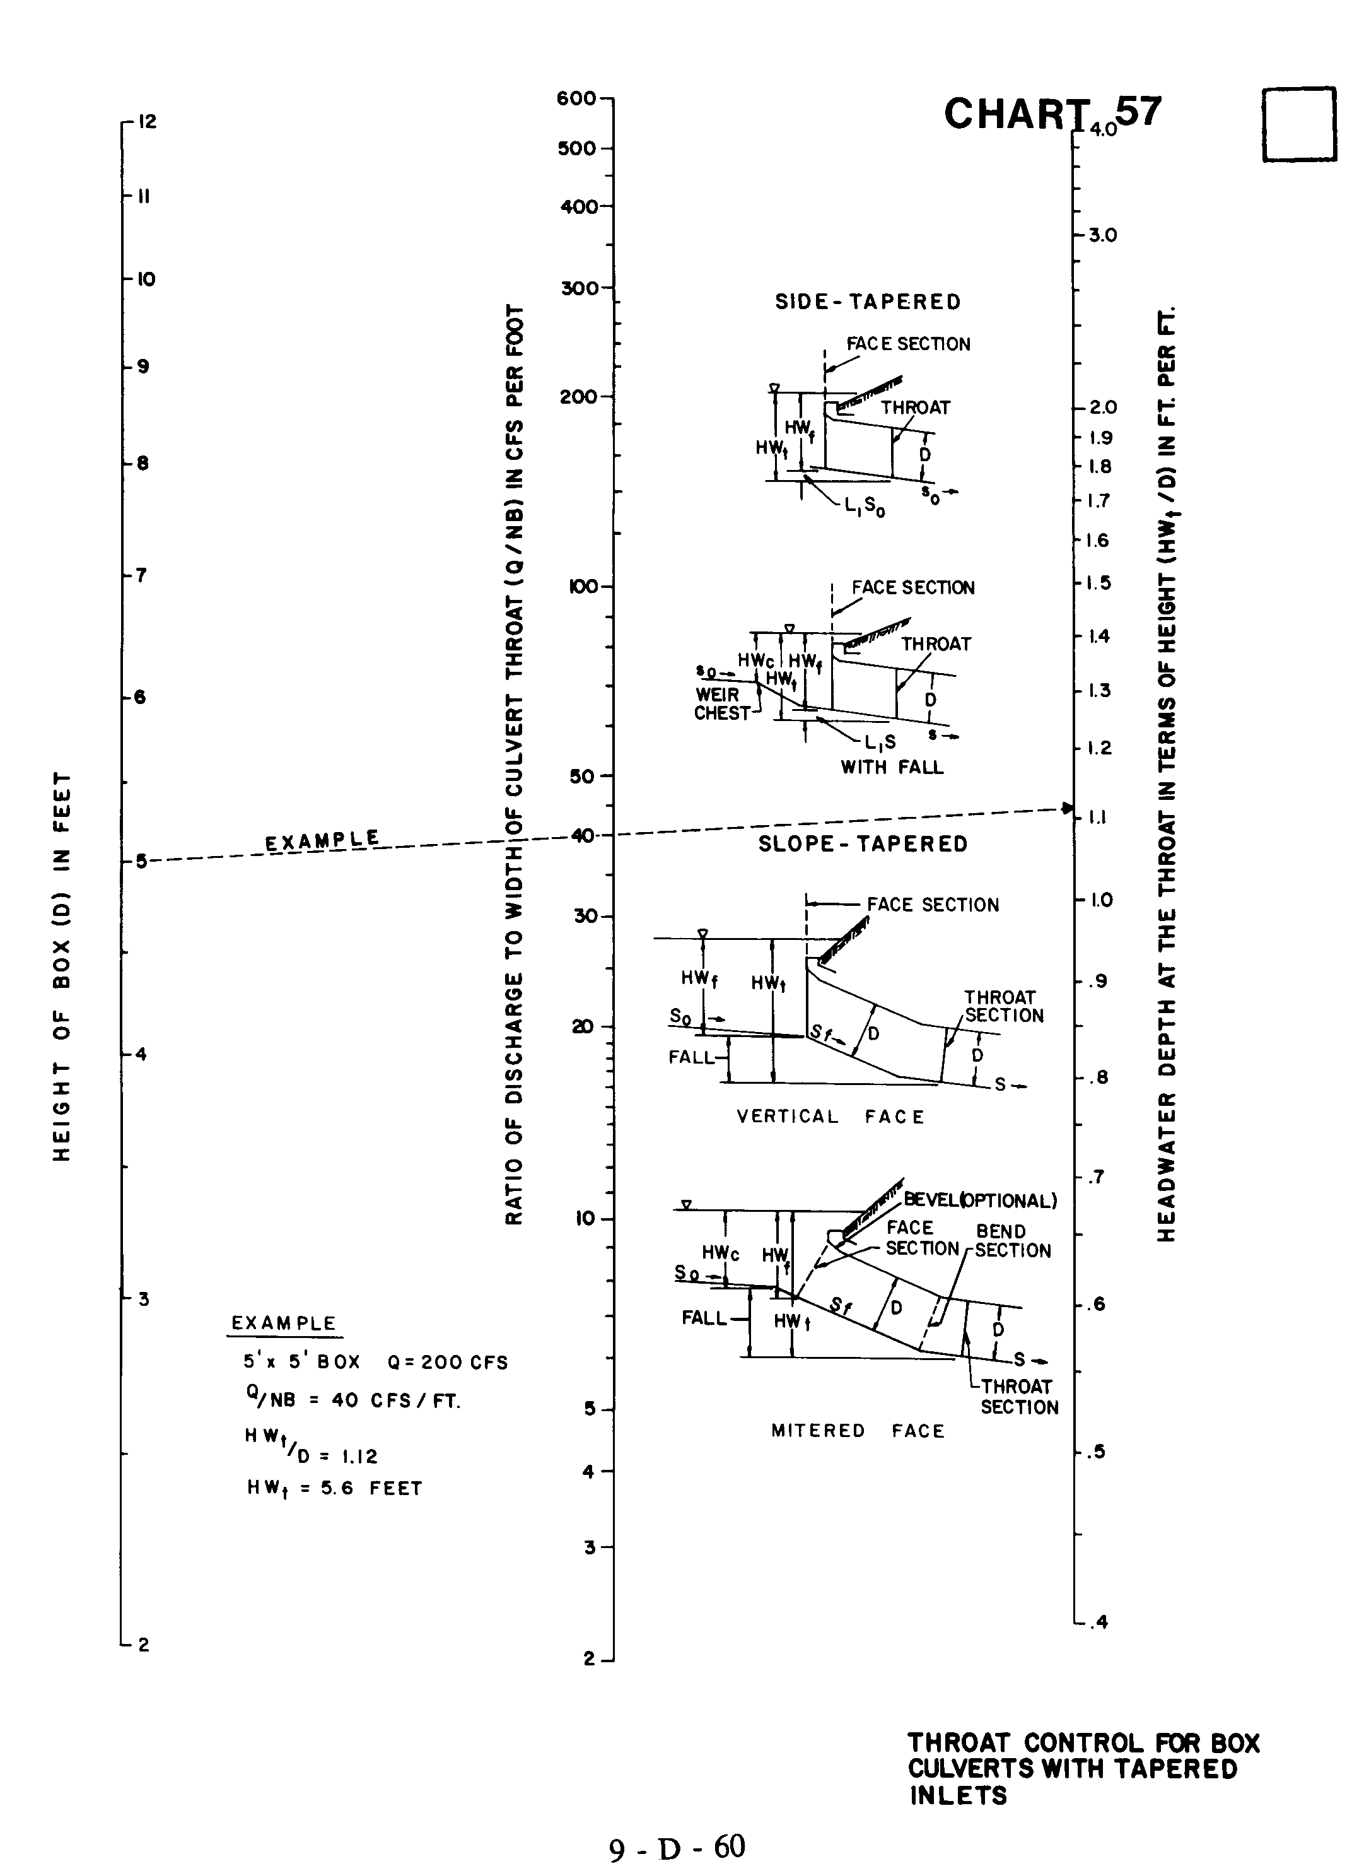

Source: HDS-5

