Chart 8C-56 Face Control, Non-Rectangular Section,

Side-Tapered to Circular
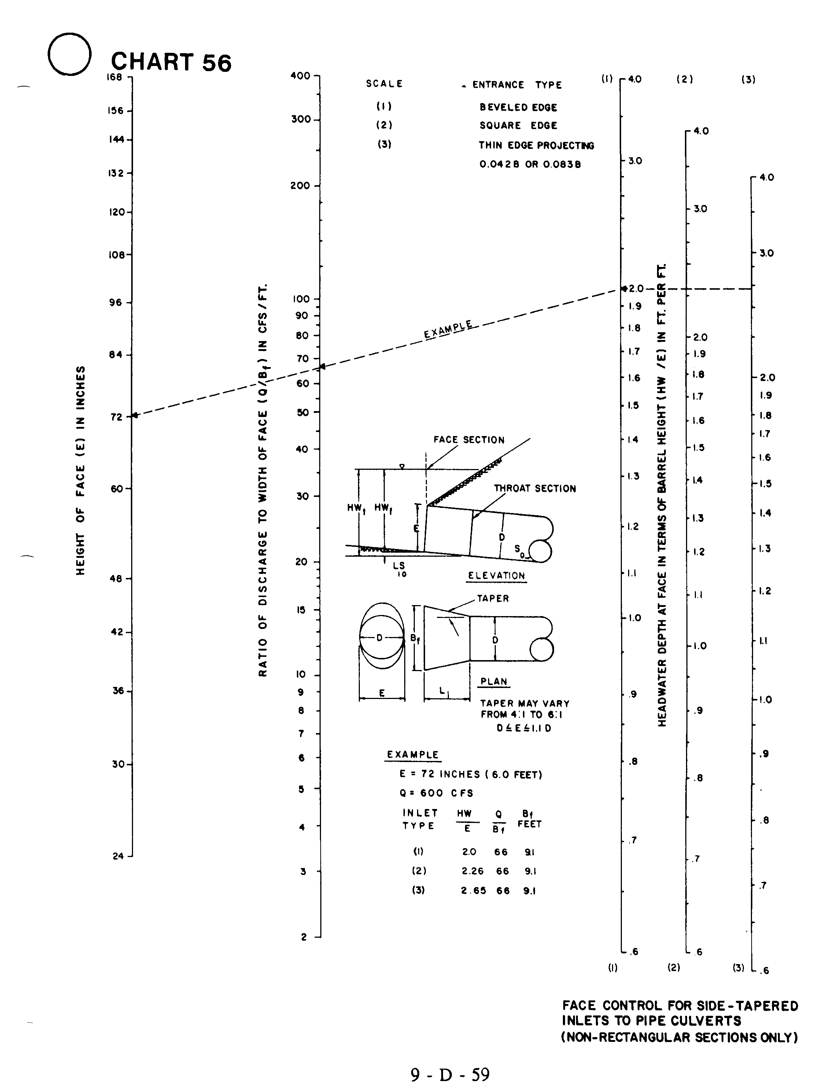

Source: HDS-5

