Appendix 8C-53 Critical Depth, Structural Plate Ellipse,

Long Axis Horizontal
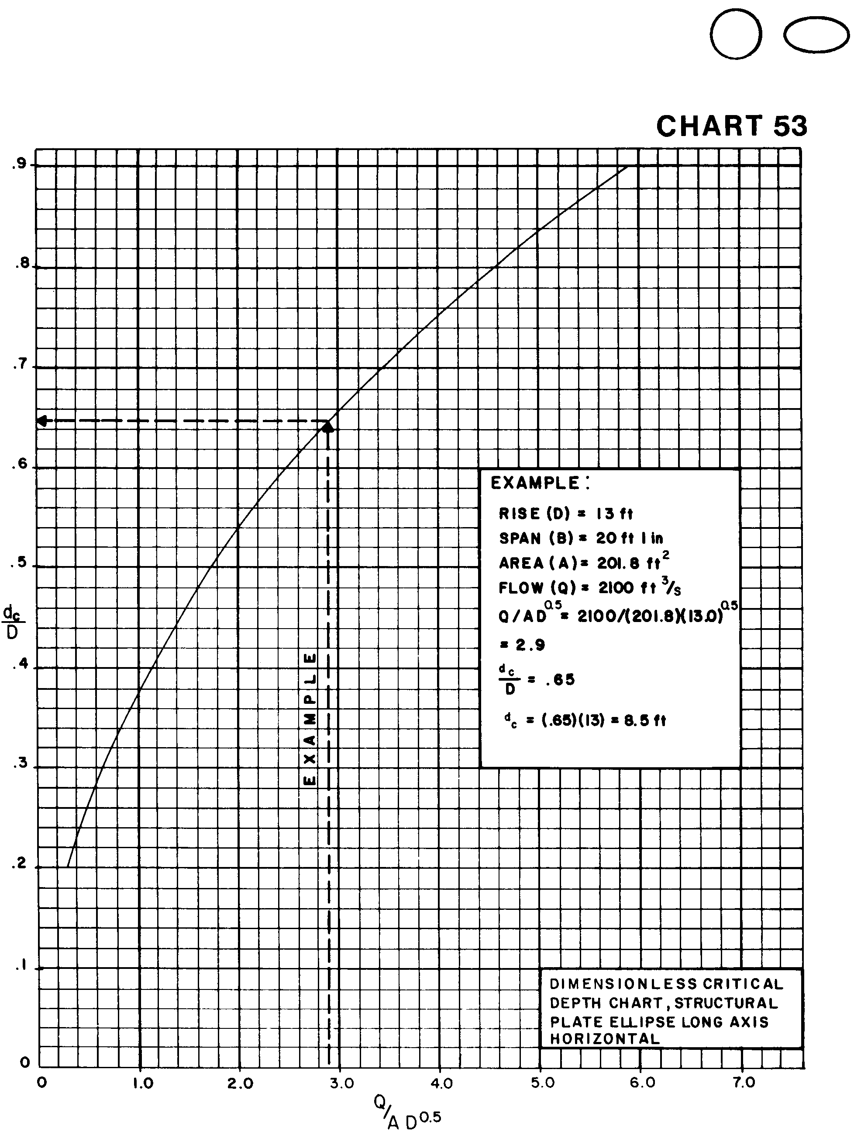

Source: HDS-5

