Appendix 8C-52 Inlet Control,

Structural Plate Corrugated

Metal Arch, High and Low Profile
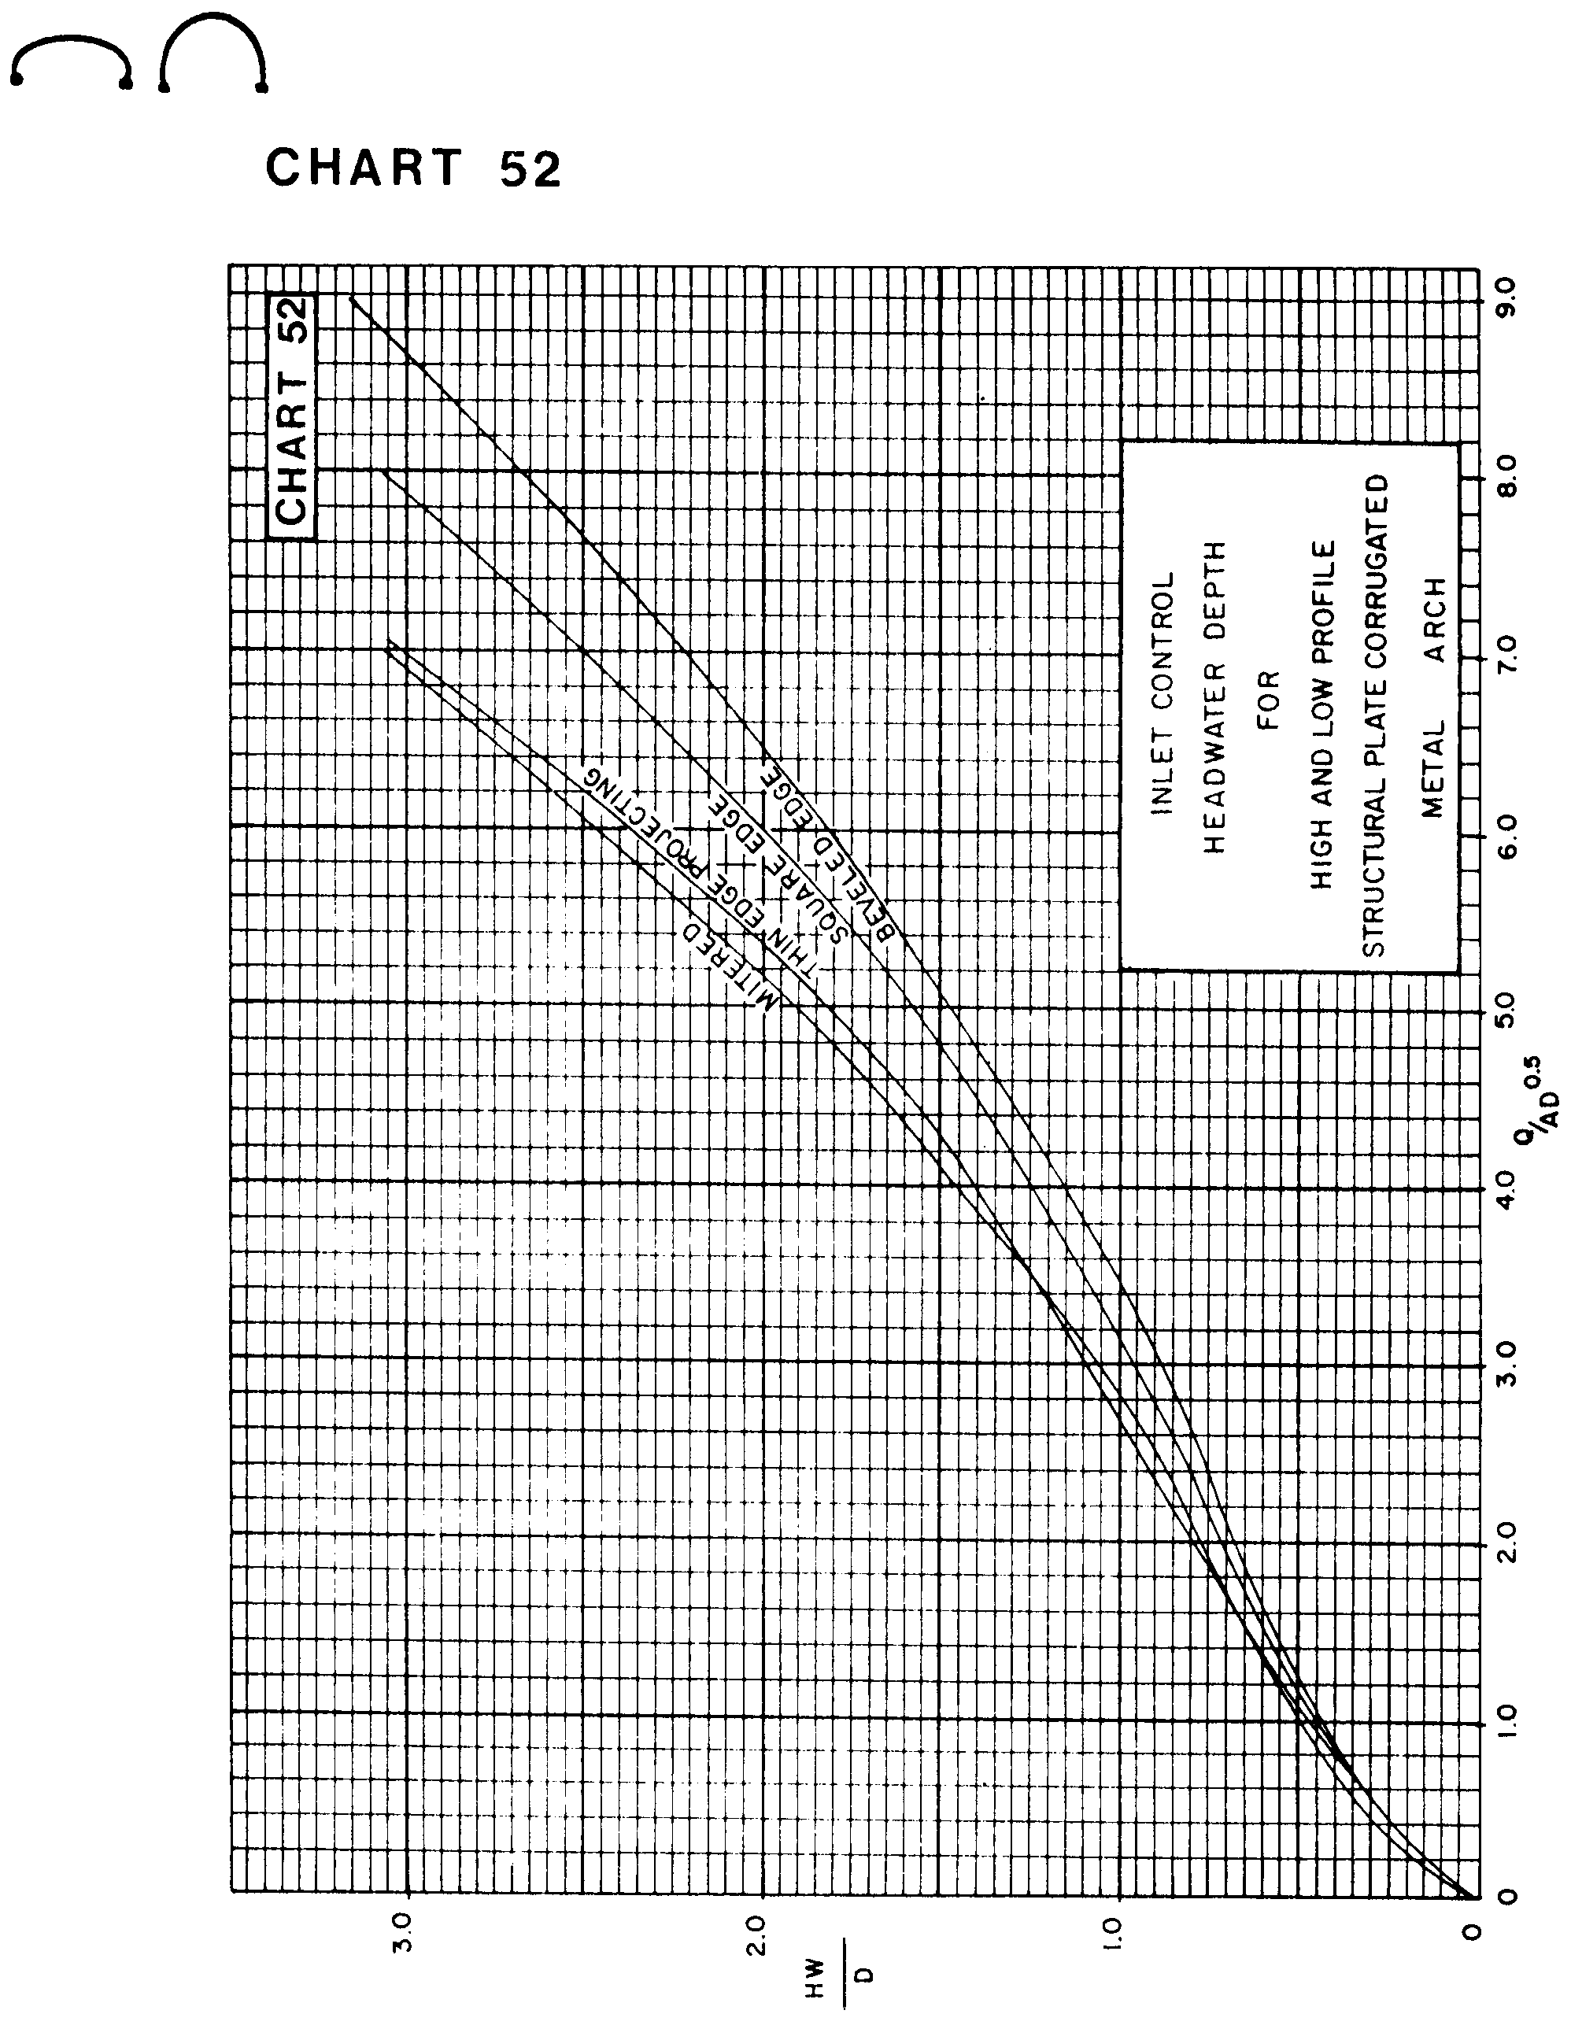

Source: HDS-5

