Appendix 8C-50 Outlet Control, Corrugated Metal Arch,

Earth Bottom,

0.5≤ Rise/Span
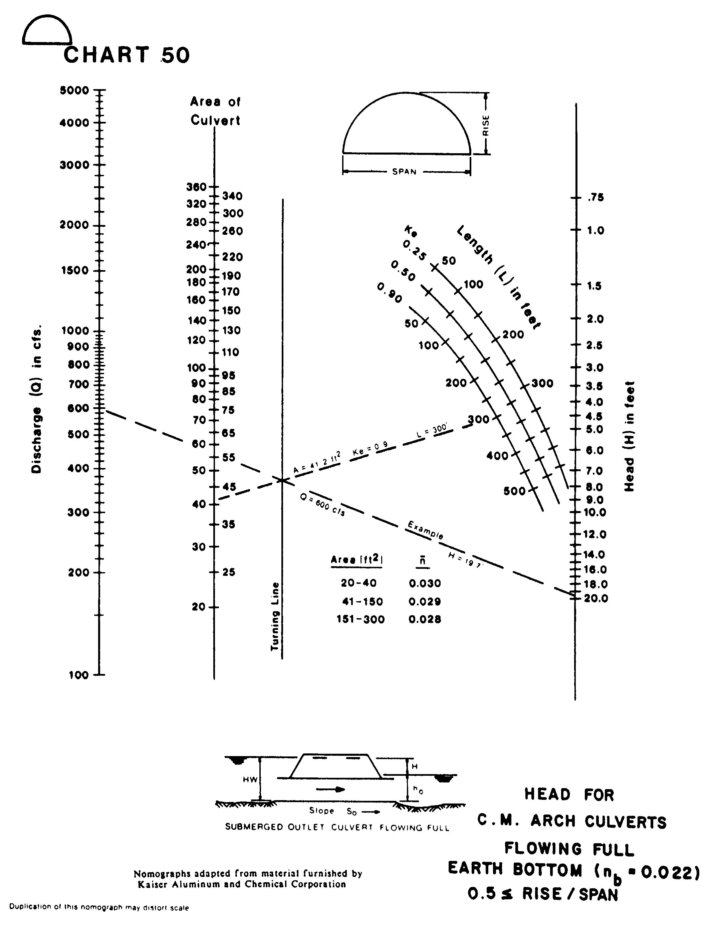
Source: HDS-5

