Appendix 8C-49 Outlet Control, Corrugated Metal Arch,

Earth Bottom,

0.4≤ Rise/Span <0.5
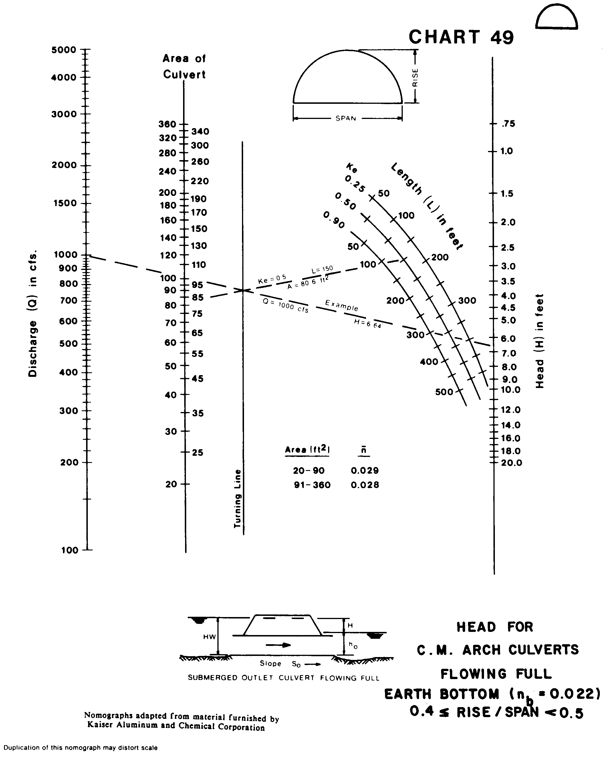
Source: HDS-5

