Appendix 8C-47 Outlet Control, Corrugated Metal Arch,

Concrete Bottom,

0.5≤ Rise/Span
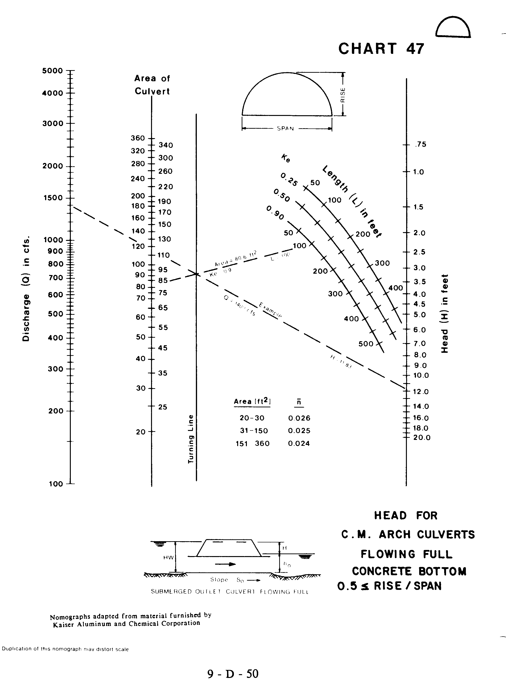
Source: HDS-5

