Appendix 8C-44 Critical Depth, Corrugated Metal Arch

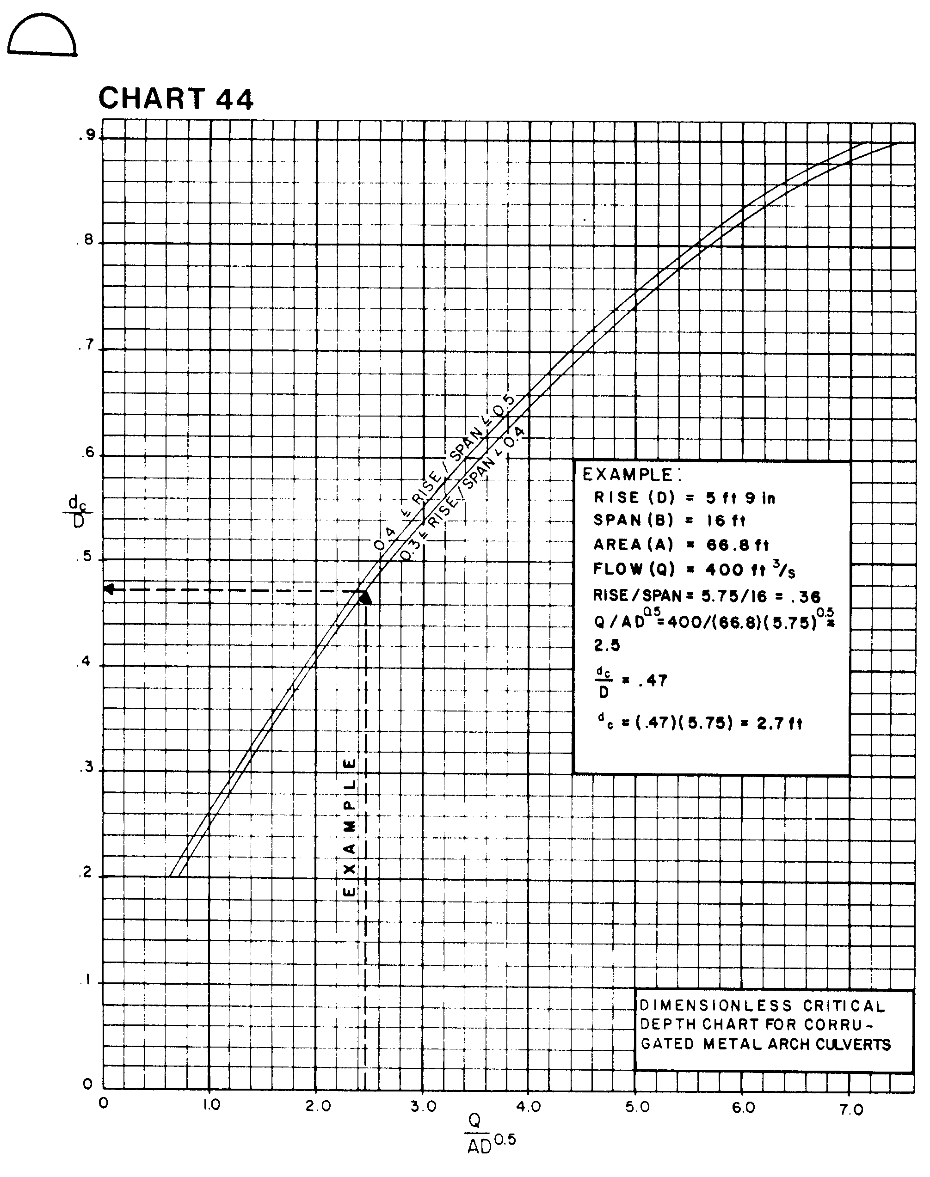

Source: HDS-5

