Appendix 8C-42 Inlet Control, Corrugated Metal Arch,

0.4≤ Rise/Span <0.5
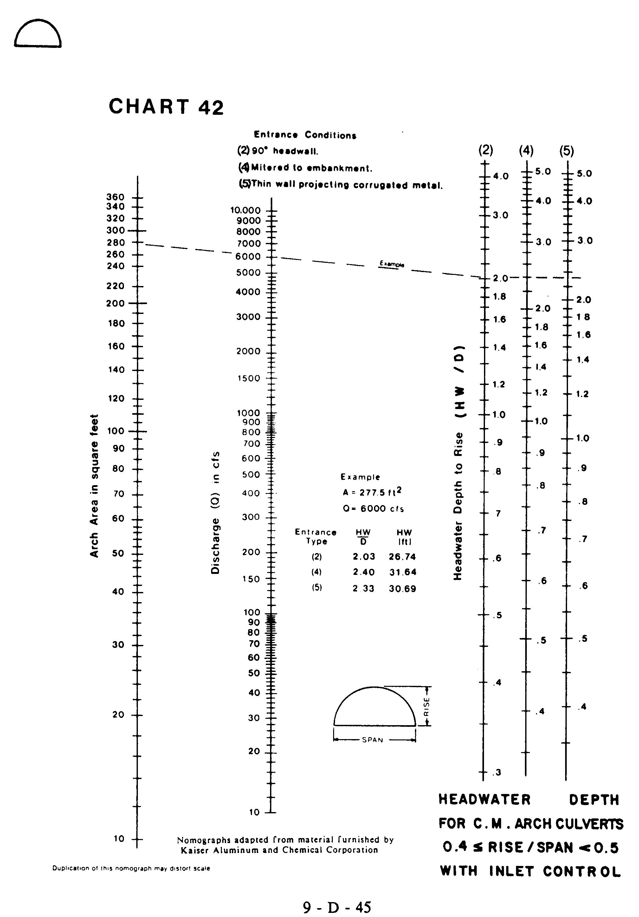
Source: HDS-5

