Appendix 8C-41 Inlet Control, Corrugated Metal Arch,

0.3≤ Rise/Span <0.4
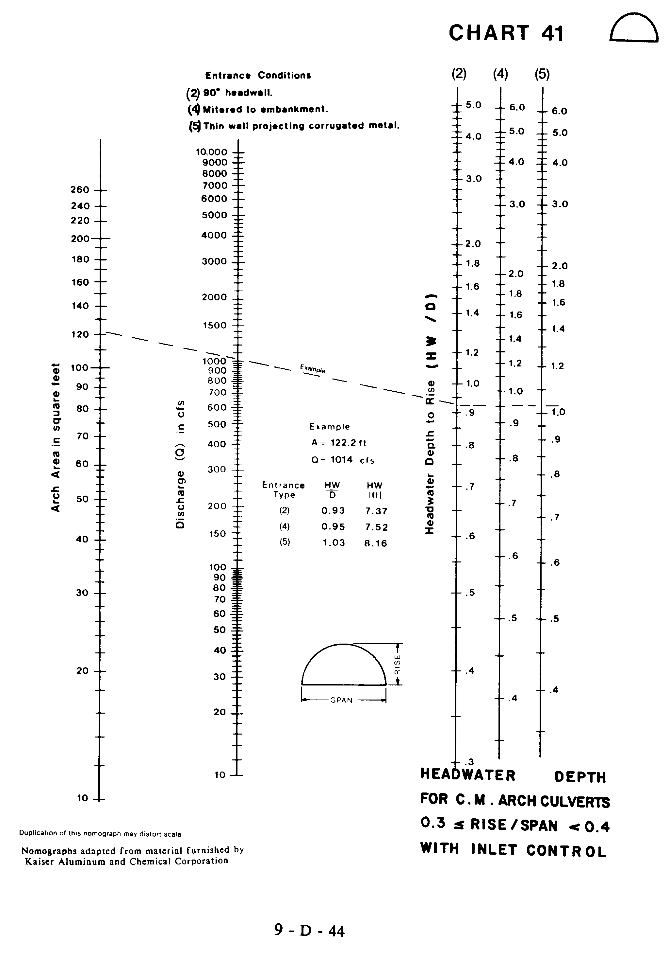

Source: HDS-5

